



**Hands-on Labs**

|  |  |
| --- | --- |
| **Author** | Pablo Szuster (pszuster@rehdat.com) |
| **Version** | 3-GCE |
| **Updated** | July 24th 2017 |
| **Fuse Version:** | FIS 2.0 |

**Index**

[RedHat OpenShift Introduction](#_rm43zt5gqqmm)

[Apache Camel Introduction](#_jhaf94gou4ef)

[Fuse Integration Services Introduction](#_8mn0xg7evy6u)

[Notes](#_1egkumx159qd)

[Lab 0 - Setup](#_wov94cbcpcns)

[JBoss Developer Studio](#_9h2dfgwfo49p)

[Openshift](#_31abt2y1hnmh)

[Gogs](#_qsczfutbess)

[Lab 1 - Files](#_x2sgvwwgor1m)

[Lab 2 - Data Transformation](#_xtjl668lygr)

[Lab 3 - Routing](#_ut5zjhg1acdt)

[Part A - Content Based Routing](#_tdl8i2srv5nz)

[Part B - Message Splitting](#_klhqdub2bgaw)

[Lab 4 - Database](#_2m1pi7d3ti57)

[Lab 5 - SOAP Web Services](#_owno8y672ea8)

[Lab 6 - REST Web Services](#_1g4pdmxfzr90)

[Lab 7 - Messaging](#_is4lhhn8teyh)

[Lab 8 - Debugging](#_nrklvjukw8fi)

[Part A - Local Debugging](#_gf7dzw93wqbd)

[Part B - Server Debugging](#_ilufc9aefmb3)

[Lab 9 - Circuit Breaker](#_fl3dk4ahsrz1)

[Lab 10 - Security](#_n9j4po6206q0)

[10a - Payload Level Security](#_kwkonx1ldq4t)

[10b - Transport Level Security](#_agg7vx4pbplo)

[10c - Authentication](#_4soel7wzlhym)

[Lab 11 - Continuous Integration / Continuous Delivery](#_cddql3ak86ut)

[Lab 12 - Testing](#_kto1nte1oyi1)

[Lab 13 - Scalability](#_63zvpglf7mlj)

[Part A - High Availability](#_q579agfg7azd)

[Part B - Load Balancing](#_o0z4kau0z09v)

[Part C - Manual Scaling](#_jxow62hrpobh)

[Appendix](#_drvgvi3zu2mz)

[Components reference](#_p6zf9yaxmrje)

# RedHat OpenShift Introduction

OpenShift Enterprise by Red Hat is a Platform as a Service (PaaS) that provides developers and IT organizations with a cloud application platform for deploying new applications on secure, scalable resources with minimal configuration and management overhead. OpenShift Enterprise supports a wide selection of programming languages and frameworks, such as Java, Ruby, and PHP.  
  
Built on Red Hat Enterprise Linux and Google Kubernetes, OpenShift Enterprise provides a secure and scalable multi-tenant operating system for today’s enterprise-class applications, while providing integrated application runtimes and libraries. OpenShift Enterprise brings the OpenShift PaaS platform to customer data centers, enabling organizations to implement a private PaaS that meets security, privacy, compliance, and governance requirements.  
  
OpenShift v3 is a layered system designed to expose underlying Docker and Kubernetes concepts as accurately as possible, with a focus on easy composition of applications by a developer. For example, install Ruby, push code, and add MySQL.

Docker provides the abstraction for packaging and creating Linux-based, lightweight containers. Kubernetes provides the cluster management and orchestrates Docker containers on multiple hosts. OpenShift Enterprise adds:

* Source code management, builds, and deployments for developers
* Managing and promoting images at scale as they flow through your system
* Application management at scale
* Team and user tracking for organizing a large developer organization

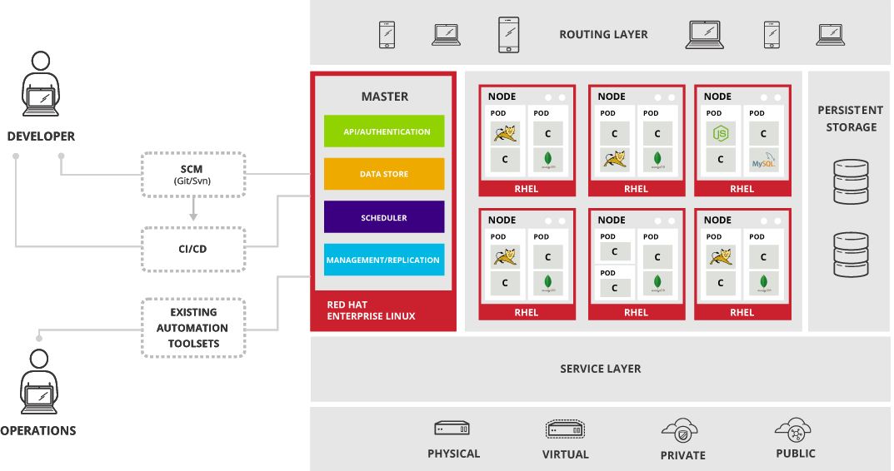

Within OpenShift Enterprise, Kubernetes manages containerized applications across a set of containers or hosts and provides mechanisms for deployment, maintenance, and application-scaling. Docker packages, instantiates, and runs containerized applications. A Kubernetes cluster consists of one or more masters and a set of nodes.

The master is the host or hosts that contain the master components, including the API server, controller manager server, and etcd. The master manages nodes in its Kubernetes cluster and schedules pods to run on nodes.

A node provides the runtime environments for containers. Each node in a Kubernetes cluster has the required services to be managed by the master. Nodes also have the required services to run pods, including Docker, a kubelet, and a service proxy. OpenShift Enterprise creates nodes from a cloud provider, physical systems, or virtual systems.

**CORE CONCEPTS**

**Container**

The basic units of OpenShift Enterprise applications are called containers. Linux container technologies are lightweight mechanisms for isolating running processes so that they are limited to interacting with only their designated resources. Many application instances can be running in containers on a single host without visibility into each others' processes, files, network, and so on. Typically, each container provides a single service (often called a "micro-service"), such as a web server or a database, though containers can be used for arbitrary workloads.

The Linux kernel has been incorporating capabilities for container technologies for years. More recently the Docker project has developed a convenient management interface for Linux containers on a host. OpenShift Enterprise and Kubernetes add the ability to orchestrate Docker containers across multi-host installations.

Docker containers are based on Docker images. A Docker image is a binary that includes all of the requirements for running a single Docker container, as well as metadata describing its needs and capabilities. You can think of it as a packaging technology. Docker containers only have access to resources defined in the image unless you give the container additional access when creating it. By deploying the same image in multiple containers across multiple hosts and load balancing between them, OpenShift Enterprise can provide redundancy and horizontal scaling for a service packaged into an image.  
  
You can use Docker directly to build images, but OpenShift Enterprise also supplies builders that assist with creating an image by adding your code or configuration to existing images.

**Docker Registry**

A Docker registry is a service for storing and retrieving Docker images. A registry contains a collection of one or more Docker image repositories. Each image repository contains one or more tagged images. Docker provides its own registry, the Docker Hub, but you may also use private or third-party registries. Red Hat provides a Docker registry at registry.access.redhat.com for subscribers. OpenShift Enterprise can also supply its own internal registry for managing custom Docker images.

**Pod**

OpenShift Enterprise leverages the Kubernetes concept of a pod, which is one or more containers deployed together on one host, and the smallest compute unit that can be defined, deployed, and managed.

Pods are the rough equivalent of a machine instance (physical or virtual) to a container. Each pod is allocated its own internal IP address, therefore owning its entire port space, and containers within pods can share their local storage and networking.

Pods have a lifecycle; they are defined, then they are assigned to run on a node, then they run until their container(s) exit or they are removed for some other reason. Pods, depending on policy and exit code, may be removed after exiting, or may be retained in order to enable access to the logs of their containers.

OpenShift Enterprise treats pods as largely immutable; changes cannot be made to a pod definition while it is running. OpenShift Enterprise implements changes by terminating an existing pod and recreating it with modified configuration, base image(s), or both. Pods are also treated as expendable, and do not maintain state when recreated. Therefore pods should usually be managed by higher-level controllers, rather than directly by users.

**Service**

A Kubernetes service serves as an internal load balancer. It identifies a set of replicated pods in order to proxy the connections it receives to them. Backing pods can be added to or removed from a service arbitrarily while the service remains consistently available, enabling anything that depends on the service to refer to it at a consistent internal address.

Services are assigned an IP address and port pair that, when accessed, proxy to an appropriate backing pod. A service uses a label selector to find all the containers running that provide a certain network service on a certain port.

**Project**

A project is a Kubernetes namespace with additional annotations, and is the central vehicle by which access to resources for regular users is managed. A project allows a community of users to organize and manage their content in isolation from other communities. Users must be given access to projects by administrators, or if allowed to create projects, automatically have access to their own projects.

**Build**

A build is the process of transforming input parameters into a resulting object. Most often, the process is used to transform input parameters or source code into a runnable image. A BuildConfig object is the definition of the entire build process.

OpenShift Enterprise leverages Kubernetes by creating Docker containers from build images and pushing them to a Docker registry.

Build objects share common characteristics: inputs for a build, the need to complete a build process, logging the build process, publishing resources from successful builds, and publishing the final status of the build. Builds take advantage of resource restrictions, specifying limitations on resources such as CPU usage, memory usage, and build or pod execution time.

The OpenShift Enterprise build system provides extensible support for build strategies that are based on selectable types specified in the build API. There are three build strategies available:

* Docker build: invokes the plain docker build command, and it therefore expects a repository with a Dockerfile and all required artifacts in it to produce a runnable image.
* Source-to-Image (S2I) build: is a tool for building reproducible Docker images. It produces ready-to-run images by injecting application source into a Docker image and assembling a new Docker image. The new image incorporates the base image (the builder) and built source and is ready to use with the docker run command. S2I supports incremental builds, which re-use previously downloaded dependencies, previously built artifacts, etc.
* Custom build: The Custom build strategy allows developers to define a specific builder image responsible for the entire build process. Using your own builder image allows you to customize your build process.

**Replication Controller**

A replication controller ensures that a specified number of replicas of a pod are running at all times. If pods exit or are deleted, the replication controller acts to instantiate more up to the defined number. Likewise, if there are more running than desired, it deletes as many as necessary to match the defined amount.

A replication controller configuration consists of:

1. The number of replicas desired (which can be adjusted at runtime).
2. A pod definition to use when creating a replicated pod.
3. A selector for identifying managed pods.

**Route**

An OpenShift Enterprise route is a way to expose a service by giving it an externally-reachable hostname like www.example.com.

A defined route and the endpoints identified by its service can be consumed by a router to provide named connectivity that allows external clients to reach your applications. Each route consists of a route name (limited to 63 characters), service selector, and (optionally) security configuration.

**xPaaS**

JBoss xPaaS services provide the powerful capabilities of JBoss Middleware as cloud-based services on OpenShift. With the ability to run these services as containerized deployments across a variety of different environments, you can trust Red Hat JBoss Middleware to be your solution of choice for enterprise applications. (<https://access.redhat.com/documentation/en/red-hat-jboss-middleware-for-openshift/> )

Currently, the following are available:

* Red Hat JBoss Enterprise Application Platform
* Red Hat JBoss Web Server
* Red Hat JBoss A-MQ
* Red Hat JBoss Fuse (Fuse Integration Services)
* Red Hat JBoss BRMS (Decision Server)
* Red Hat JBoss Data Grid
* Red Hat JBoss SSO image.
* Red Hat JBoss Data Virtualization (Data Services)
* Red Hat JBoss BPMS (Process Server)
* Red Hat Java

# 

# 

# Apache Camel Introduction

Building complex systems from scratch is a very costly endeavor, and one that’s almost

never successful. An effective and less risky alternative is to assemble a system like a

jigsaw puzzle from existing, proven components. We depend daily on a multitude of such integrated systems, making possible everything from phone communications,

financial transactions, and healthcare to travel planning and entertainment.

You can’t finalize a jigsaw puzzle until you have a complete set of pieces that plug

into each other simply, seamlessly, and robustly. That holds true for system integration

projects as well. But whereas jigsaw puzzle pieces are made to plug into each

other, the systems we integrate rarely are. Integration frameworks aim to fill this gap.

As an integrator, you’re less concerned about how the system you integrate works and

more focused on how to interoperate with it from the outside. A good integration

framework provides simple, manageable abstractions for the complex systems you’re

integrating and the “glue” for plugging them together seamlessly. Apache Camel is such an integration framework.

At the core of the Camel framework is a routing engine, or more precisely a routing engine

builder. It allows you to define your own routing rules, decide from which sources to accept messages, and determine how to process and send those messages to other destinations. Camel uses an integration language that allows you to define complex routing rules, akin to business processes. One of the fundamental principles of Camel is that it makes no assumptions about the type of data you need to process. This is an important point, because it gives you, the developer, an opportunity to integrate any kind of system, without the need to

convert your data to a canonical format. Camel offers higher-level abstractions that allow you to interact with various systems using the same API regardless of the protocol or data type the systems are using. Components in Camel provide specific implementations of the API that target different protocols and data types. Out of the box, Camel comes with support for over 80

protocols and data types. Its extensible and modular architecture allows you to implement

and seamlessly plug in support for your own protocols, proprietary or not.

These architectural choices eliminate the need for unnecessary conversions and make

Camel not only faster but also very lean.

# Fuse Integration Services Introduction

Red Hat JBoss Fuse Integration Services provides a set of tools and containerized xPaaS images that enable development, deployment, and management of integration microservices within OpenShift.

So imagine you have an integration service with a route that starts with a message queue based endpoint, then you apply some transformation on the message, and based on its content, you decide where to go next.  
When you deploy this integration service, it becomes an independent unit of schedule and scale on the OpenShift platform, allowing for easy addition or removal of more replicas of this route to make sure your SLAs are maintained.

Fuse Integration Services enables creation of pattern-based and modular microservices-style integration services that can be deployed, removed, and redeployed in a continuous fashion using the underlying OpenShift capabilities for more rapid connections.Also, each route deployment, no matter the number of replicas it might have, can be seen as a single unique service with its load being balanced across all of your replicas. Client applications see one endpoint, and the platform takes care of spreading the load.

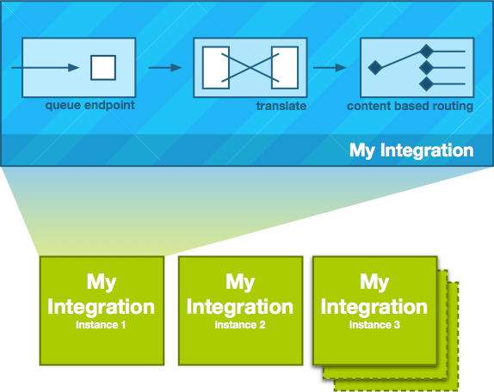

You can start using Fuse Integration Services by creating an application and deploying it to OpenShift using one of the following OpenShift Source-to-Image (S2I) application development workflows:

**S2I binary workflow**

S2I with build input from a binary source. This workflow is characterised by the fact that the build is partly executed on the developer’s own machine. After building a binary package locally, this workflow hands off the binary package to OpenShift. For more details, see Binary Source from the OpenShift 3.3 Developer Guide.

**S2I source workflow**

S2I with build input from a Git source. This workflow is characterised by the fact that the build is executed entirely on the OpenShift server. For more details, see Git Source from the OpenShift 3.3 Developer Guide.

**Red Hat JBoss Fuse provide two popular way to solve these problem by using two frameworks**,

**Spring Boot**

Spring Boot is the most popular framework for microservice these days, due to it’s simplicity to get started, by adding the Spring boot starter module that conveniently connects the dependency needed, and allowing developer to select the libraries they need in the creation time. To start the application, simple execute a command line to bring it up, yes, it’s just a FAT JAR, without the redundant or unneeded dependency, therefore it’s extremely lightweight.

**Karaf**

The OSGi technology is a set of specifications that define a dynamic component system for Java. These specifications enable a development model where applications are (dynamically) composed of many different (reusable) components

* The internal implementation is private to each bundle,
* The behaviour exposed by the bundle is described by its stated ‘Capabilities‘,
* The dependencies a bundle has on its local environment are described by its stated ‘Requirements‘.
* Finally semantic versioning is used. A bundle’s Capabilities are versioned (major.minor.micro). Meanwhile a bundle’s Requirements specify the acceptable version ranges within which the Capabilities of third parties must fall.

Due to strong isolation OSGi bundles may be dynamically loaded or unloaded from a running JVM. As the bundles are self-describing, a process know as ‘resolution’ may be used to ensure that all inter-related bundles are automatically loaded into the runtime and wired together.

OSGi fit into the general microservices definition: lightweight communications, independently deployable etc, but they can also mitigate some of the criticisms of microservices cited above. Service boundaries are hard to predict in advance, so rather than forcing all services to run as separate processes, OSGi allows the decision to go remote to be deferred until deployment.

OSGi has a flexible capabilities model for handling service (and other) dependencies. Components specify the capabilities they provide and those they require, which facilitates automated resolution and deployment.

# Notes

|  |  |
| --- | --- |
| general_info_polished.png | *You can access the documentation for every component by clicking on the Properties -> Documentation tab.* |
| general_info_polished.png | After finishing a lab it is recommended to delete the corresponding OpenShift project. |

# Lab 0 - Setup

## OC

1. Copy the provided **oc** binary file to any location.
2. Add the **oc** binary pathto the **PATH** of your OS.
3. Open a terminal.
4. Execute the following command: **oc login** [**https://fisworkshop.fis[your**](about:blank) **instance #].rhcol.com:8443 -u admin -p admin**

## JBoss Developer Studio

1. Start the JBDS installation using the provided installer.
2. Accept the terms of the license agreement and click **Next**.
3. Accept default installation path and click **Next.**
4. Accept default JVM and click **Next.**
5. Click **Next.**
6. Review the installation summary and click **Next.**
7. Once finished, click **Next.**
8. Click **Done.**
9. Accept the default workspace and click **OK**.
10. Once JBDS starts, click on the **Software/Update** tab in **Red Hat Central**.
11. Select **JBoss Fuse Development** and **Switchyard.**
12. Click on the **Install/Update(2)** button.
13. Click **Next.**
14. Click **Next.**
15. Accept the terms of the license agreements and click **Finish.**
16. Click **Yes** to restart JBDS.
17. Close **Red Hat Central.**

## Maven

1. **Red Hat Official Maven repositories**
   1. Make sure you have the **Red Hat Official Maven repositories** configured in your local **settings.xml** file.
   2. Add the following repository urls into your **~/.m2/settings.xml**:
      1. <http://maven.repository.redhat.com/ga/>
      2. <http://maven.repository.redhat.com/techpreview/all/>
      3. <https://maven.repository.redhat.com/earlyaccess/all>
   3. You can also use the JBoss Maven Integration to add these repos in your settings.xml through JBDS/Eclipse
   4. From **Window main menu > Preferences > JBoss Tools > JBoss Maven Integration**

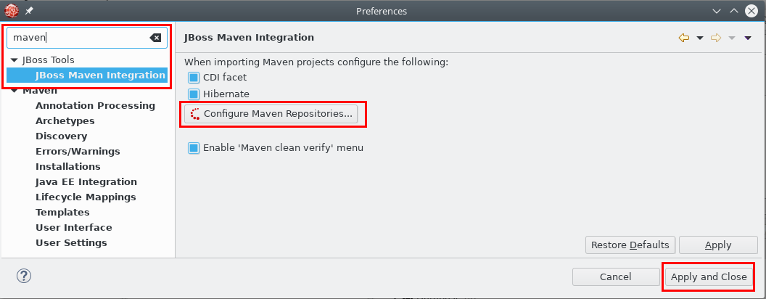

1. **Corporate Maven mirror repositories**
   1. If you are using a corporate maven repo system (eg: Nexus, Artifactory, etc), configure it to mirror the above Red Hat repos
   2. Configure it on your local settings.xml
2. **Corporate Proxy settings**
   1. If you use a proxy server configure it on your local settings.xml

|  |
| --- |
| <proxies>  <proxy>  <id>http-proxy-server</id>  <active>true</active>  **<protocol>http</protocol>**  <username>proxyuser</username>  <password>proxypass</password>  <host>xxxx</host>  <port>xxxxx</port>  <nonProxyHosts>localhost|local.net</nonProxyHosts>  </proxy>  <proxy>  <id>https-proxy-server</id>  <active>true</active>  **<protocol>https</protocol>**  <username>proxyuser</username>  <password>proxypass</password>  <host>xxxx</host>  <port>xxxxx</port>  <nonProxyHosts>localhost|local.net</nonProxyHosts>  </proxy>  </proxies> |

## 

## Openshift

1. Open JBDS.
2. Click on **Window -> Show View.**
3. Search for the **OpenShift Explorer** view.
4. Click **OK**.
5. Click on the **New Connection Wizard** link.

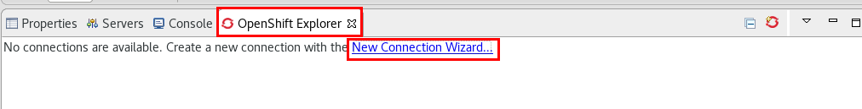

1. Make sure **OpenShift 3**  is selected as **Server Type**.
2. Enter the following values:
   1. **Server:** [https://fisworkshop.fis[your instance #].rhcol.com:8443](https://192.168.99.102:8443)
   2. **Protocol:** Basic
   3. **Username:** admin
   4. **Password:** admin
3. Click **Finish.**

**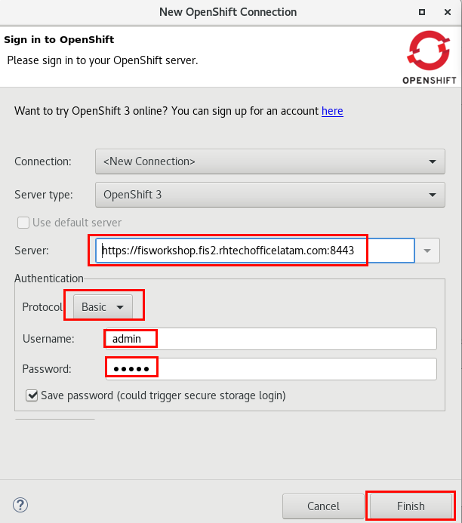**

1. Accept the certificate.
2. If prompted, enter a password to secure all the passwords in JBDS.

## Gogs

1. Open JBDS.
2. Click on the **Open Perspective** icon.



1. Select the **Git** perspective.
2. Click on the **Clone a git repository** link.

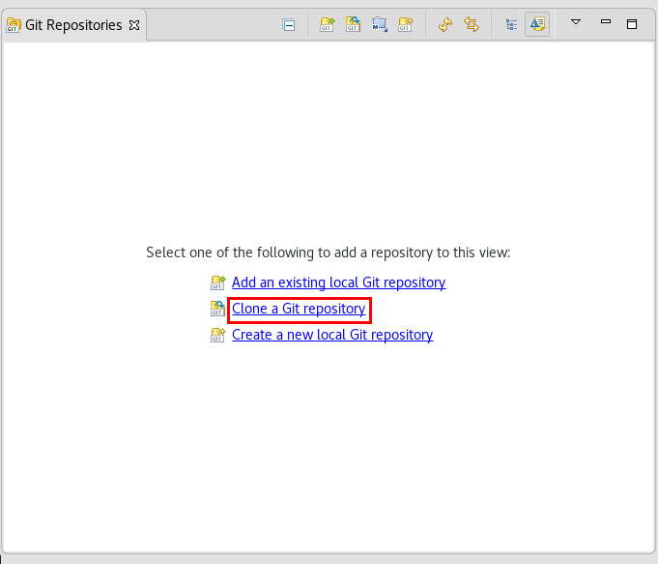

1. Enter the URI: [http://gogs.fis[your instance #].rhcol.com/user1/workshop](about:blank)
2. Enter
   1. **User**: user1
   2. **Password**: user1
3. Click **Next**.

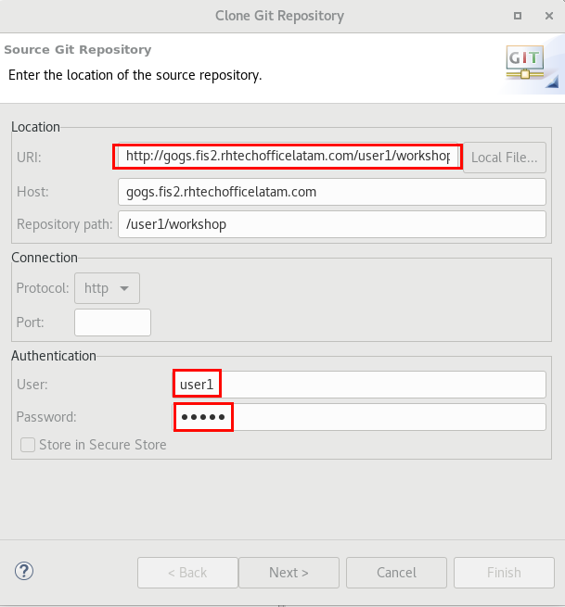

1. Click **Next.**
2. Click **Finish.**

# 

# 

# Lab 1 - Files

|  |  |
| --- | --- |
| RH_Icon_Compass_Shiny.png | In this lab you will create a camel route that reads files from a file system directory, logs a message and transfer their content to another directory. |

1. Switch to the **Fuse Integration** perspective.

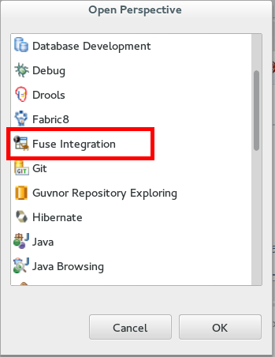

1. Select **File -> New -> Fuse Integration Project**

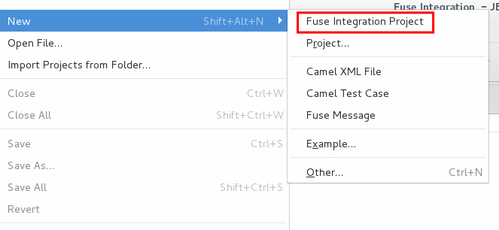

1. Enter “**Lab1**” as the project name, and click **Next**.
2. Accept the defaults and click **Next**.
3. Select **Spring DSL** as the project type and click **Finish**.

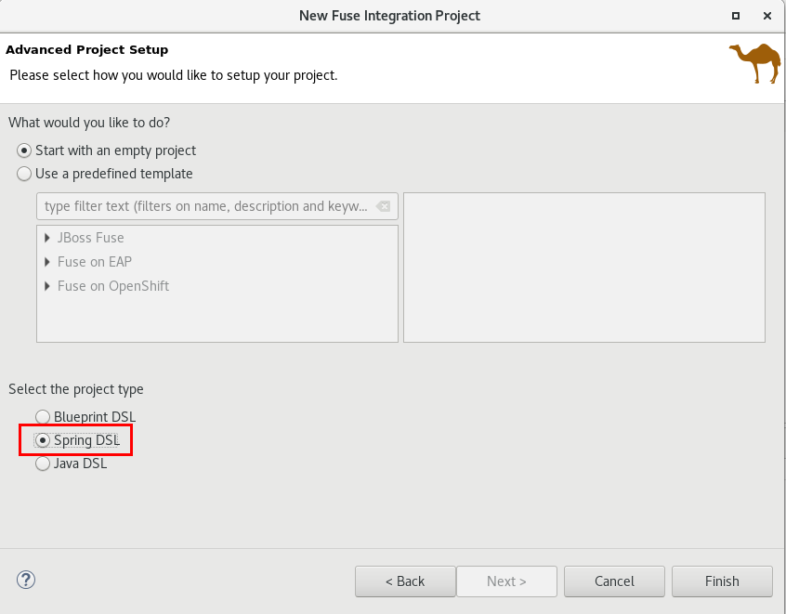

1. A new Fuse project is displayed in the Project Explorer: 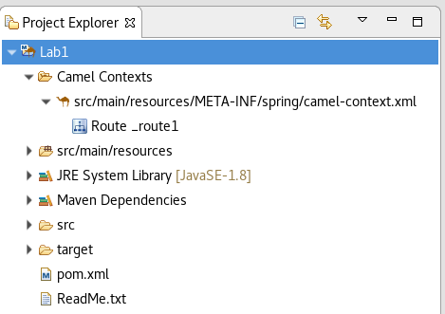
2. Double-click on the camel context file under **Camel Contexts**.
3. Click on the **Design** tab.
4. Drag a **File** component from the Components palette and drop it into the existing route.

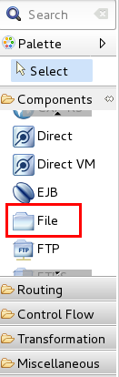

* 1. Click on the **Properties** tab -> **Advanced**
     1. **Path->Directory Name**: InputDir
     2. **Consumer->Delete**: checked

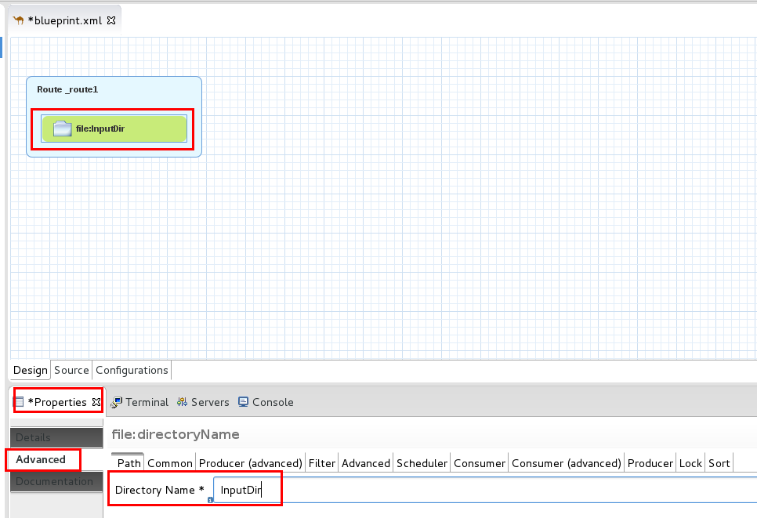

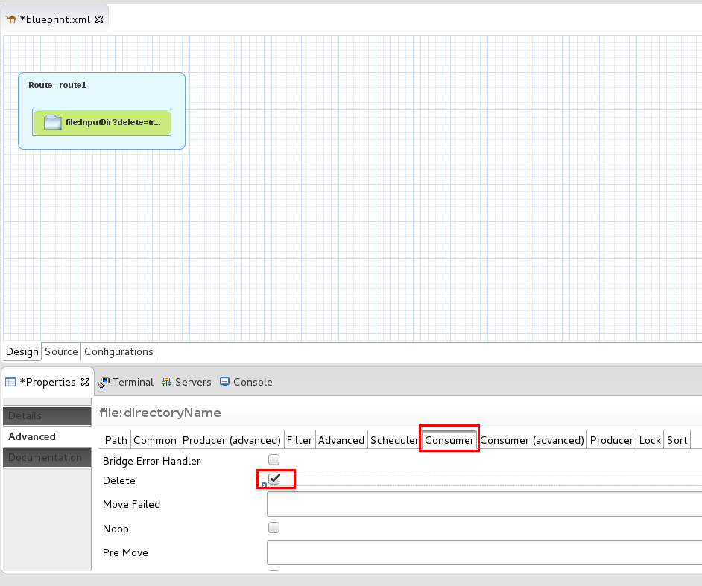

|  |  |
| --- | --- |
| general_info_polished.png | *The File component has a lot of configuration options, some are general , some apply when it acts as a Consumer (reads files) and some when it acts as a Producer (writes files).*   * *Directory Name: is the filesystem dir where it will be reading/writing files.* * *Consumer-> Delete means it will delete the file after processing it..* |

1. Drag a **Log** component from the **Components** palette and drop it onto the file component.
2. Click on the **Properties** tab
   1. **Message**: ${in.header.CamelFileName} with content -> ${body}

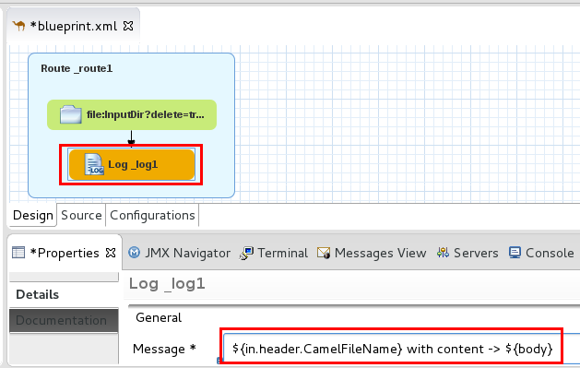

|  |  |
| --- | --- |
| general_info_polished.png | *The Log component logs message exchanges to the underlying logging mechanism. You can use a simple language expression to construct the message.*  [*https://access.redhat.com/documentation/en/red-hat-jboss-fuse/6.3/paged/apache-camel-component-reference/chapter-99-log*](https://access.redhat.com/documentation/en/red-hat-jboss-fuse/6.3/paged/apache-camel-component-reference/chapter-99-log) |

1. Drag a **File** component from the **Components** palette and drop it onto the **Log** component.
   1. Click on the **Properties** -> **Advanced** ->**Path**
      1. **Directory Name**: OutputDir
   2. Click on the **Properties** -> **Advanced** -> **Common**
      1. **File Name:** ${date:now:yyyyMMddhhmmss}-read.xml

1. Save the file (Ctrl+S).

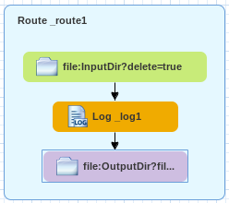

|  |  |
| --- | --- |
| general_info_polished.png | *The expressions used in the properties of the Log and setHeader components are written in “simple expression language”. They begin with a “${“ and end with “}”, and use reserved words to access parts of the message e.g: body, in.headers or functions e.g.: date. For more information:* [*https://access.redhat.com/documentation/en/red-hat-jboss-fuse/6.3/paged/apache-camel-development-guide/chapter-30-the-simple-language*](https://access.redhat.com/documentation/en/red-hat-jboss-fuse/6.3/paged/apache-camel-development-guide/chapter-30-the-simple-language) |

1. Right-click **camel-context.xml**, **Run As => Local Camel Context (without tests)**

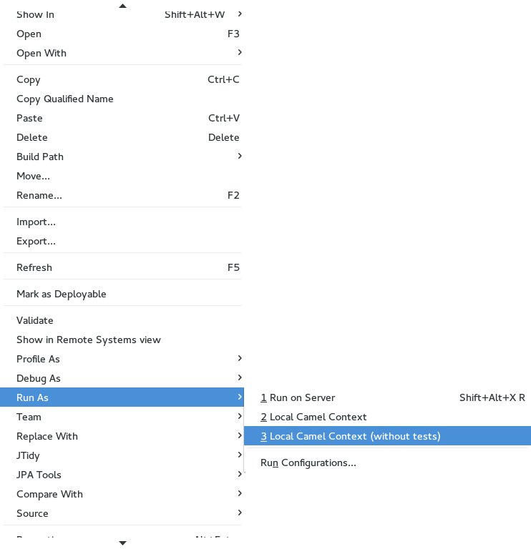

1. Refresh the **Lab1** project by clicking on its name and pressing **F5**.
2. Right-click on the automatically created **InputDir** folder and click **Import..**
3. Select **General->File System** and click **Next**.
4. Browse to **~/FuseWorkshop/support/Lab1** and click **OK**.
5. Select **File1.xml** and click **Finish**.

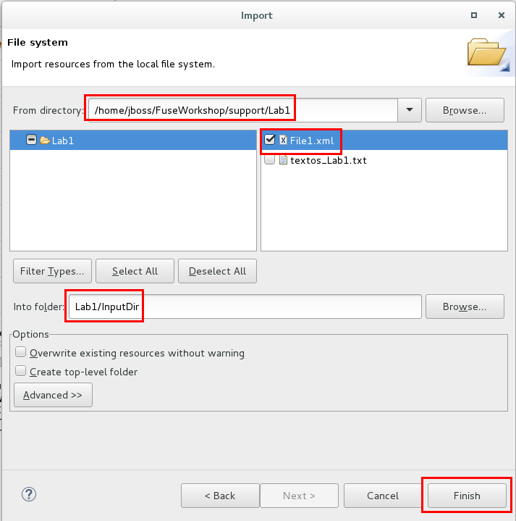

1. Watch the console log and verify the route ran without errors.
2. Click on **Lab1** and press F5 to refresh.
3. Expand **OutputDir** folder, and verify there’s a new file with current date as its name.
4. Check its contents and delete it.
5. Close all open files.
6. Stop the Camel route

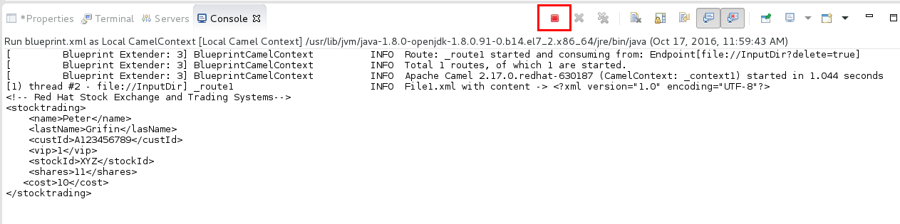

# Lab 2 - Data Transformation

|  |  |
| --- | --- |
| RH_Icon_Compass_Shiny.png | In this lab you will transform an XML file to a JSON file using a Data Mapper. This component has a visual transformation tool that allows you to map fields from the source structure to the target structure. |

1. Click on the menu **File->Import..**
2. Select **General-**> “**Existing Project into Workspace**” and click Next.
3. Click on “**Select** **archive file**” and browse to **~/FuseWorkshop/support/Lab2/Lab2.zip**
4. Click **Finish.**
5. Right-click on **Lab2** project and select **New -> Folder**
6. Enter “**Schemas**” and click **Finish.**
7. Right-click on the **Schemas** folder -> **Import**
8. Select **General -> File System** and browse to **~/FuseWorkshop/support/Lab2/**
9. Select **stocktrading.xsd** and **stocktrading.json** andclick **Finish.**

**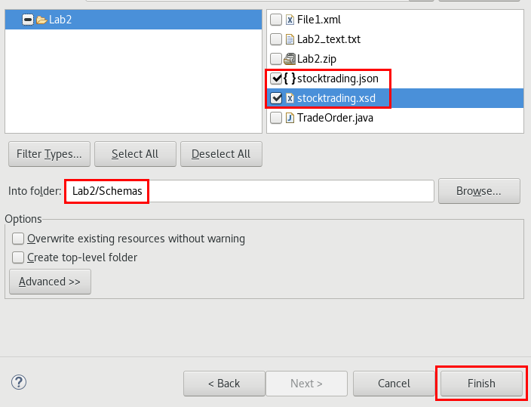**

1. Right-click on the imported **stocktrading.xsd** file and select **Generate->JAXB Classes**

**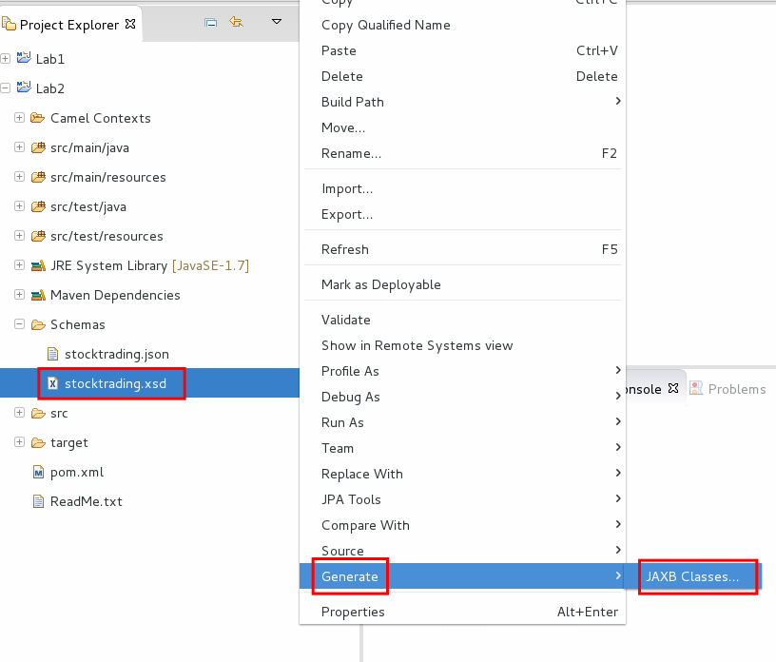**

1. Select **Lab2** as destination project and click **Next**.
2. Enter **com.demo.mycompany**  as package and click **Finish.**
3. Click **Yes** in the warning dialog.

**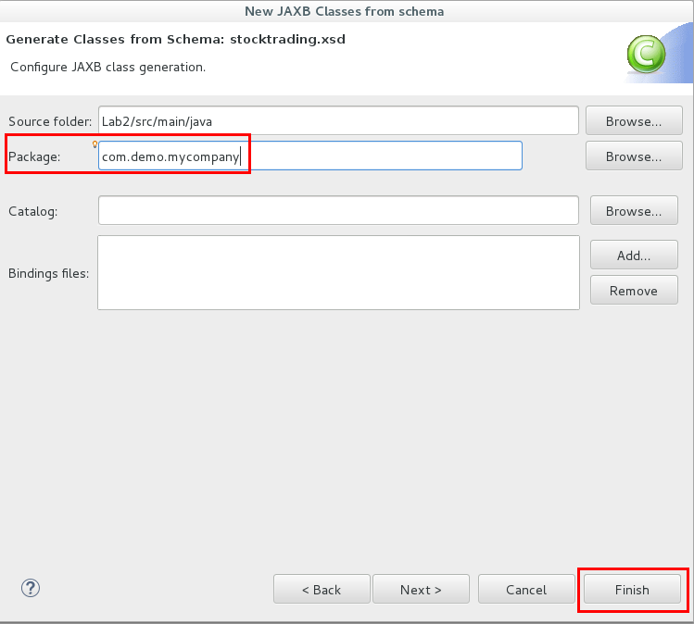**

|  |  |
| --- | --- |
| general_info_polished.png | *Java Architecture for XML Binding (JAXB) allows Java developers to map Java classes to XML representations. JAXB provides two main features: the ability to marshal Java objects into XML and the inverse, i.e. to unmarshal XML back into Java objects.* |

1. Open **camel-context.xml** to modify the Camel route.
2. Delete the **Log** component from the route.

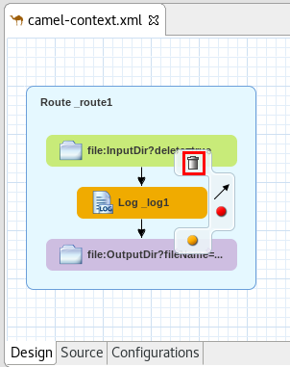

1. Save the file (Ctrl+S).
2. Drag “**Data Transformation**” component from the **Transformation** palette and drop it onto the arrow between the **File** and the second **File** components.
3. In the **New Fuse Transformation** dialog, enter:
   1. **Transform ID**: transOrder
   2. **Dozer file path**: transOrder.xml
   3. **Source Type:** Java
   4. **Target Type**: JSON

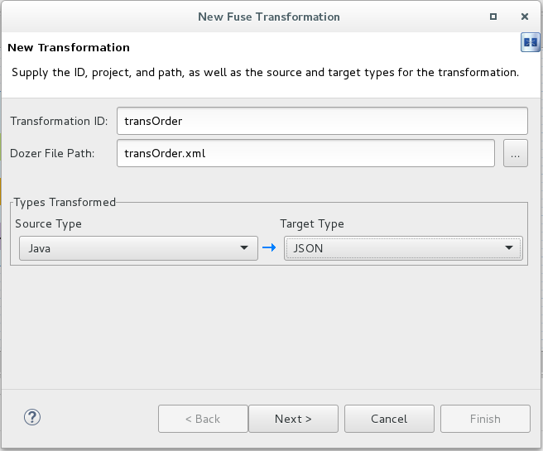

1. Click **Next**
2. **Source** **Type (Java)**:
   1. Click on the browse button  and enter **Stocktrading** in the dialog and select the first class in the list.
   2. Click **OK** and **Next.**
3. **Target** **Type (JSON)**:
   1. Select “JSON Instance Document”.
   2. Browse for the **stocktrading.json** file.
4. Click **Finish**.
5. In the **Data Transformation Editor**, link each of the following source fields with their corresponding target fields by dragging and dropping them:
   1. custId
   2. stockId
   3. vip

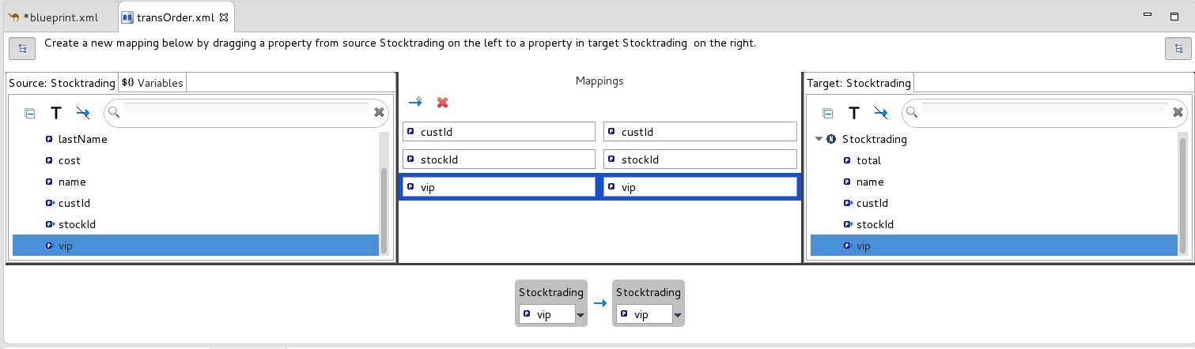

1. Create a new mapping by clicking on the  button.
2. Drag and drop the **name** target field to the right box.
3. Click on the arrow in the left box and select **Set expression**.

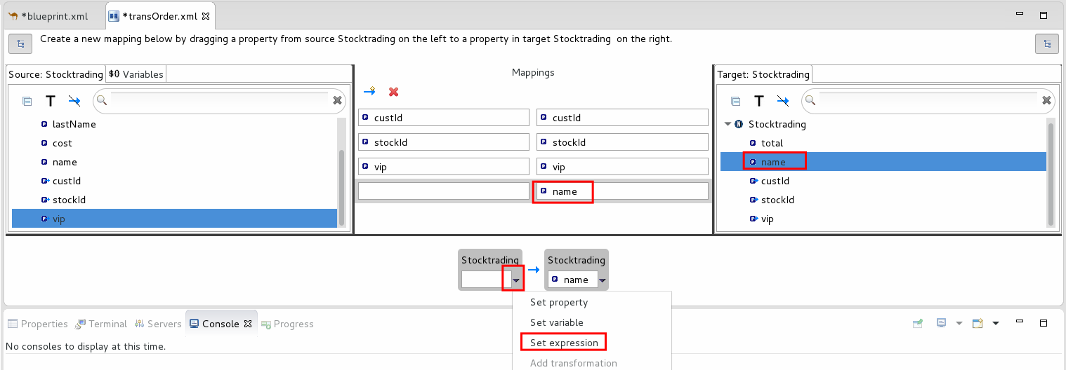

1. Select **Simple** as the Language, and enter: ***${body.name} ${body.lastName}*** as the Expression.
2. Click **OK**.

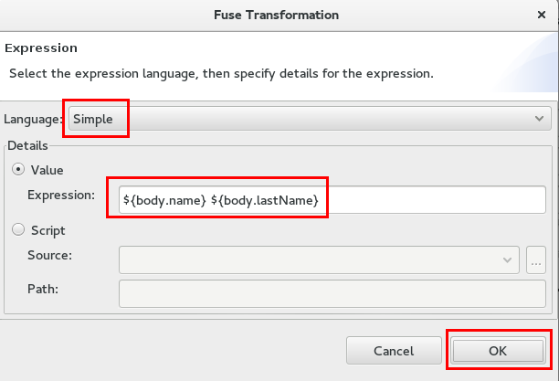

1. Create another mapping by clicking on the  button again.
2. Drag and drop the **total** target field to the right box.
3. Click on the arrow in the left box and select **Set expression**.

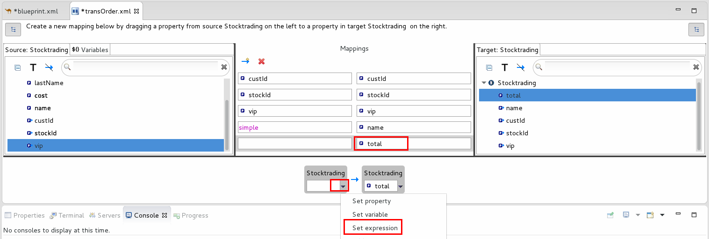

1. Select **Groovy** as the Language, and enter the following as Expression: ***request.body.shares \* request.body.cost***
2. Click **OK**.

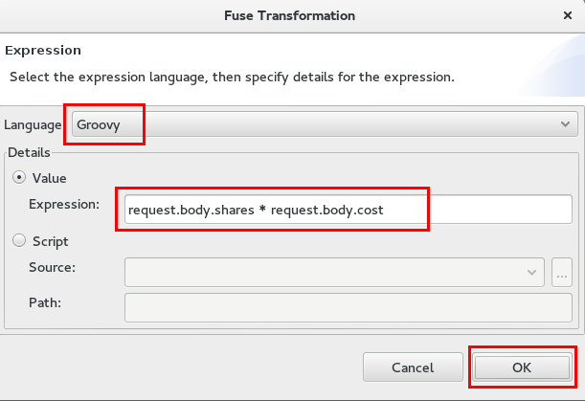

1. Close the Data Transformation editor.

|  |  |
| --- | --- |
| general_info_polished.png | *Groovy is a Java-based scripting language that allows quick parsing of object. The Groovy support is part of the camel-script module.*  [*https://access.redhat.com/documentation/en/red-hat-jboss-fuse/6.3/paged/apache-camel-development-guide/chapter-17-groovy*](https://access.redhat.com/documentation/en/red-hat-jboss-fuse/6.3/paged/apache-camel-development-guide/chapter-17-groovy) |

|  |  |
| --- | --- |
| general_info_polished.png | *http://dozer.sourceforge.net/*  *Dozer is a Java Bean to Java Bean mapper that recursively copies data from one object to another. Typically, these Java Beans will be of different complex types.*  *More information in:* [*https://access.redhat.com/documentation/en-US/Red\_Hat\_JBoss\_Fuse/6.2.1/html/Apache\_Camel\_Component\_Reference/IDU-Dozer.html*](https://access.redhat.com/documentation/en-US/Red_Hat_JBoss_Fuse/6.2.1/html/Apache_Camel_Component_Reference/IDU-Dozer.html) |

1. Save the file (Ctrl+S).

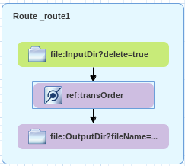

1. Drag an **Unmarshal** component from the **Transformation** palette and drop it onto the arrow between the **File** and **Data Transformation** components.
2. Click on the properties tab and select:
   1. **Data Format Type:** jaxb
   2. **Context Path:** com.demo.mycompany

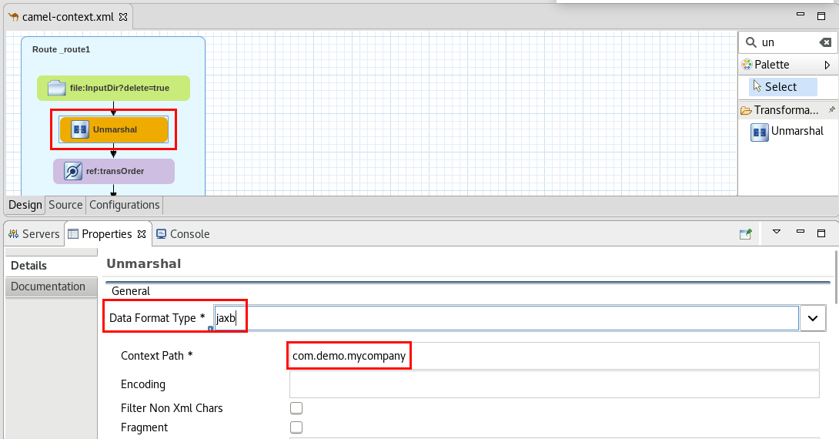

|  |  |
| --- | --- |
| general_info_polished.png | *The Marshal component serializes a bean to some binary or textual format for transmission over some transport via a Camel component.*  *The Unmarshal component is the opposite, and parses a payload into a specified bean type.*  *In both cases you have to define a data format to use (*[*http://camel.apache.org/data-format.html*](http://camel.apache.org/data-format.html) *)* |

|  |  |
| --- | --- |
| general_info_polished.png | *This Unmarshal component will process the incoming XML file and generate a Java object using the JAXB annotated class generated earlier (com.demo.mycompany.Stocktrading)* |

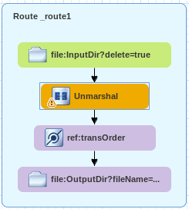

.

1. Edit the second **File** component’s properties:
   1. **Advanced -> Common-> File Name**: change file extension to “.json”

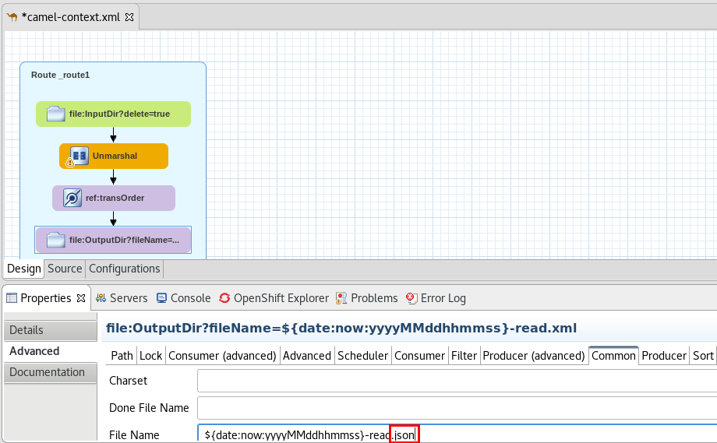

1. Save the file (Ctrl+S).

|  |  |
| --- | --- |
| general_info_polished.png | If an error appears in the **camel-context.xml,** click on the **Source** tab, search for the **objectFactory="false"** attribute and delete it. |

1. Run the camel route by right-clicking **blueprint.xml**, **Run As -> “Local Camel Context (without tests)”**
2. Right-click on the **InputDir** folder and select **Import**.
   1. If the folder doesn’t appear in the folder tree, refresh it (F5).
3. Browse to **~/FuseWorkshop/support/Lab2** and select **File1.xml**.
4. Click **Finish**.
5. Expand **OutputDir**.
6. Inspect the JSON file contents and verify that the **name** property is the concatenation of  **name + last name**, and **total** is the multiplication of **shares** per **cost.**
7. Close all the open files.
8. Stop the camel route by clicking the stop button .

# Lab 3 - Routing

## Part A - Content Based Routing

|  |  |
| --- | --- |
| RH_Icon_Compass_Shiny.png | In this lab you will route the request based on its contents. If customer status is VIP, then the file will go to a VIP folder, otherwise it will be transformed to JSON and be sent to a Regular folder.    This is the implementation of the Content Based Router - Enterprise Integration Pattern (<https://access.redhat.com/documentation/en/red-hat-jboss-fuse/6.3/paged/apache-camel-development-guide/chapter-8-message-routing#MsgRout-Fig-CBRP> ) |

1. Import an “Existing project into Workspace” from **~/FuseWorkshop/support/Lab3/Lab3.zip**”.
2. Open **camel-context.xml**.
3. Drag a **Choice** component from the **Routing** palette and drop it onto the arrow between the **Unmarshal** and the **Data Transformation** components.

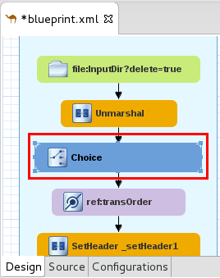

1. Drag and Drop a **When** and an **Otherwise** component inside the **Choice** component.

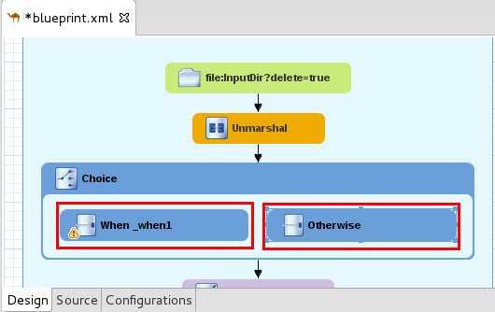

|  |  |
| --- | --- |
| general_info_polished.png | *You could add as many* ***When*** *components as needed, one for each condition.* |

1. Click on the **When** component and click on the **Properties** tab.
   1. **Language:** simple
   2. **Expression**: ${body.vip} >= 3
      1. **Note:** there’s a space before and after the “>=” operator.

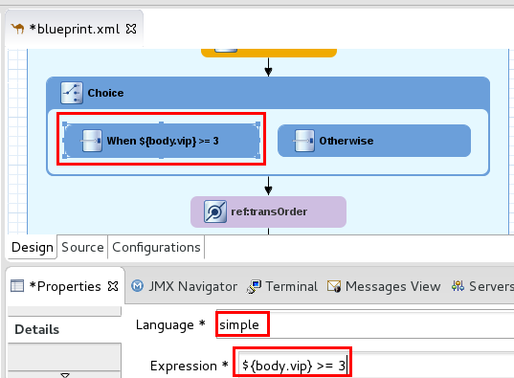

1. Drag the following existing components and drop them into the **Otherwise** box:
   1. **ref:TransOrder** (DataTransformation)
   2. **File**

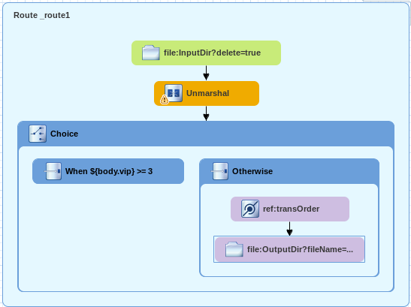

1. Drag a **Log** component from the Components palette and drop it onto the **When** component.
2. Edit the new **Log** Component:
   1. **Message**: ${body.name} is a VIP Customer

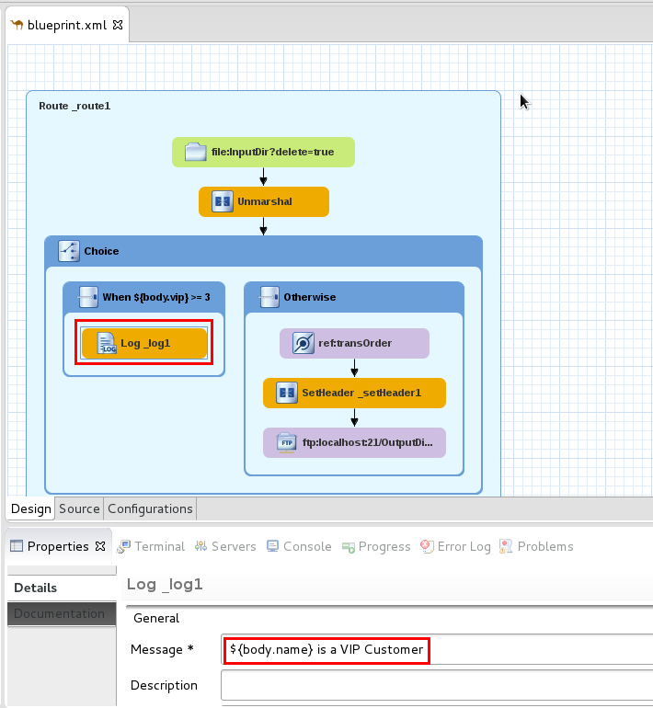

1. Drag a new **File** component from the Components palette, and drop it onto the **Log** component:
   1. **Advanced -> Path -> Directory Name:** VIPDir
   2. **Advanced -> Common -> File Name**: ${date:now:yyyyMMddhhmmss}-VIPCustomer.xml

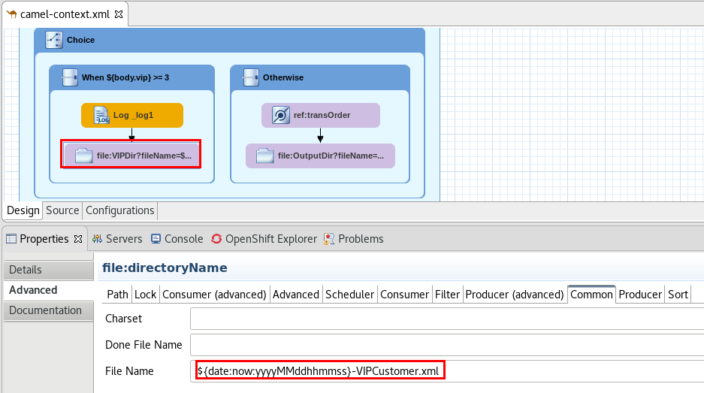

1. Save the file (Ctrl+S).

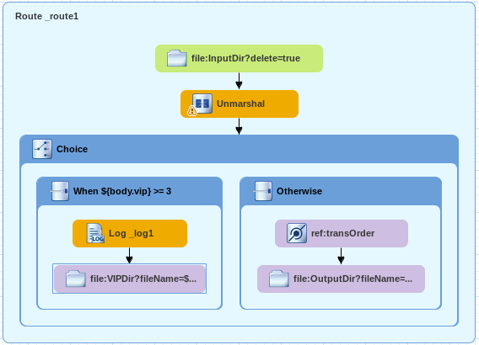

1. Run the route by right-clicking **camel-context.xml -> Run As -> Local Camel Context (without tests)**
2. Right-Click on the **InputDir** folder.
3. Select **General -> File System.**
4. Import **File2.xml** from **~/FuseWorkshop/support/Lab3**.
5. Verify that this time, the file is routed through the VIP branch, so there is a log message and the file ends up in the “***VIPdir****”* folder.
6. Close all the open files.
7. Stop the camel route by clicking the stop button .

## Part B - Message Splitting

|  |  |
| --- | --- |
| RH_Icon_Compass_Shiny.png | In this lab you will add a Split component, to split a multiple-instance message into separate messages and process them individually.    This component implements the Splitter - Enterprise Integration Pattern (<https://access.redhat.com/documentation/en/red-hat-jboss-fuse/6.3/paged/apache-camel-development-guide/chapter-8-message-routing#MsgRout-Splitter> ) |

1. Open the **camel-context.xml** file under **Camel Context**.
2. Drag and Drop a **Route** component from the **Routing** palette into the Canvas.

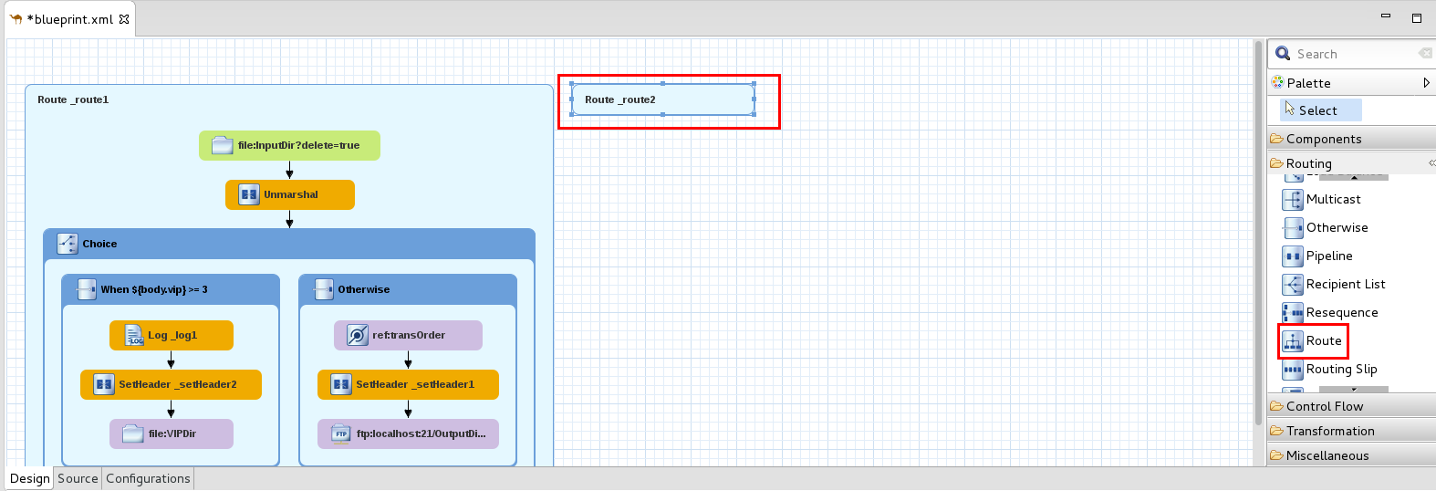

1. Drag a **File** component from the Components palette and drop it onto the new empty route.
2. Click on the Properties tab and enter the following values:
   1. **Advanced->Path -> Directory Name**: MultipleInput
   2. **Consumer->Delete**: True

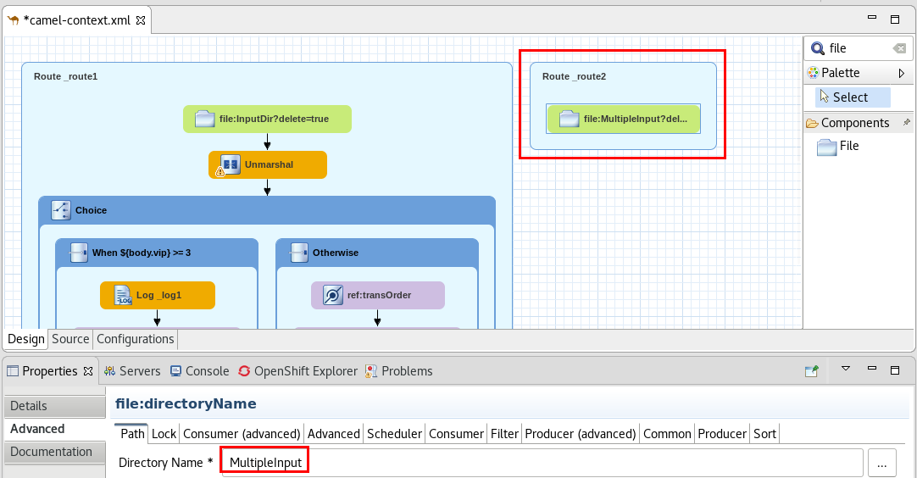

1. Drag a **Split** component from the **Routing** palette and drop it onto the **file** component.
2. Edit **Split** properties:
   1. **Language**: xpath
   2. **Expression:** //stocktrading

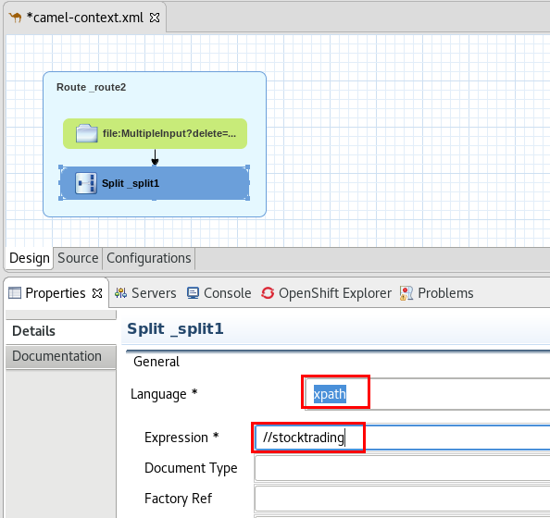

1. Drag a **Log** component from the Components palette, and drop it onto the Split component.
   1. **Message**: Processing element: ${body}

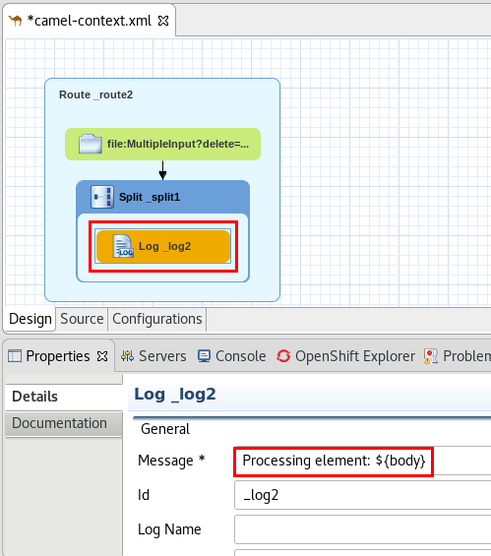

1. Drag a **File** endpoint and drop it onto the **Log** component.
   1. **Advanced -> Path -> Directory Name**:InputDir
   2. **Advanced -> Common -> File Name:** ${date:now:yyyyMMddhhmmssSSS}-read.xml
2. Save the file (Ctrl+S).

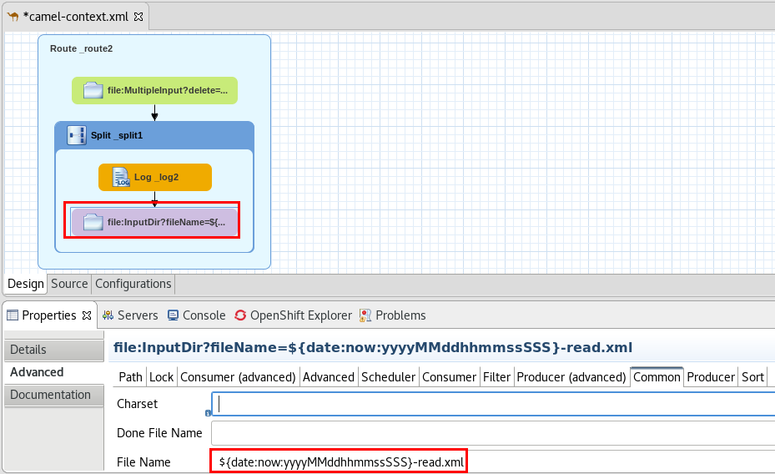

1. Inspect the contents of **~/FuseWorkshop/support/Lab3/File3.xml.**

|  |  |
| --- | --- |
| general_info_polished.png | *For each element in the XML document, the splitter will generate a new Message, which will be processed by the subsequent nodes in the route. If we set the “parallelProcessing” option to true in the splitter component, all the splitted messages would be processed concurrently.* |

1. Run the routes by right-clicking **camel-context.xml -> Run As -> Local Camel Context (without tests)**
2. Right-click on the automatically created “***MultipleInput***” folder in the **Project Explorer**.
3. Select **Import** -> **File System.**
4. Browse to **~/FuseWorkshop/support/Lab3/** ,select **File3.xml** and click **Finish.**
5. This should fire route #2, which will generate a file for each element in the incoming XML file.
6. Then, each generated file (in the InputDir folder) should trigger an instance of route#1 to process it.
7. Close all open files.
8. Stop the camel routes by clicking the stop button. 

# 

# Lab 4 - Database

|  |  |
| --- | --- |
| RH_Icon_Compass_Shiny.png | In this lab you will process a CSV file and insert a record in a Database for each line. To do this, you will use the a Bindy component to parse the CSV file, and a JPA component to insert rows in a PostgreSQL DB running on OpenShift.    **JPA**: Enables you to store and retrieve Java objects from persistent storage using EJB 3's Java Persistence Architecture (JPA), which is a standard interface layer that wraps Object/Relational Mapping (ORM) products such as OpenJPA, Hibernate, TopLink, and so on. <https://access.redhat.com/documentation/en/red-hat-jboss-fuse/6.3/paged/apache-camel-component-reference/chapter-86-jpa>  **Bindy**: Enables the parsing and binding of non-structured data via Java Beans. These Java Beans consists of binding mappings defined with annotations.  <https://access.redhat.com/documentation/en/red-hat-jboss-fuse/6.3/paged/apache-camel-component-reference/chapter-14-bindy> |

1. Click  **File -> Import.**
2. Select **General -> Existing Project into Workspace.**
3. Select **archive file**.
4. Browse to **~/FuseWorkshop/support/Lab4/** and select **Lab4.zip**.
5. Disregard the errors.
6. Right-click on the **Lab4** project, and select **New-> JPA Entities from tables.**
7. Click on the “add connections”  button.
8. Select **PostgreSQL** and click **Next**.

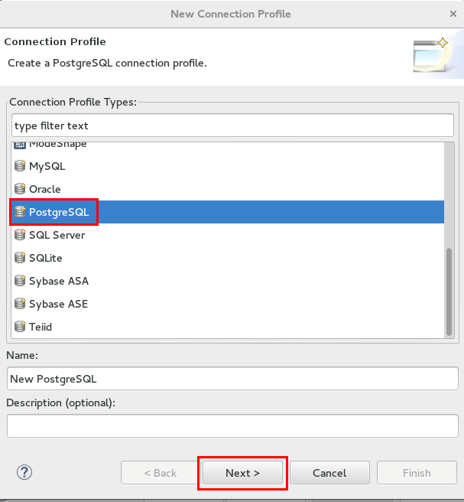

1. Click on the “New driver definition” button .
2. Select **PostgreSQL JDBC Driver** and click on the **JAR List** tab.
3. Select the driver file and click on the **Edit JAR/Zip** button.

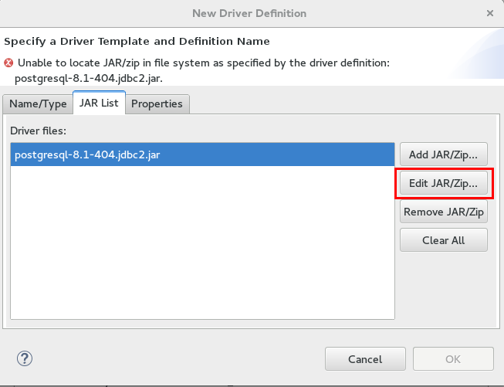

1. Browse to **~/FuseWorkshop/support/Lab4** and select **postgresql-9.4-1201.jdbc4.jar**
2. Click on the **Properties** tab and complete the following:
   1. **Connection URL**: jdbc:postgresql://fisworkshop.fis[your instance #].rhcol.com:30432/JBossBank
   2. **Database Name**: JBossBank
   3. **User Name**: admin
   4. **Password**: password
3. Click **OK**.

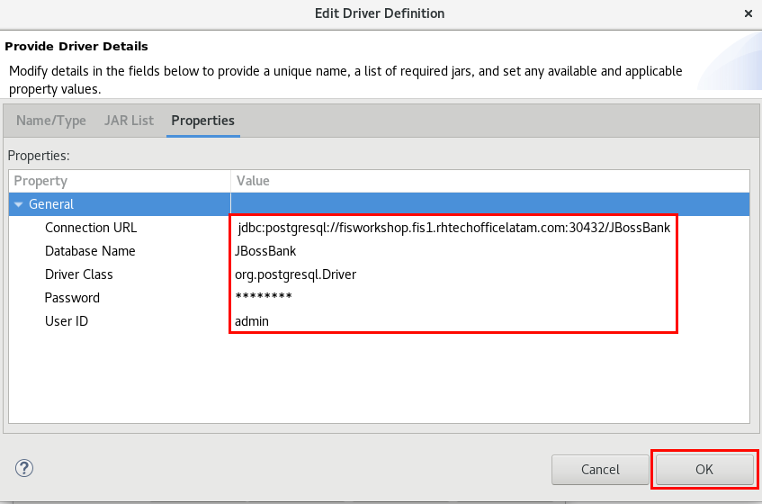

1. Click on the **Test Connection** button to validate the connection.
2. Click **Finish**.
3. In the **Select Tables** dialog, select the **public** schema and check the **transactions** table.

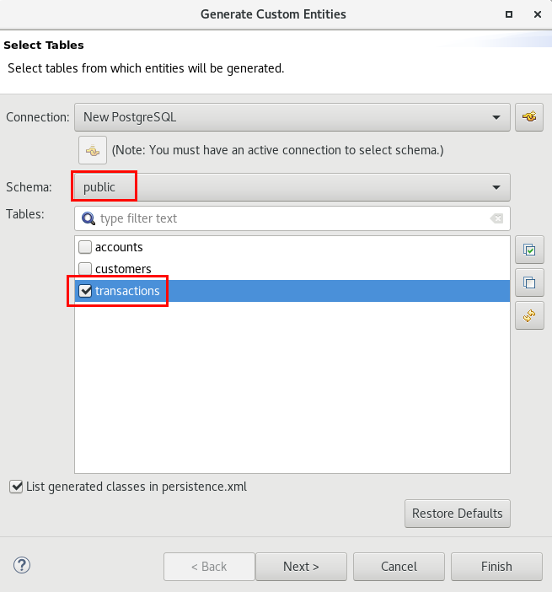

1. Click **Next**.
2. Click **Next.**
3. In the **Customize Defaults dialog**, in the **Domain java class** area, enter:
   1. **package:** com.jbossbank
   2. **Source folder:** src/main/java
4. Click **Finish.**

**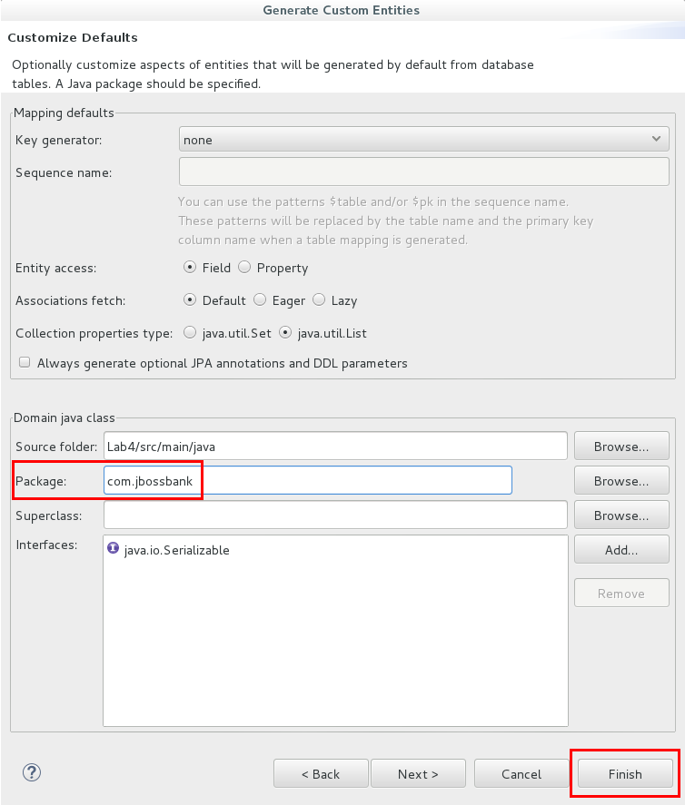**

1. A new java class that represents the Transactions table has been created under **src/main/java/com.jbossbank**.
2. Open **camel-context.xml** by double-clicking it.
3. Drag a **File** component from the Components palette and drop it into the Route.
   1. Edit its properties
      1. **Advanced -> Path -> Directory Name:** TransactionsDir
      2. **Advanced -> Consumer -> Delete: true**

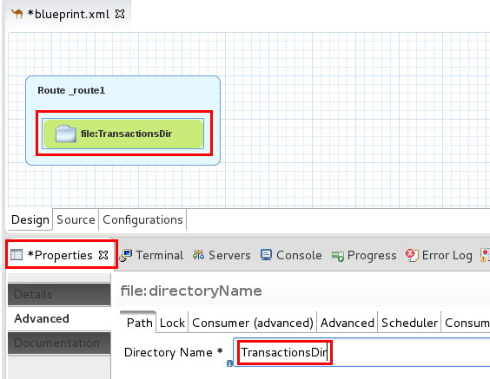

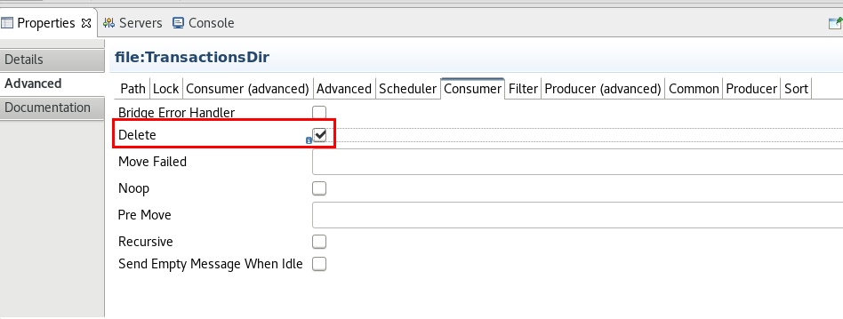

1. Click on the **Configurations** tab.
2. Click on the **Add** button.
3. Select **Data Format** and click **OK**.

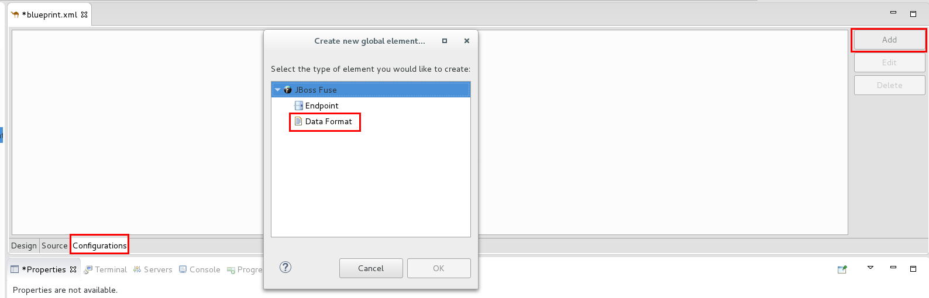

1. Select “**bindy-csv**“ as the **Data Format**.
2. Enter “transactionsCSV” as **Id**.
3. Click on **Finish**.

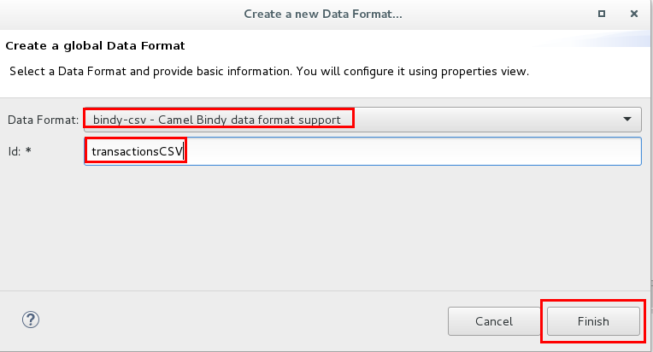

1. In the properties tab, enter “com.jbossbank.Transaction” as **Class Type**.

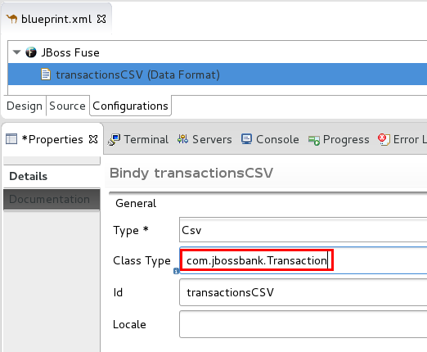

1. Click on the **Design** tab.
2. Drag an **Unmarshal** component from the Transformation palette and drop it onto the **File** component.
   1. Click on the **Ref** dropdown and select **transactionsCSV**.

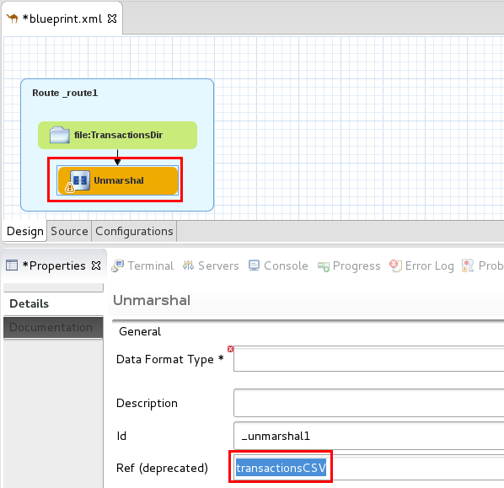

1. Drag a **Generic** component from the Components palette and drop it onto the Unmarshal component.
2. Enter “jpaTransactions” as the **Id**.
3. Uncheck “**Show only palette components”.**
4. Select **JPA**.
5. Click **Finish**.

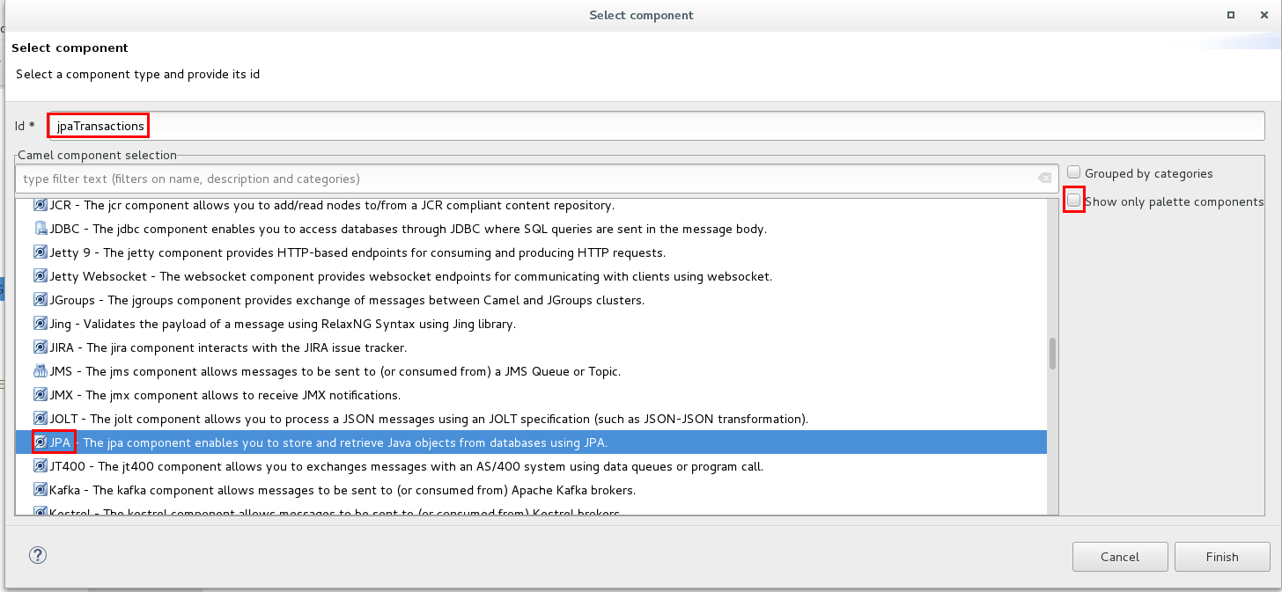

1. Link the **Unmarshal** component to the **JPA** component.
2. Click on the **JPA** component and edit its properties:
   * 1. **Advanced->** **Path**
        1. **Entity Type:** java.util.ArrayList
     2. **Advanced-> Common**
        1. **Persistence Unit:** Lab4

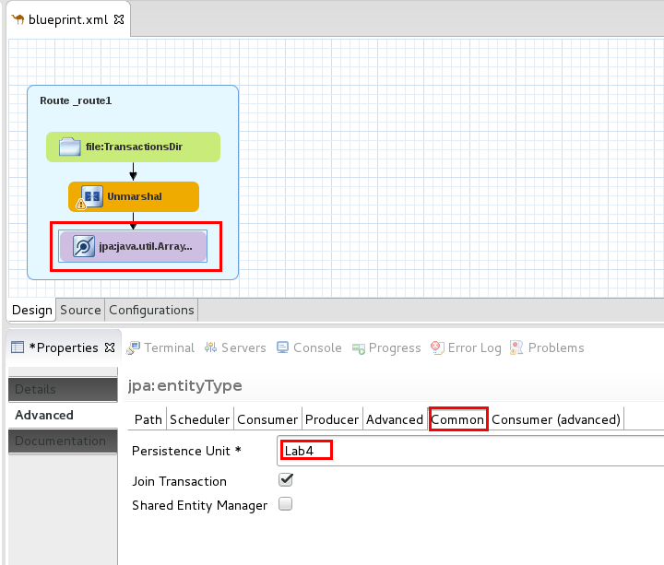

|  |  |
| --- | --- |
| general_info_polished.png | *We define java.util.ArrayList as the Entity Type because we will be sending a list of transactions (read and unmarshalled from the csv file) to be inserted in the table.* |

1. Save the blueprint file (Ctrl+S).
2. Right-click on **src/main/resources/META-INF** folder and select **Import** **-> General -> File System**
3. Browse to **~/FuseWorkshop/support/Lab4** and select **persistence.xml**.
4. Open **persistence.xml** file under **JPA Content**, and review its contents.
5. Click on the **Properties** tab.
6. Edit **hibernate.connection.url** and change it to fisworkshop.fis[your instance #].rhcol.com

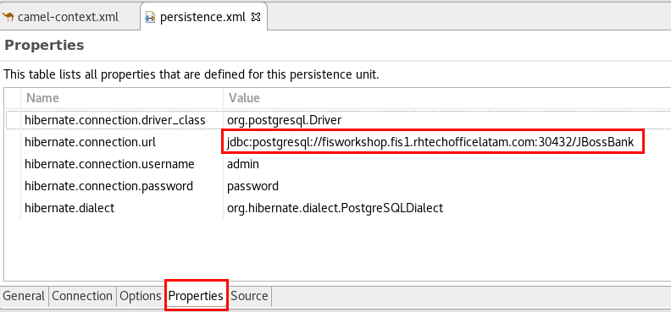

1. Open **Transaction.java** under src/main/java/com.jbossbank.
2. Add the following annotation before “@Entity”: **@CsvRecord( separator = ";" , skipFirstLine = true )**
3. Add the following annotation before the **transactionid** property: **@DataField(pos = 1)**
4. Add the following annotation before the **accountid** property: **@DataField(pos = 2)**
5. Add the following annotation before the **amount** property: **@DataField(pos = 3)**
6. Add the following annotation before the **clientid** property: **@DataField(pos = 4)**

**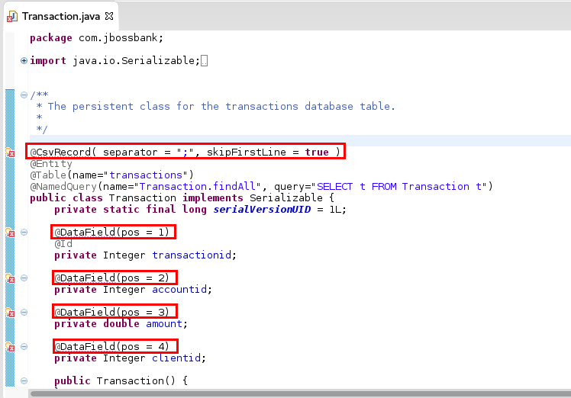**

1. Click on the error marker next to **@CsvRecord** annotation and select the first suggestion (Import CsvRecord)

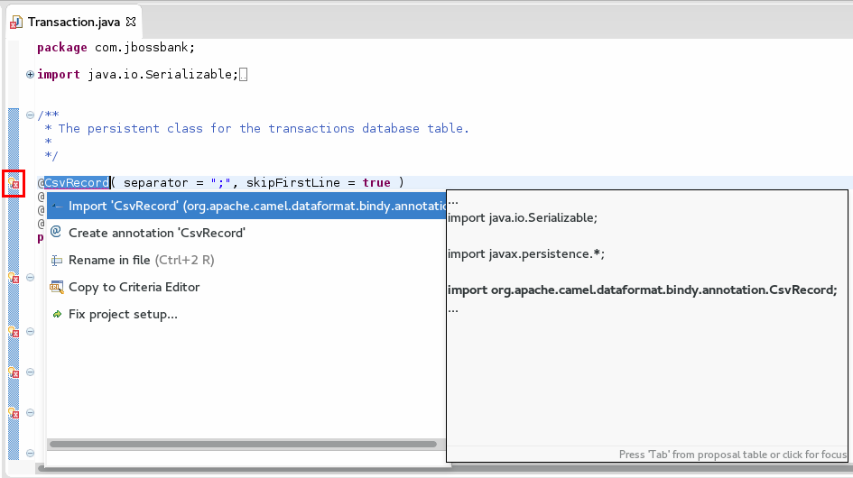

1. Click on the error marker next to any **@DataField** annotation and select the first suggestion (Import DataField).
2. Save the file and close it (Ctrl+S).
3. Run the Camel Route by right-clicking **camel-context.xml**, **Run As -> Local Camel Context (without tests).**
4. Once the route is running, right-click on the **TransactionsDir** folder.
   1. If it doesn’t appear, just refresh Lab4 project (F5).
5. Click **Import**, **General -> File System**
6. Browse to **~/FuseWorkshop/support/Lab4,** and select **Transactions.csv**
7. Click **Finish**.
8. The route will process the CSV file and insert each line into the PostgreSQL database.
9. Stop the camel route by clicking on the **Stop** button .
10. Close all open files.
11. Open the **Database Development** perspective.

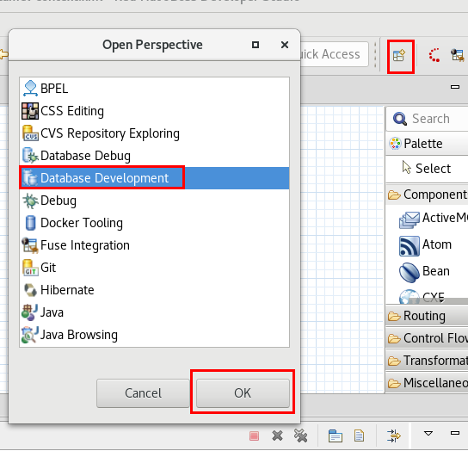

1. In the **Data Source Explorer**, expand **Database Connections -> New PostgreSQL -> JBossBank -> Catalogs -> JBossBank -> Schemas -> public -> Tables**
2. Right-click on the **transactions table** and select **Data -> Sample contents.**

**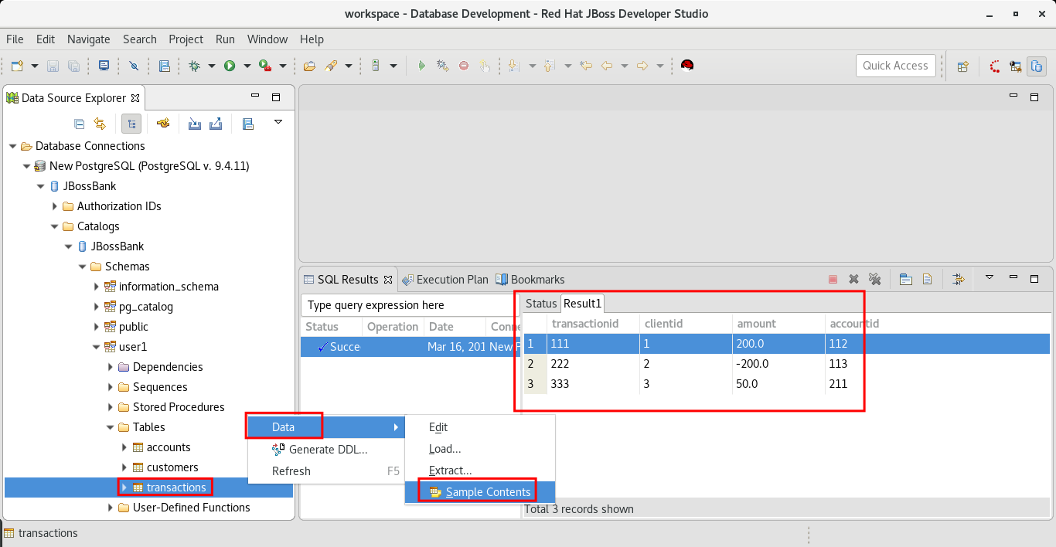**

# 

# Lab 5 - SOAP Web Services

|  |  |
| --- | --- |
| RH_Icon_Compass_Shiny.png | In this lab you will create a SOAP web service that exposes two operations using CXF, and then you will deploy it to OpenShift. (<https://access.redhat.com/documentation/en/red-hat-jboss-fuse/6.3/paged/apache-camel-component-reference/chapter-29-cxf> )    The first SOAP operation (getCustomerAccounts) queries the accounts table and returns a list of accounts. The second operation (getAccountBalance) returns the current account balance for a given customer ID. |

|  |  |
| --- | --- |
| general_info_polished.png | *Apache CXF is an open source services framework. CXF helps you build and develop services using frontend programming APIs, like JAX-WS and JAX-RS. These services can speak a variety of protocols such as SOAP, XML/HTTP, RESTful HTTP, or CORBA and work over a variety of transports such as HTTP, JMS or JBI. (*[*https://access.redhat.com/documentation/en/red-hat-jboss-fuse/6.3/paged/apache-cxf-development-guide/*](https://access.redhat.com/documentation/en/red-hat-jboss-fuse/6.3/paged/apache-cxf-development-guide/) *)* |

1. Select **File -> Import - > General -> Existing Project into Workspace**
2. Click on the **Select Archive File** and browse to ~**/FuseWorkshop/support/Lab5.**
3. Select **Lab5.zip.**
4. Expand the folder: **src/main/resources/wsdl.**
5. Right-click on **JBossBankServices.wsdl**, and select **New -> Java Files from WSDL.**

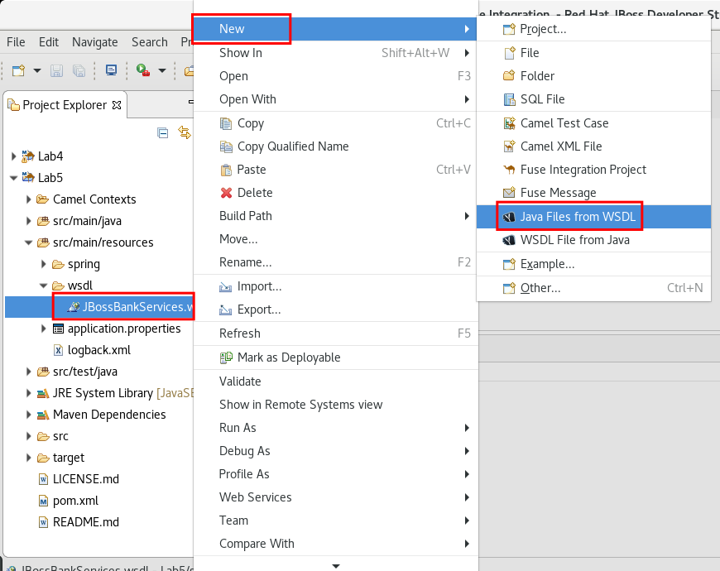

1. Make sure to leave the default values and click **Finish**.

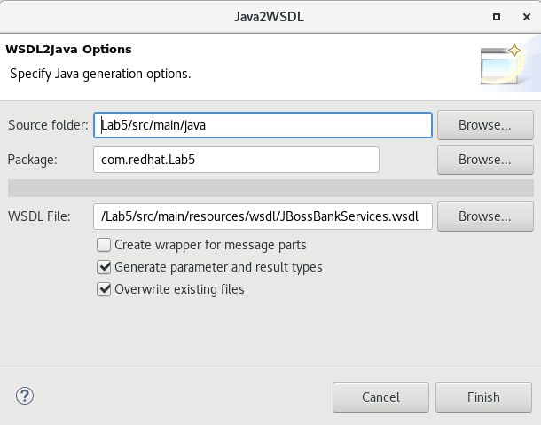

|  |  |
| --- | --- |
| general_info_polished.png | This CXF plugin will generate a group of Java classes that represent a skeleton to implement the web service described by a WSDL file. |

1. Review the generated Java classes under the **com.redhat.Lab5** package in the **src/main/java** folder.
2. Double-click on the **camel-context.xml** file to open the Camel Editor.
3. Click on the **Source** tab.
4. Copy and Paste the following xml lines before the <camelContext>:

|  |
| --- |
| <cxf:cxfEndpoint address="/JBService" id="ws" serviceClass="com.redhat.Lab5.JBossBankServices"/> |

|  |  |
| --- | --- |
| general_info_polished.png | *This line describes a CXF Endpoint which is associated with the main Java class created by the CXF plugin from the WSDL file. This means that the endpoint will implement the web service described in that file.* |

1. Save the file (Ctrl+S).

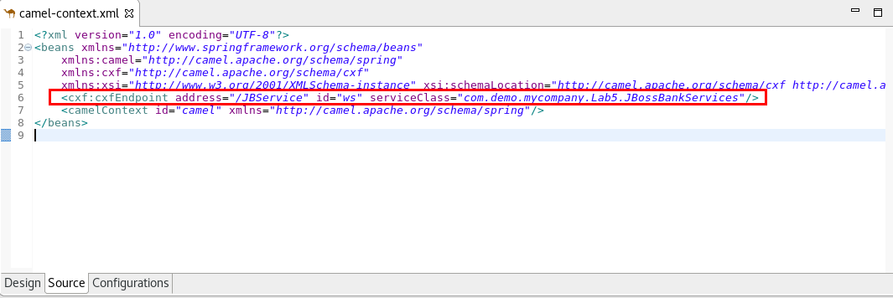

1. Click on the **Design** tab.
2. Drag a **Route** component from the **Routing** palette and drop it into the canvas.
3. Drag a **CXF** component from the **Components** palette and drop it into the Route.
4. Edit its properties and modify the **url** to: **cxf:bean:ws**

**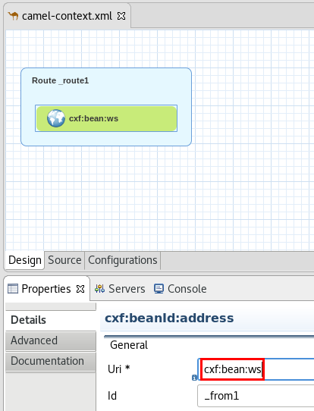**

1. Drag a **Choice** component from the **Routing** palette and drop it onto the **cxf** component.
2. Drag two **When** components from the **Routing** palette and drop them onto the **Choice** component.
3. Edit the first **When** properties:
   1. **Language:** simple
   2. **Expression:** ${header.operationName} == 'getCustomerAccounts'
4. Edit the second **When** properties:
   1. **Language:** simple
   2. **Expression:** ${header.operationName} == 'getAccountBalance'
5. Save the file (Ctrl+S).

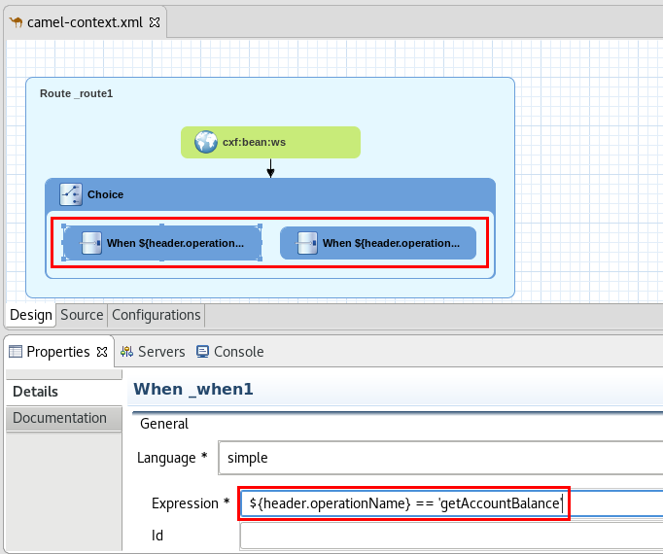

|  |  |
| --- | --- |
| general_info_polished.png | *The SOAP operation name of the incoming web service request is parsed by CXF and placed in a header called “*operationName”. |

1. Drag a **SQL** component from the Components palette and drop it onto the first **When** component .
2. Edit its properties:
   1. **Advanced -> Path -> Query**: select \* from accounts where customerid = #
   2. **Advanced -> Common -> Data Source:** dataSource
   3. **Advanced -> Common -> Output Class:** com.redhat.Lab5.Account

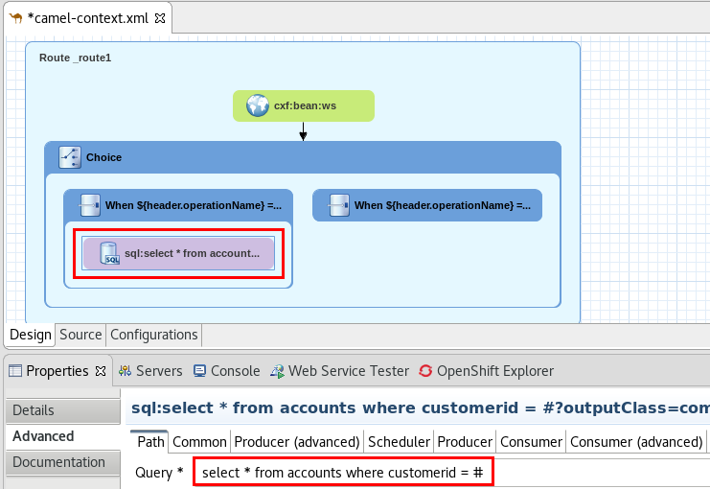

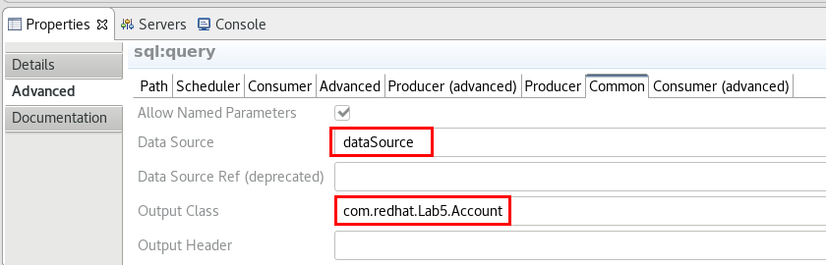

|  |  |
| --- | --- |
| general_info_polished.png | *The SQL component allows you to work with databases using JDBC queries. Unlike the JDBC component ,this component uses spring-jdbc behind the scenes for the actual SQL handling.*  <https://access.redhat.com/documentation/en/red-hat-jboss-fuse/6.3/paged/apache-camel-component-reference/chapter-163-sql-component> |

1. Drag a **Bean** component from the Components palette and drop it onto the **SQL** component.
2. Edit its properties:
   1. **Method**: setAccount(${body})
   2. **Bean Type:** com.redhat.Lab5.Accounts
3. Save the file (Ctrl+S).

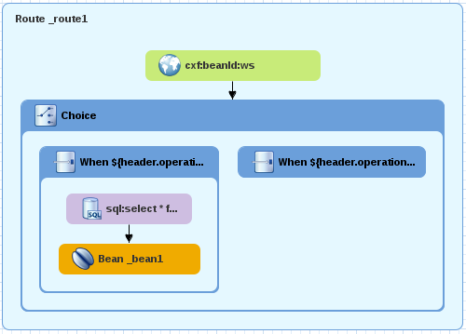

|  |  |
| --- | --- |
| general_info_polished.png | *The bean component binds beans to Apache Camel message exchanges. It allows you to call methods from or instantiate Java beans.*  <https://access.redhat.com/documentation/en/red-hat-jboss-fuse/6.3/paged/apache-camel-component-reference/chapter-11-bean>  *Here we will call a method of the Accounts bean to set the content of the body (a list of accounts) to its accounts property. This way, CXF will receive the expected Account object and transform it to a proper XML reply.* |

1. Go to the **com.redhat.Lab5** package under **src/main/java** and open **Accounts.java**
2. Go to the end of the file (before the last curly bracket) and add the following method:

|  |
| --- |
| public Accounts setAccount(List<Account> accounts){  this.account = accounts;  return this;  } |

1. Save the file (Ctrl+S) and close it.

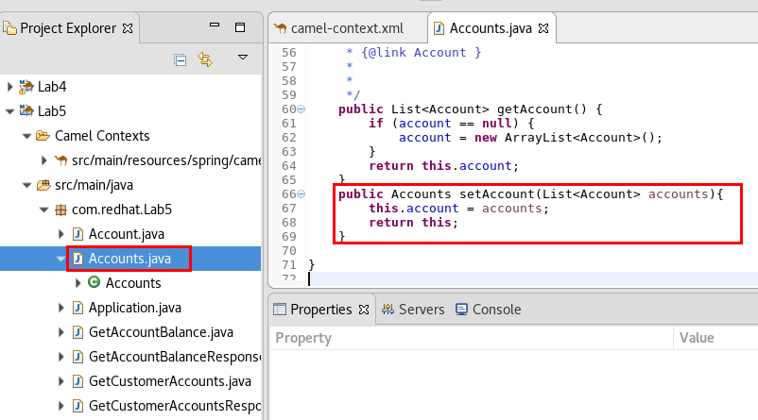

1. Drag another **SQL** component from the Components palette and drop it onto the second **When** component.
2. Edit its properties:
   1. **Advanced -> Path -> Query**: select \* from accounts where accountid = #
   2. **Advanced -> Common -> Data Source:** dataSource
   3. **Advanced -> Common -> Output Class:** com.redhat.Lab5.Account
   4. **Advanced -> Common -> Output Type:** SelectOne

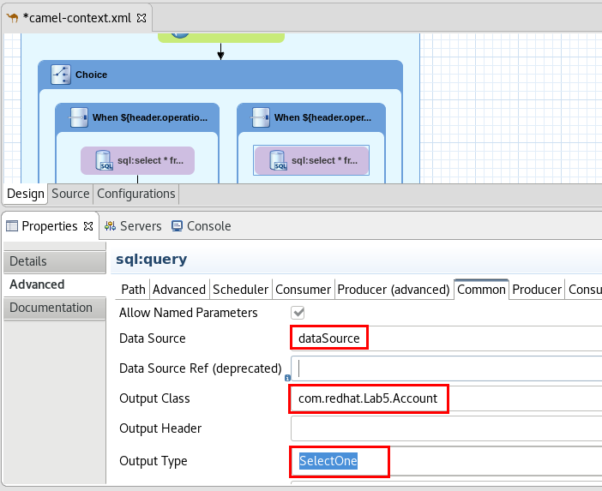

|  |  |
| --- | --- |
| general_info_polished.png | *In this case we selected “SelectOne” because we expect only one row coming back from the DB.* |

1. Drag a **setBody** component from the Transformation palette and drop it onto the **SQL** component.
2. Edit its properties:
   1. **Language:** simple
   2. **Expression**: ${body.getAccountBalance()}
3. Save the file (Ctrl+S).

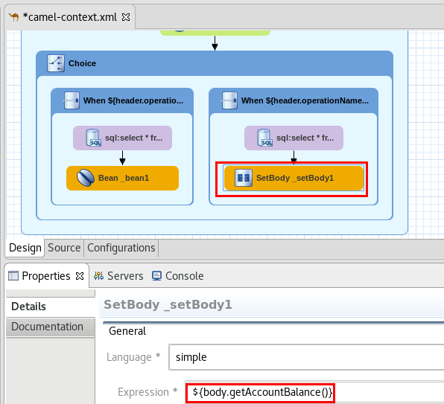

1. Double-click on the **application.properties** file under **src/main/resources/**
2. Click on the **Add** button
   1. **Name**: spring.datasource.username
   2. **Value**: admin

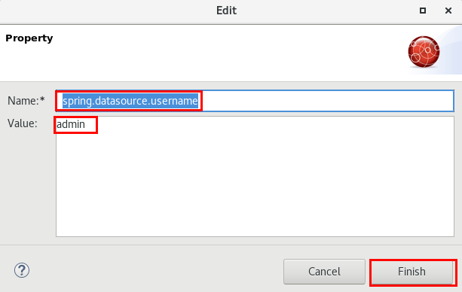

1. Click on the **Add** button
   1. **Name**: spring.datasource.password
   2. **Value**: password
2. Click on the **Add** button
   1. **Name:** spring.datasource.url
   2. **Value**: jdbc:postgresql://fis2td-db.db.svc.cluster.local:5432/JBossBank

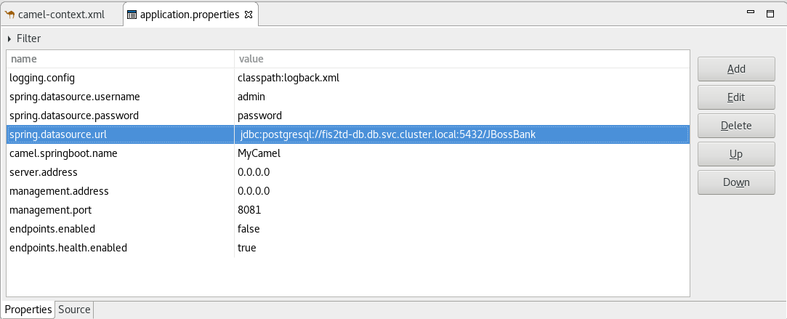

1. Save the file (Ctrl+S) and close it.
2. Go to the **Openshift Explorer** view.
3. Right-click on the **admin** connection, and select **New -> Project.**
4. Enter the following:
   1. **Project Name:** lab5
   2. **Display Name:** Lab5
   3. **Description:** Lab5 - SOAP
5. Click **Finish.**

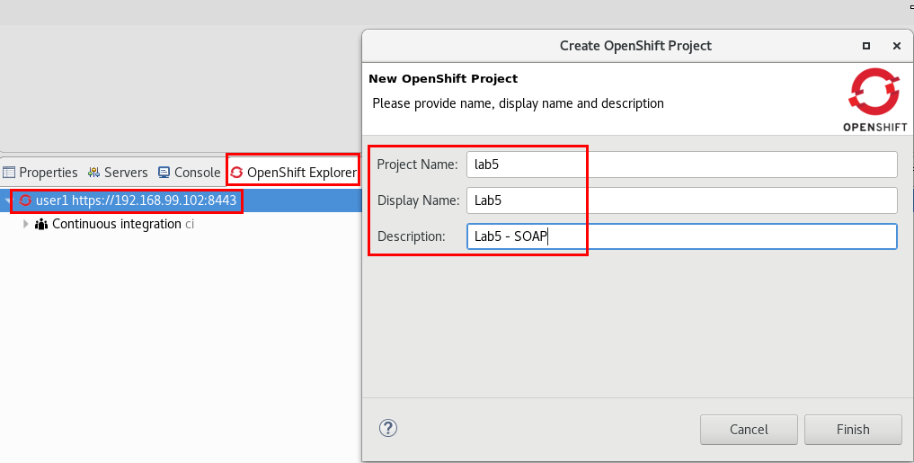

1. Go to the **Project Explorer** view.
2. Right-click on the **Lab5** project and select  **Run As -> Run configurations..**
3. Click on **Maven Build -> DeployLab5.**
4. Click on the **JRE** tab.
5. Change the “-Dkubernetes.master” property to match your instance #.

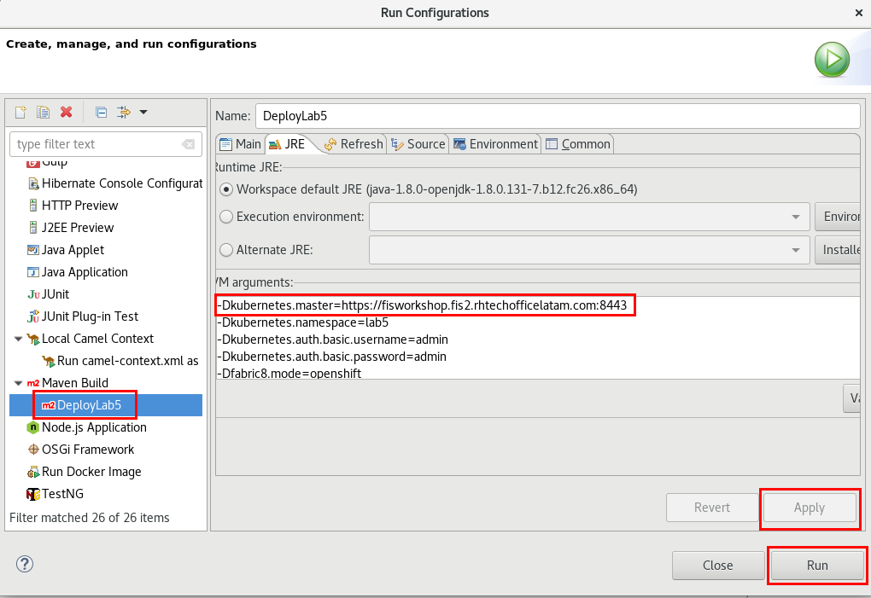

1. Click on the **Apply** and **Run** buttons.
2. Once the deployment to Openshift finishes, right-click on the **lab5** service under the **Lab5** Openshift Project and select **Show in -> Web Console**. (login with admin/admin)

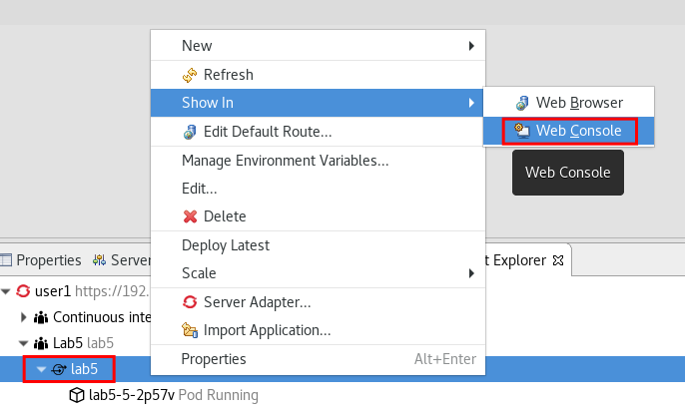

1. In Openshift web console, click on the **Actions ->** **Create Route** button.

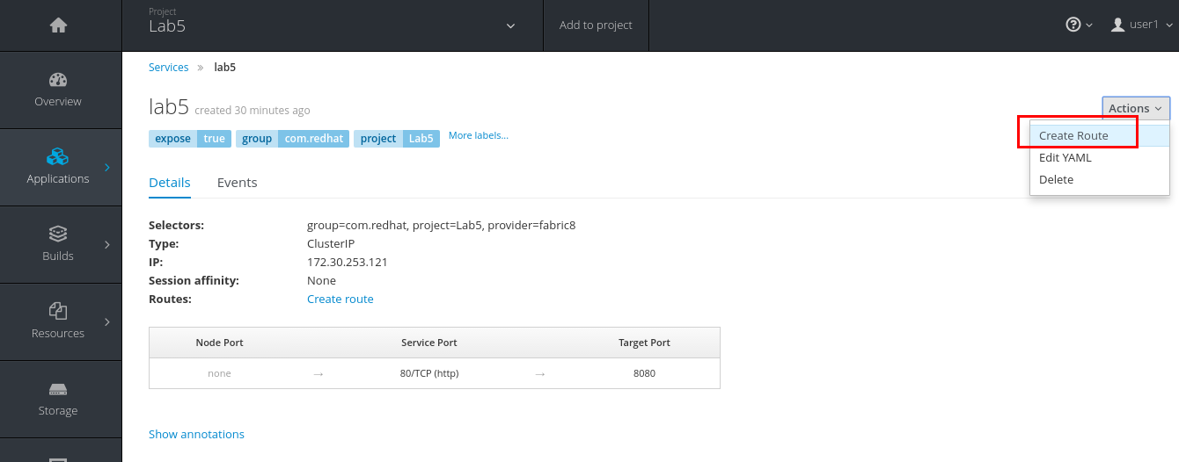

1. Leave the defaults and click **Create**.
2. Go back to JBDS.
3. Open the **Web Service Tester** view (**Window->Show View**).
4. Select **JAX-WS** in the combo.
5. Enter [http://lab5-lab5.apps.fis[your](about:blank) instance #].rhcol.com[/services/JBService?wsdl](http://lab5-lab5.apps.192.168.99.102.nip.io/services/JBService?wsdl) in the url box.
6. Click on the “**Get from WSDL”** icon.

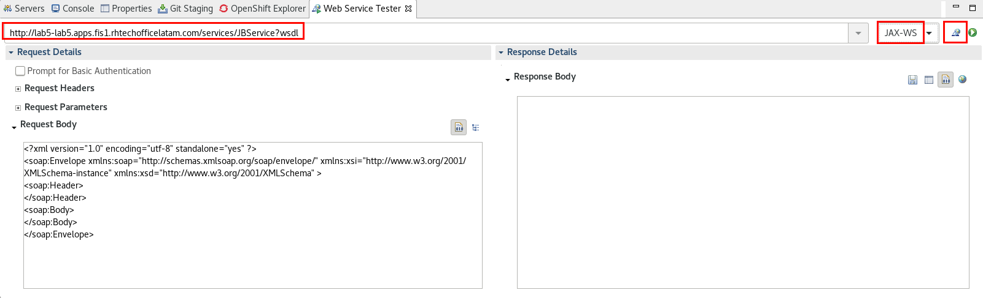

1. Select the **getAccountBalance** operation and click **OK**.

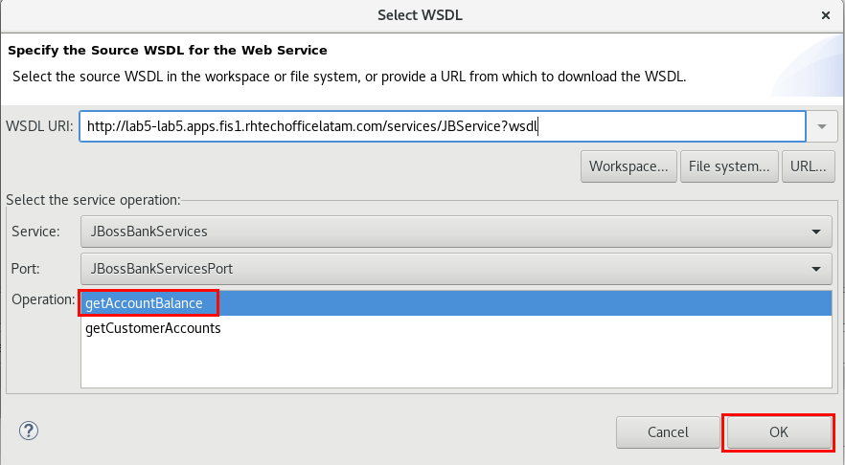

1. Replace the **“0”** parameter with a “**111**”.
2. Click on the **Invoke** icon.

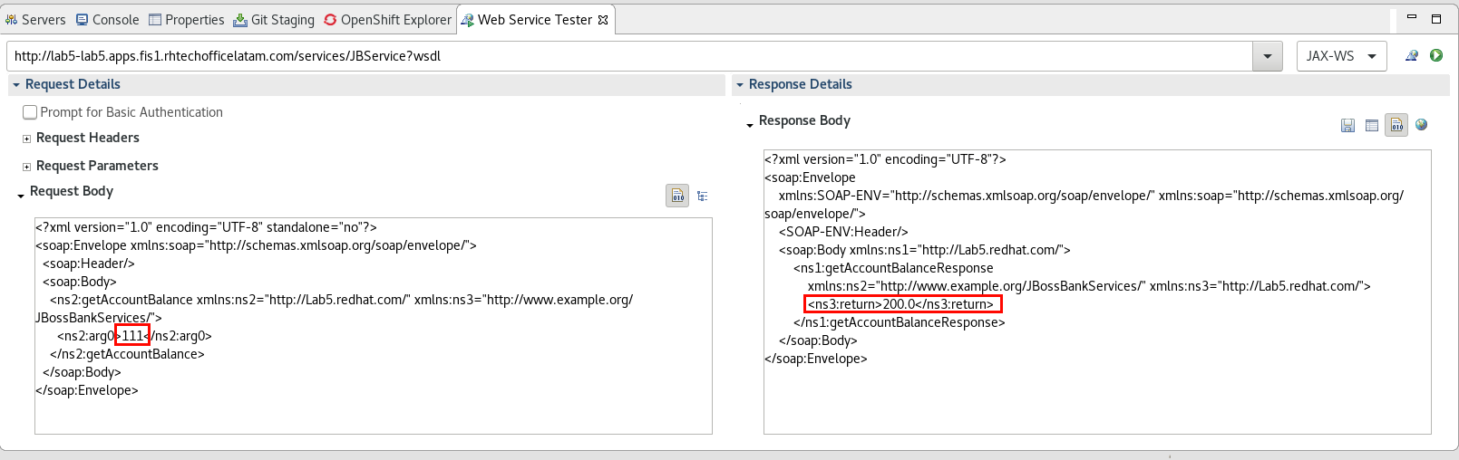

1. Click on the **“Get from WSDL”** icon.
2. Select the **getAccounts** operation and click **Yes** to accept replacing the request.
3. Replace the “0” parameter with a “1”.
4. Click on the **Invoke** icon.

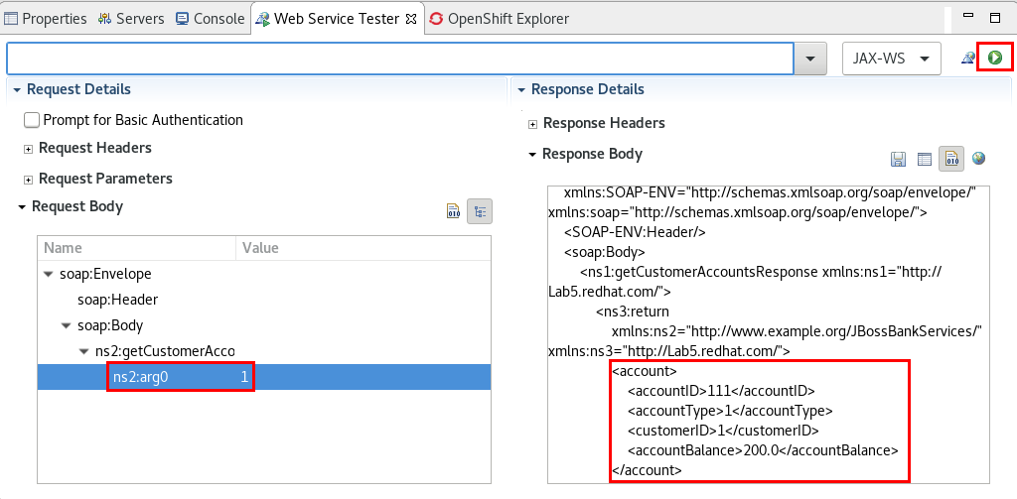

1. Close all the open files.

# Lab 6 - REST Web Services

|  |  |
| --- | --- |
| RH_Icon_Compass_Shiny.png | In this lab you will create a route that exposes a REST Web Service using the REST DSL and deploy it to OpenShift.    This web service will expose two operations: 1) A (GET) Orders request that will query a web API for an order, and 2) A (POST) operation that appends the contents of the request to a file. |

|  |  |
| --- | --- |
| general_info_polished.png | *Apache Camel supports multiple approaches to defining REST services. In particular, Apache Camel provides the REST DSL (Domain Specific Language), which is a simple but powerful fluent API that can be layered over any REST component and provides integration with Swagger.*  [*https://access.redhat.com/documentation/en/red-hat-jboss-fuse/6.3/paged/apache-camel-development-guide/chapter-4-defining-rest-services*](https://access.redhat.com/documentation/en/red-hat-jboss-fuse/6.3/paged/apache-camel-development-guide/chapter-4-defining-rest-services)  *Other alternatives when using REST are: CXF RS, Spark Rest, and Restlet* |

1. Select **File -> Import -> General -> Existing Projects into Workspace.**
2. Browse to **/FuseWorkshop/support/Lab6** and select **Lab6.zip**.,
3. Double-click on the **camel-context.xml** file under **Camel Contexts**.
4. Click on the **Source** tab.
5. Copy and paste the following XML lines inside **<camelContext>**

|  |
| --- |
| <restConfiguration apiContextPath="api-docs" component="servlet"  enableCORS="true" host="lab6-lab6.apps.fis2.rhcol.com">  <camel:apiProperty key="api.title" value="Lab6"/>  <camel:apiProperty key="api.version" value="1.0.0"/>  <camel:apiProperty key="cors" value="true"/>  </restConfiguration>  <rest path="/lab6">  <get outType="java.lang.String" produces="application/json" uri="/orders/{orderid}">  <to uri="direct:orders"/>  </get>  <post consumes="text/plain" type="java.lang.String" outType="java.lang.String" uri="/append">  <to uri="direct:append"/>  </post>  </rest> |

|  |  |
| --- | --- |
| general_info_polished.png | *Apache Camel offers a REST styled DSL which can be used with Java or XML. The intention is to allow end users to define REST services using a REST style with verbs such as get, post, delete etc.*  *The Rest DSL is a facade that builds Rest endpoints as consumers for Camel routes. The actual REST transport is leveraged by using Camel REST components such as Restlet, Spark-rest, and others that has native REST integration.* |

1. Change the **host="lab6-lab6.apps.fis2.rhcol.com"** attribute to match your instance #.
2. Save the file (Ctrl+S).

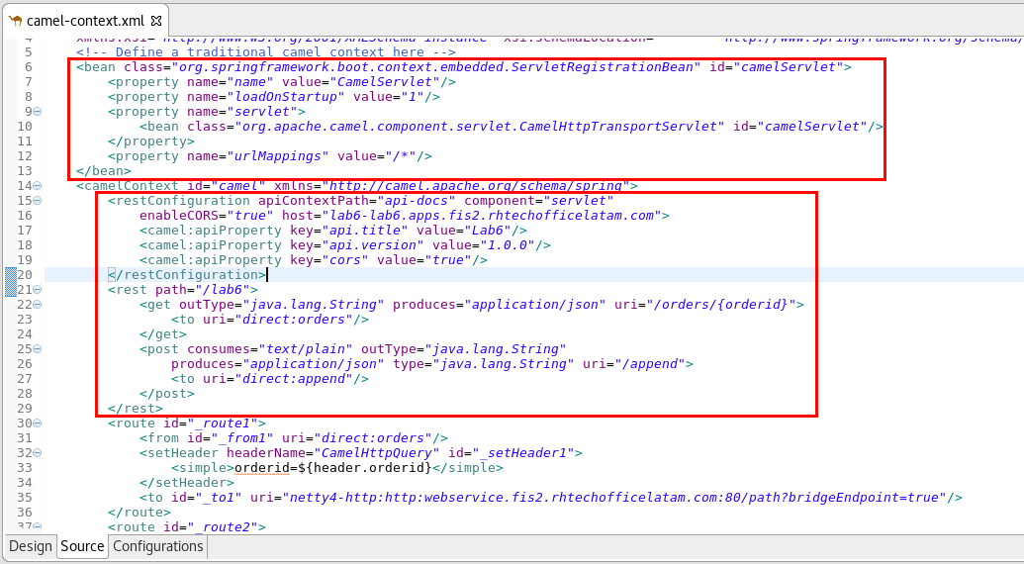

1. Click on the **Design** tab.
2. Drag a **route** component from the **Routing** palette and drop it onto the canvas.
3. Drag a **Direct** component from the Components palette onto the **Route**.
   1. Edit its properties
      1. **Advanced -> Path -> Name:** orders

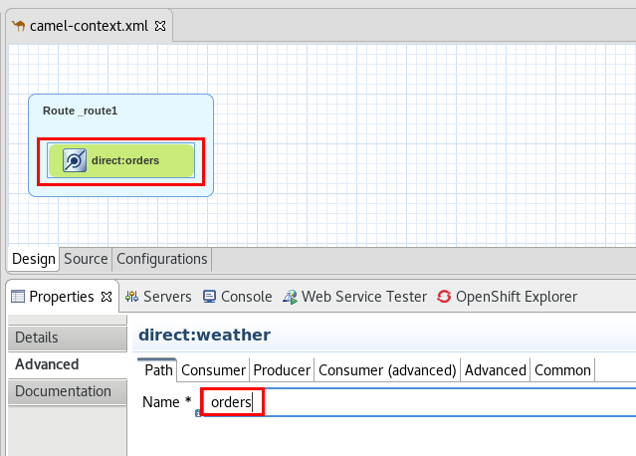

|  |  |
| --- | --- |
| general_info_polished.png | *The direct component provides direct, synchronous invocation of any consumers when a producer sends a message exchange. This endpoint can be used to connect existing routes in the same camel context.*  *(*[*https://access.redhat.com/documentation/en/red-hat-jboss-fuse/6.3/paged/apache-camel-component-reference/chapter-34-direct*](https://access.redhat.com/documentation/en/red-hat-jboss-fuse/6.3/paged/apache-camel-component-reference/chapter-34-direct) *)* |

1. Drag a **setHeader** component from the Transformation palette and drop it onto the **Direct** component.
   1. Edit its properties
      1. **Language**: simple
      2. **Expression:** orderid=${header.orderid}
      3. **Header Name:** CamelHttpQuery

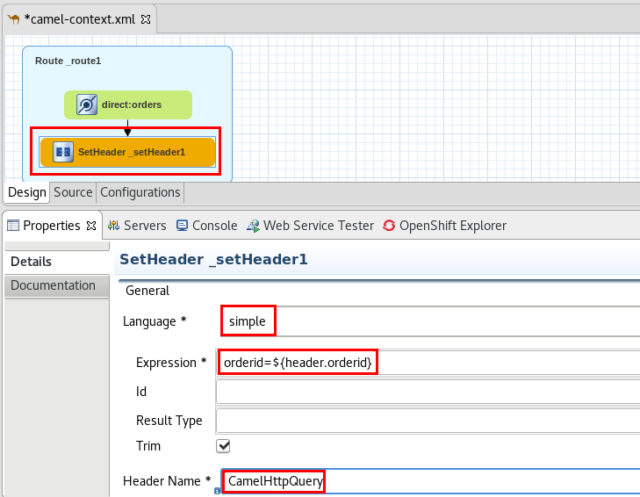

1. Drag a **Netty4 HTTP** component from the Components palette and drop it onto the last **SetHeader** component.
2. Edit **Netty4HTTP** component’s properties
   1. **Advanced -> Path -> Host:** fis2td-ws.ws.svc.cluster.local
   2. **Advanced -> Path -> Protocol:** http
   3. **Advanced -> Path -> Path:**
   4. **Advanced -> Path -> Port:** 8080
   5. **Advanced -> Comon -> Bridge Endpoint:** true

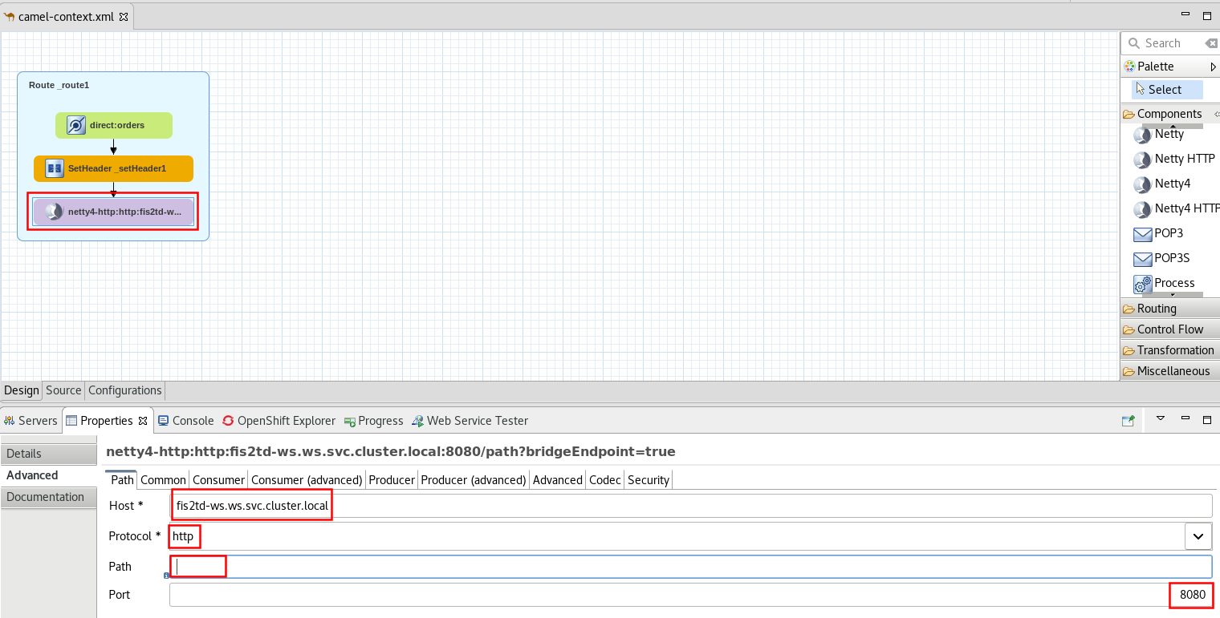

1. Save the file (Ctrl+S).

|  |  |
| --- | --- |
| general_info_polished.png | *The netty4-http component provides HTTP-based endpoints for calling external HTTP resources (as a client to call external servers using HTTP).*  *(*[*https://access.redhat.com/documentation/en-us/red\_hat\_jboss\_fuse/6.3/html/apache\_camel\_component\_reference/idu-netty4-http*](https://access.redhat.com/documentation/en-us/red_hat_jboss_fuse/6.3/html/apache_camel_component_reference/idu-netty4-http) *)* |

1. Drag **Route** component from the Routing palette and drop it in the canvas.

|  |  |
| --- | --- |
| general_info_polished.png | *By creating a new Route, we are defining a new integration route that is independent from the first one, but share the same camel context.* |

1. Drag a **Direct** component from the Components palette and drop it onto the new Route..
   1. Edit its properties
      1. **Advanced->Path->Name:** append

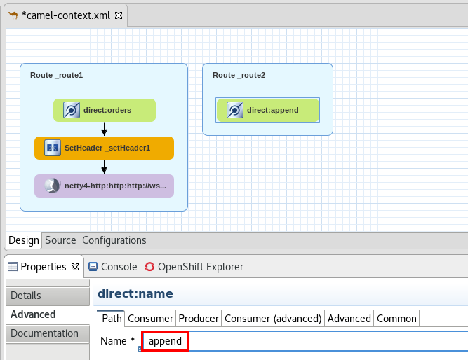

1. Drag a **File** component from the Components palette and drop it onto the **direct** component.
   1. Edit its properties
      1. **Advanced -> Path -> Directory Name:** appendDir
      2. **Advanced -> Common -> File Name:** append.txt
      3. **Advanced -> Producer -> File Exist:** Append

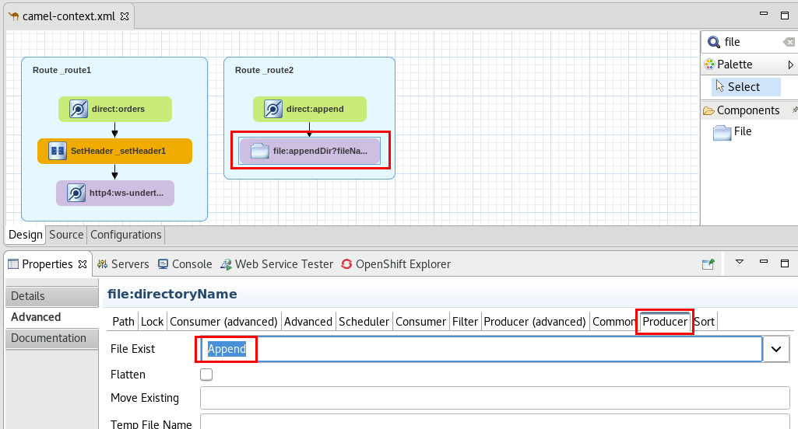

1. Drag a **setBody** component from the Transformation palette and drop it onto the **file** component.
   1. Edit its properties
      1. **Language:** constant
      2. **Expression:** {"result": "OK"}
2. Save the file (Ctrl+S).

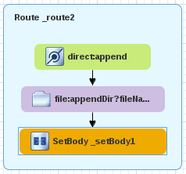

|  |  |
| --- | --- |
| general_info_polished.png | *As with the CXF web service, the last step of the route returns a message to the caller. So in the first route we return the response from the http call, and in the second route we set the body to a Json response.* |

1. Right-Click on the **Lab6** project and select **Team -> Share Project.**
2. Select **Git** and click **Next.**
3. Select the **workshop** repository and click **Finish**.

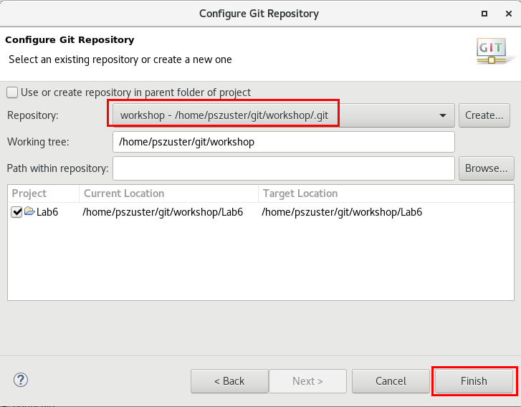

1. Right-click on the **Lab6** project in the **Project Explorer** and select **Team -> Add to Index.**
2. Right-click on the **Lab6** project in the **Project Explorer** and select **Team -> Commit.**
3. Enter a **Commit Message** (anything) and click **Commit and Push.**
4. Click **OK**.

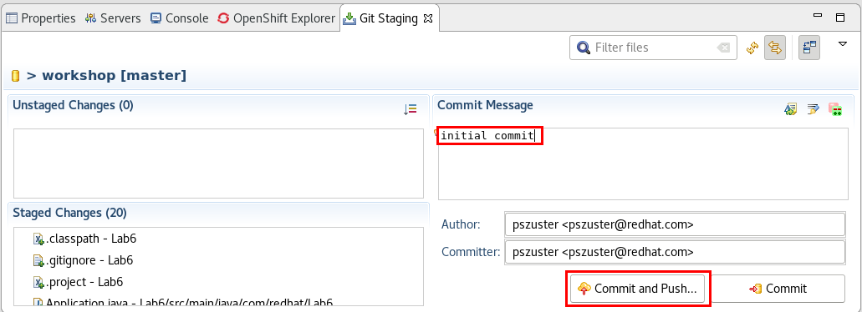

1. Enter user1/user1.
2. Click **OK**.
3. Go to the **OpenShift** **Explorer** view.
4. Right-click on the **admin** connection.
5. Select **New->Project.**
6. Enter:
   1. **Project Name:** lab6
   2. **Display Name:** Lab6
   3. **Description:** Lab6 - REST
7. Click **Finish**.

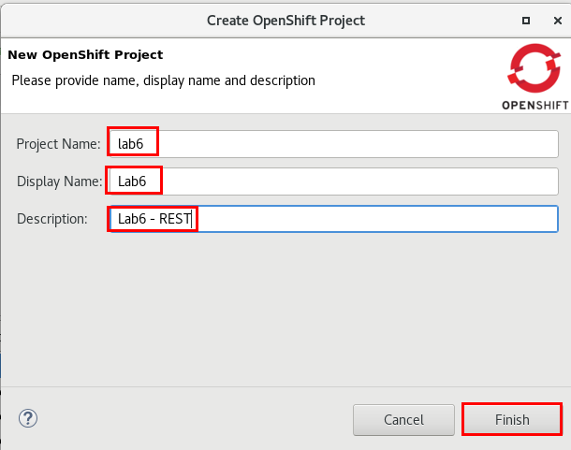

1. Right-Click on the **Lab6** project and select **New -> Application.**
2. Click on the **Browse** button and select **Lab6**.
3. Select the **fis-java-openshift:2.0** template, and click **Next**.

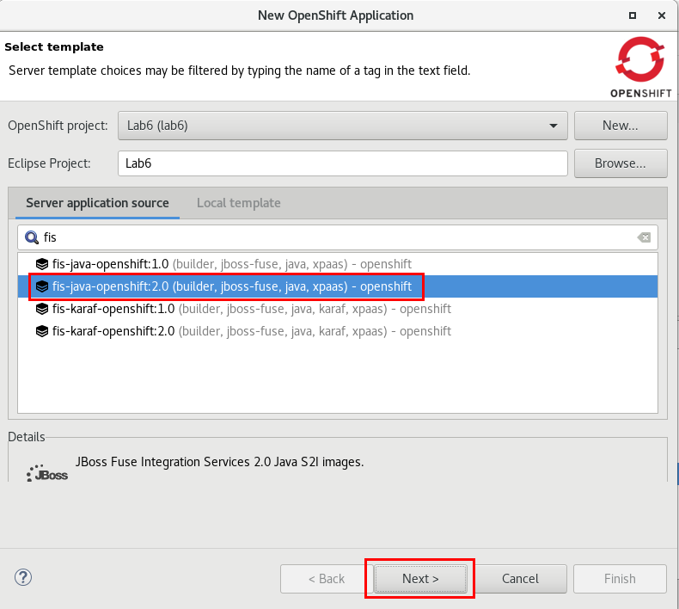

1. Enter
   1. **Name:** lab6
   2. **Git URL:** [http://gogs.fis[your](about:blank) instance#].rhcol.com/user1/workshop
   3. **Context Directory:** Lab6
2. Click on the **Add** button in **Build environment variables.**
3. Enter
   1. **Name:** MAVEN\_MIRROR\_URL
   2. **Value:** [http://nexus.fis[your](about:blank) instance #].rhcol.com/content/groups/public/
4. Click **Next.**

**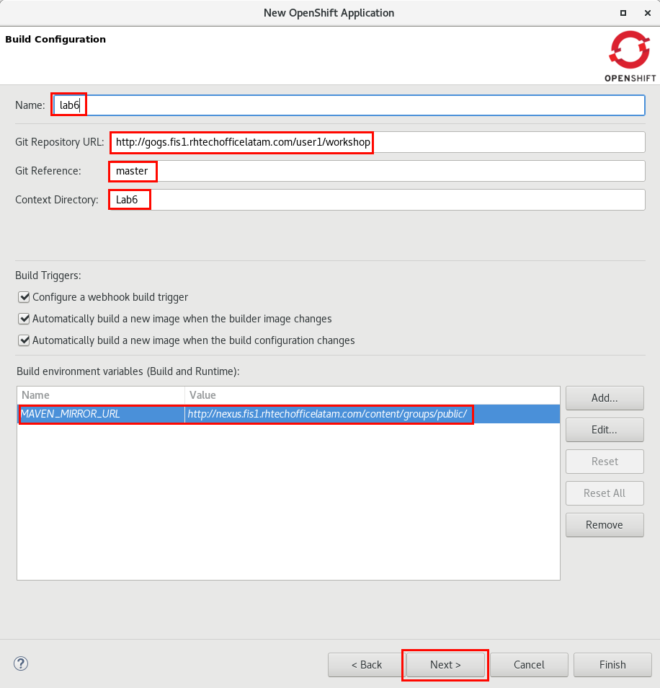**

1. Click **Next**.
2. Select the **8778-tcp** port and click on the **Edit** button.
3. Change both port numbers to **8080**.

**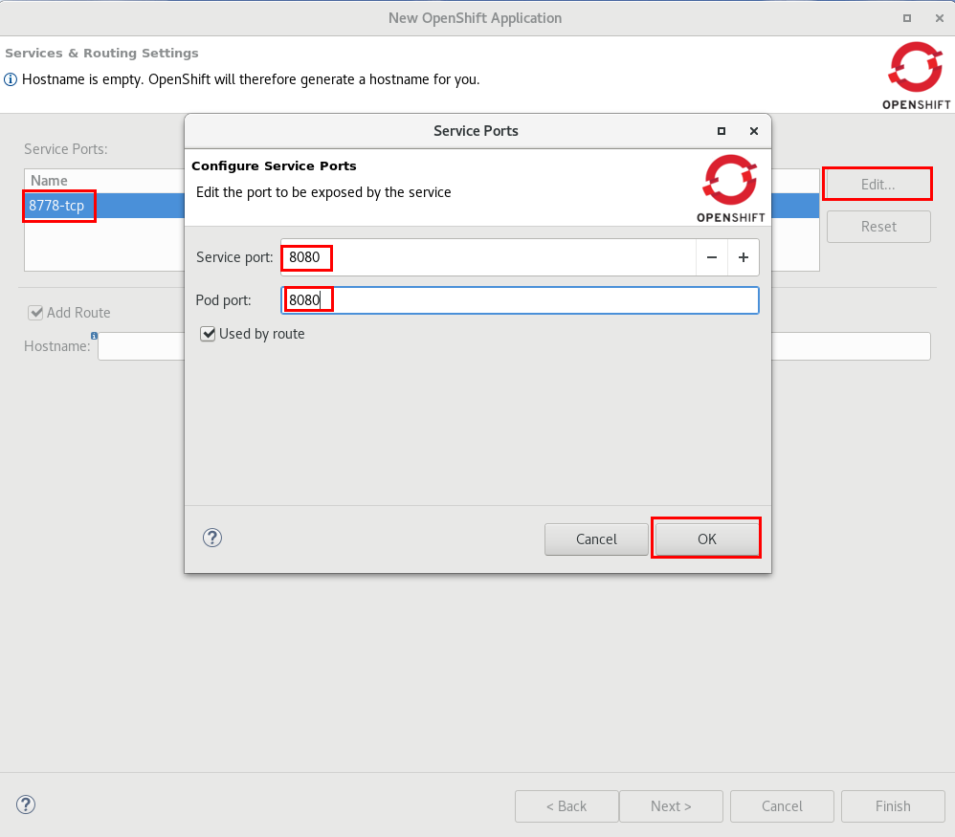**

1. Click **OK**.
2. Click **Finish.**
3. Click **OK.**
4. In the **OpenShift Explorer**, expand **Lab6 -> lab6**.
5. Right-click on the l**ab6dc-1 Build Running** pod, and click on **Build Log..**
6. Wait for the build to finish (a “Push Successful” message should appear after ~5min)
7. Open a web browser, and go to [http://swagger-ui.fis[your instance #].rhcol.com/](about:blank)
8. In the text box, enter the following API URL: [http://lab6-lab6.apps.fis[your instance #].rhcol.com/api-docs](http://lab6-lab6.apps.192.168.99.102.nip.io/api-docs)
9. Click on the **Explore** button.



1. Click on the **List Operations** link to show the available REST operations.
2. Click on the **/lab6/orders/{orderid}** link to expand it.
3. Enter **123** as the orderid parameter and click **Try it out!**

**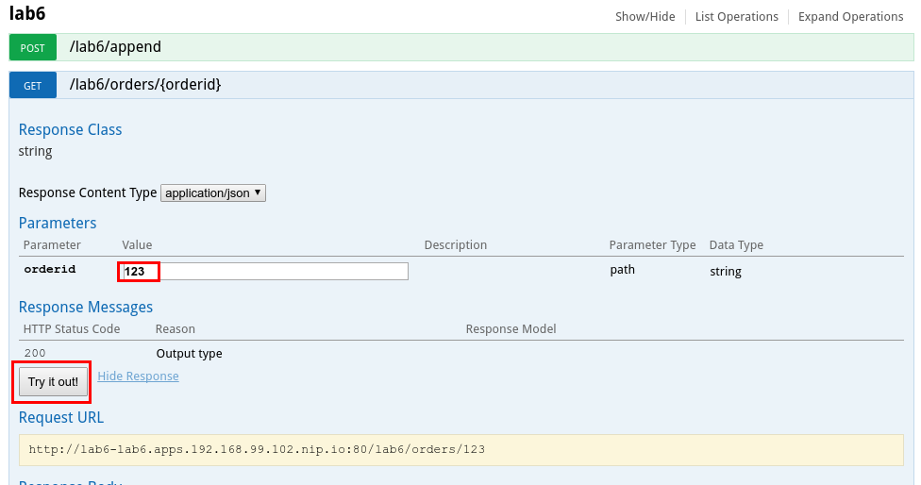**

1. You have successfully tested the first of the two routes.
2. Click on the **/lab6/append** link to expand it.
3. Enter any text in the **body** parameter.
4. Click on the **Try it out!** Button.

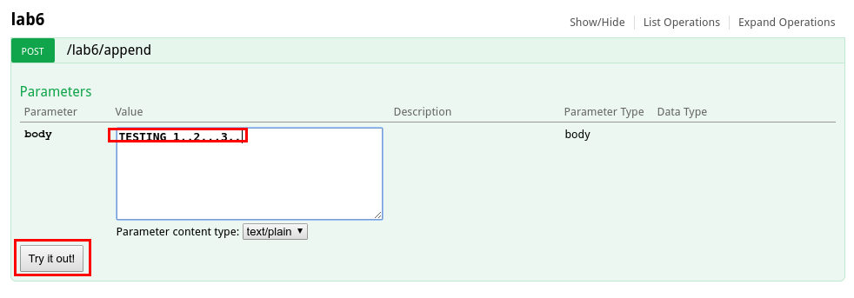

1. Close the web browser.
2. Go back to JBDS.
3. Go to the **OpenShift Explorer** view.
4. Expand **Lab6 -> lab6**.
5. Right-click on the lab6 pod and select **Show in -> Web console.**

**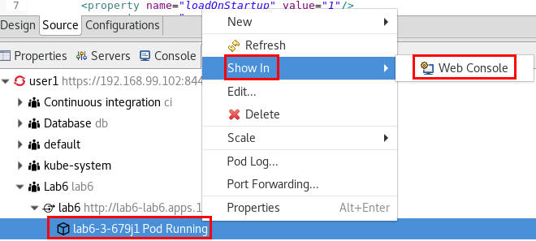**

1. In the **Web Console**, click on the **Terminal** tab.

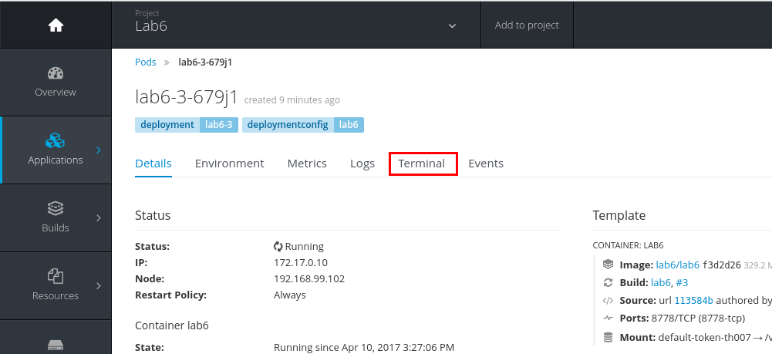

1. Enter the following commands:
   1. cd /deployments/appendDir/
   2. more append.txt

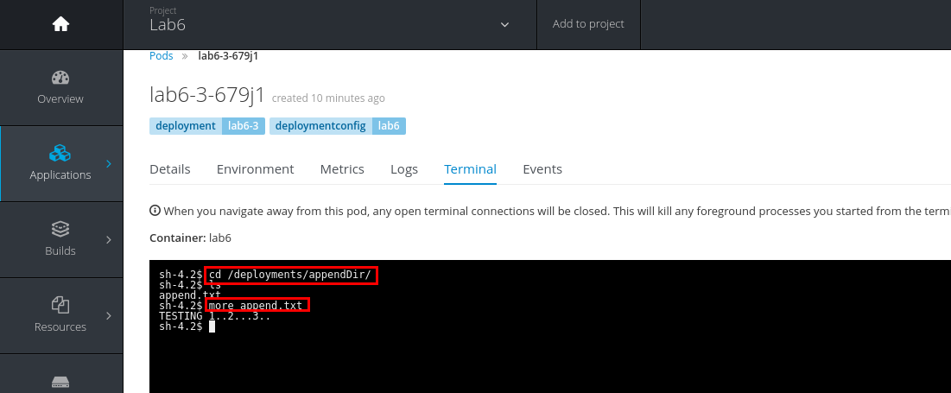

1. Check out the contents of the append.txt file.

# Lab 7 - Messaging

|  |  |
| --- | --- |
| RH_Icon_Compass_Shiny.png | In this lab you will add an ActiveMQ component to receive messages through the MoM Broker JBoss A-MQ. Using the JMS component you could connect to any JMS compliant MoM Broker.    You will build a route that listens on a queue, splits the incoming XML into multiple elements and publishes them to a topic depending on their content. Then you will build two routes that subscribe to topics and log the received messages. |

|  |  |
| --- | --- |
| general_info_polished.png | *Red Hat JBoss A-MQ, based on Apache ActiveMQ, is a JMS 1.1-compliant messaging system. It consists of a broker and client-side libraries that enable remote communication among distributed client applications. JBoss A-MQ provides numerous connectivity options and can communicate with a wide variety of non-JMS clients through its support of the OpenWire and STOMP wire protocols.It provides enterprise features like High Availability, Scalability, Reliability, Security, High Performance,etc. (*[*https://access.redhat.com/documentation/en/red-hat-jboss-a-mq/6.3/paged/product-introduction/chapter-1-what-is-jboss-a-mq*](https://access.redhat.com/documentation/en/red-hat-jboss-a-mq/6.3/paged/product-introduction/chapter-1-what-is-jboss-a-mq) *)* |

1. Select **File -> Import -> General -> Existing Project into Workspace.**
2. Click on **Select archive file** and browse to **FuseWorkshop/support/Lab7** and select **Lab7.zip**.
3. Double-click on the **camel-context.xml** file under Camel Contexts.
4. Drag a **Route** component from the **Routing** palette and drop it onto the canvas.
5. Drag an **ActiveMQ** component from the **Components** palette and drop it onto the existing Route..
   1. Edit its properties:
      1. **Advanced -> Path -> Destination Name:** Lab7
      2. **Advanced -> Path -> Destination Type:** queue

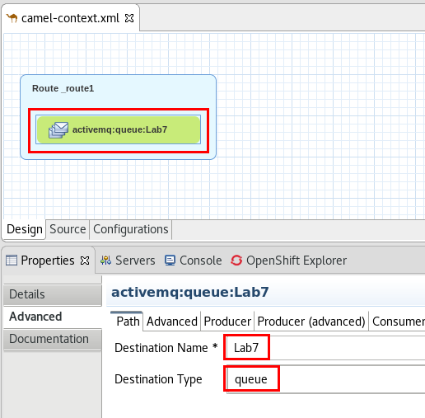

1. Drag a **Split** component from the Routing palette and drop it onto the **activemq** component.
   1. Edit its properties:
      1. **Language:** xpath
      2. **Expression:** //update

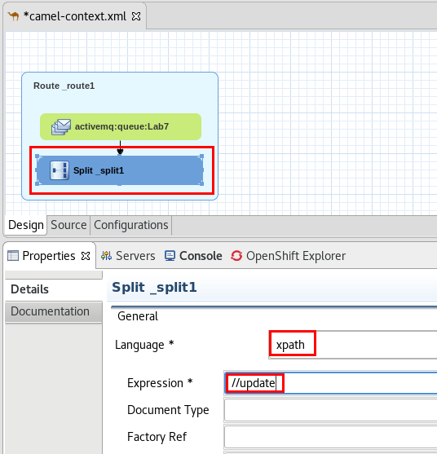

1. Drag a **setProperty** Component from the **Transformation** palette, and drop it into the split component.
   1. Edit its properties:
      1. **Language:** xpath
      2. **Expression:** //entity/text()
      3. **Property Name:** entity
2. Drag a **RecipientList** from the Routing palette and drop it onto the setProperty component.
   1. Edit its properties:
      1. **Language:** simple
      2. **Expression:** activemq:topic:Updates.${property.entity}
3. Save the file (Ctrl+S).

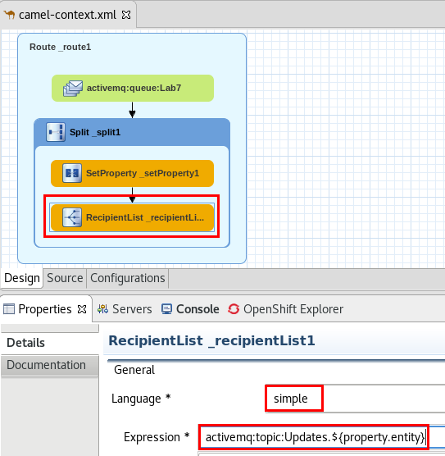

|  |  |
| --- | --- |
| general_info_polished.png | *A recipient list, is a type of router that sends each incoming message to multiple different destinations. In addition, a recipient list typically requires that the list of recipients be calculated at run time.*  [*https://access.redhat.com/documentation/en/red-hat-jboss-fuse/6.3/paged/apache-camel-development-guide/chapter-8-message-routing#MsgRout-Fig-RLP*](https://access.redhat.com/documentation/en/red-hat-jboss-fuse/6.3/paged/apache-camel-development-guide/chapter-8-message-routing#MsgRout-Fig-RLP) |

1. Click in on the route name (“\_route1).
2. Click on the **properties** tab**.**
3. Enter“mainRoute” as the **ID.**

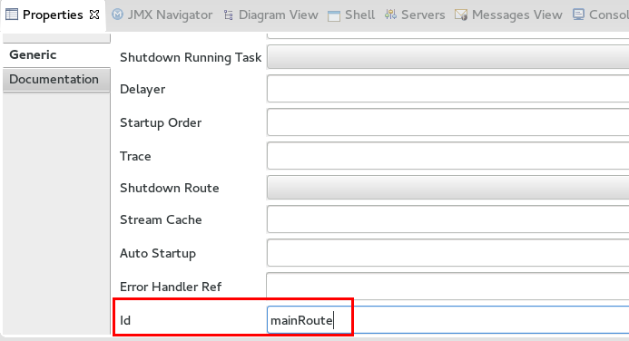

1. Drag a **Route** component from the Routing palette and drop it in the canvas.
2. Drag an **ActiveMQ** component from the Components palette and drop it in the created route .
   1. Edit its properties:
      1. **Advanced -> Path -> Destination Name:** Updates.Customer
      2. **Advanced -> Path -> Destination Type:** topic

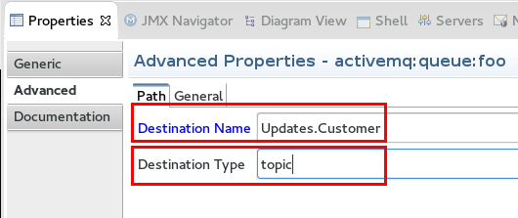

1. Drag a **setBody** component from the Transformation palette and drop it onto the activemq component.
   1. Edit its properties:
      1. **Language:** xpath
      2. **Expression:** //entityID/text()

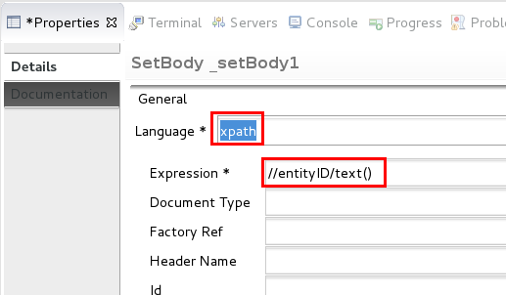

1. Drag a **Log** component from the Components palette and drop it onto the setBody component.
   1. Edit its properties:
      1. **Message:** Received an update for Customer ID: ${body}
2. Save the file (Ctrl+S).

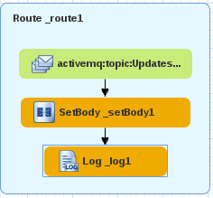

1. Click on the route’s name (“\_route1”).
2. Click on the **properties** tab**.**
3. Enter“CustomerRoute” as the **Id.**
4. Save the file (Ctrl+S).
5. Drag a **Route** component from the Routing palette and drop it in the canvas.
6. Drag an **ActiveMQ** component from the Components palette and drop it in the new route..
   1. Edit its properties:
      1. **Advanced -> Path -> Destination Name:** Updates.Product
      2. **Advanced -> Path -> Destination Type:** topic

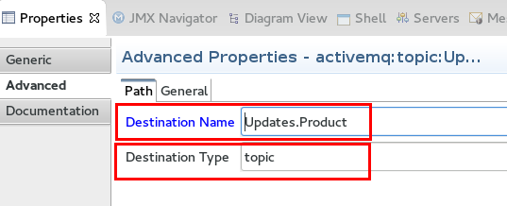

1. Drag a **setBody** component from the Transformation palette and drop it onto the activemq component.
   1. Edit its properties:
      1. **Expression:** //entityID/text()
      2. **Language:** xpath

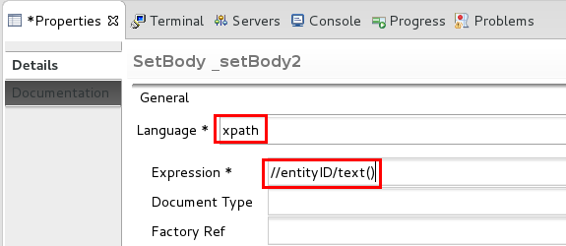

1. Drag a **Log** component from the Components palette and drop it onto the setBody component.
   1. Edit its properties:
      1. **Message:**  Received an update for Product ID: ${body}
2. Save the file (Ctrl+S).

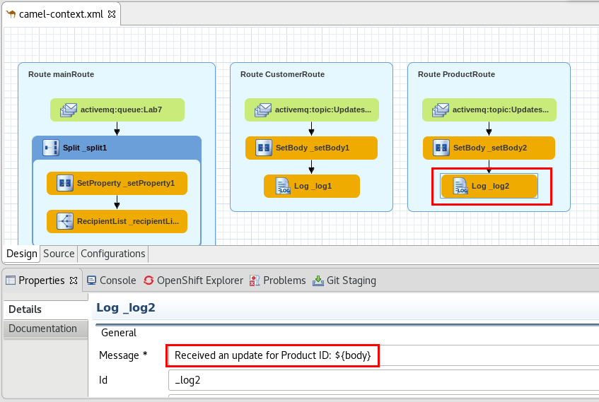

1. Click on the route’s name (“\_route1”).
2. Click on the **properties** tab**.**
3. Enter“ProductRoute” as the **Id.**
4. Save the file (Ctrl+S).
5. Double-click on **application.properties** under **src/main/resources**.
6. Add the following properties:
   1. **activemq.service.name:** broker-amq-tcp
   2. **spring.activemq.broker-url:** tcp://${${activemq.service.name}.service.host}:${${activemq.service.name}.service.port}
   3. **spring.activemq.user**: admin
   4. **spring.activemq.password:** admin
   5. **spring.activemq.inMemory:** false

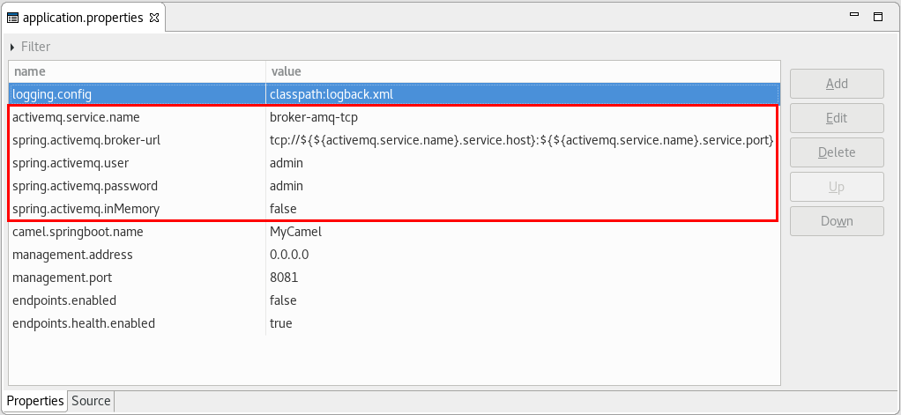

1. Save the file (Ctrl+S).
2. Go to the **OpenShift Explorer** and right-click on the **admin** connection.
3. Select **New -> Project**.
4. Enter
   1. **Project Name:** lab7
   2. **Display Name:** Lab7
   3. **Description:** Lab7 - AMQ
5. Click **Finish.**

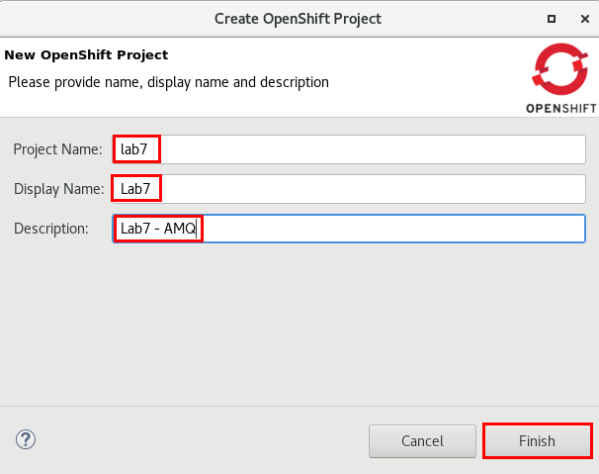

1. Right-click on the **Lab7** project in the **OpenShift Explorer** view and select **New -> Application.**
2. Select the **amq62-basic** template and click **Next**.
3. Enter the following values:
   1. **AMQ\_MESH\_DISCOVERY\_TYPE:** dns
   2. **MQ\_QUEUES**: Lab7
   3. **MQ\_TOPICS:** Updates.Customer, Updates.Product
   4. **MQ\_USERNAME**: admin
   5. **MQ\_PASSWORD**: admin
4. Click **Finish**.

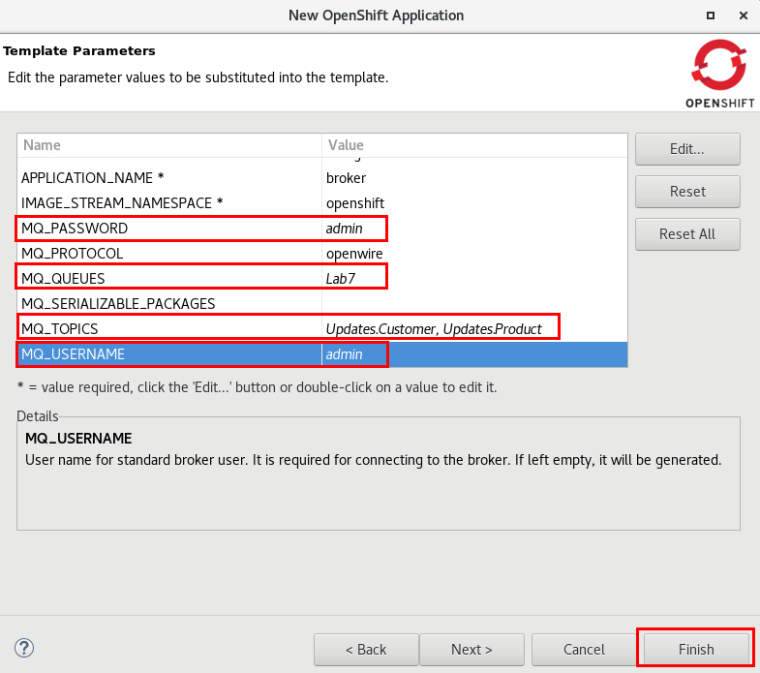

1. Click **OK**.
2. Go to the **Project Explorer** view.
3. Double-click on the **pom.xml** file.
4. Click on the **Dependencies** tab.
5. Click on the **activemq-camel-starter** dependency and click on the **Remove** button.
6. Save and close the file (Ctrl+S).
7. Right-Click on the **Lab7** project and select **Run As - > Run Configurations..**
8. Click on **Maven Build** -> **DeployLab7”**.
9. Click on the **JRE** tab.
10. Change **-Dkubernetes.master** to match your instance #.
11. Click **Apply.**
12. Click **Run**.
13. Once the Binary Source-To-Image deployment finishes, go to the **OpenShift Explorer** view.
14. Expand **Lab7 -> broker-amq-tcp**.
15. Right-click on the **broker-amq** pod and select **Show in -> Web Console.**

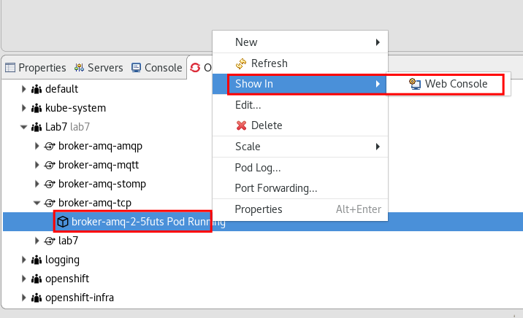

1. In the **Openshift** web console, click on the **Open Java Console** link

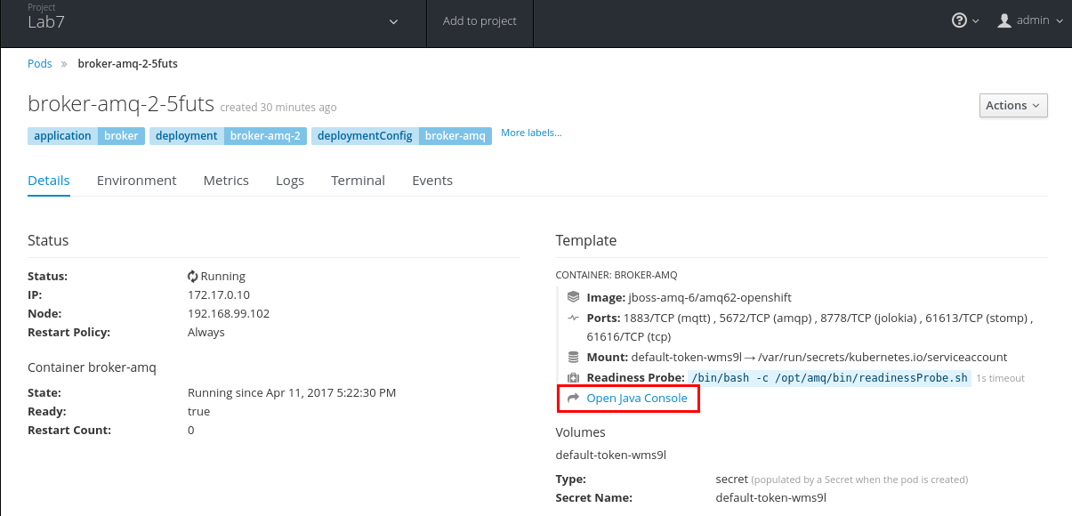

1. Click on the **User** icon.
2. Click on **Preferences.**

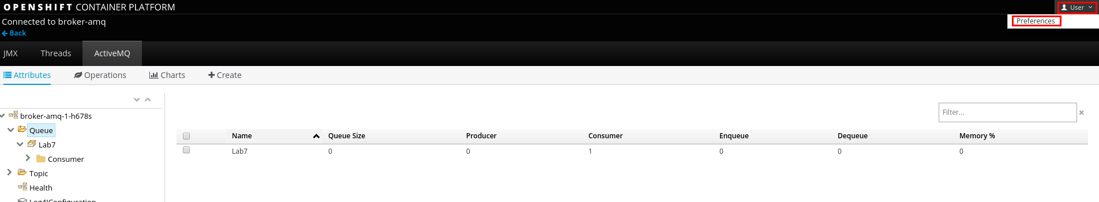

1. Click on the **ActiveMQ** tab.
2. Enter **Username**: admin / **Password**: admin.
3. Click on the **Done** button.

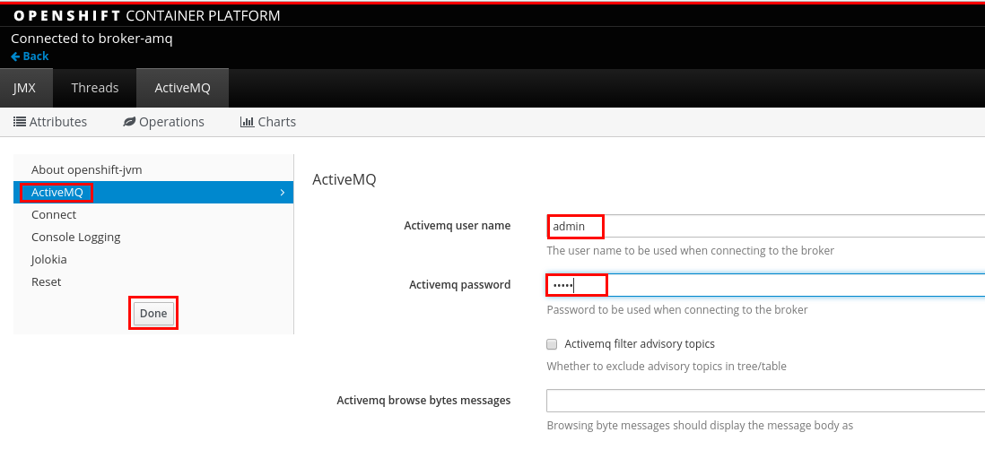

1. Expand the **Queue** folder and click on the **Lab7** queue.
2. Click on ****
3. Open **~/FuseWorkshop/support/Lab7/Message.xml** with any text editor (like gedit or vi)
4. Copy its contents and paste them into the payload box.
5. Select **XML** as the payload format.
6. Click on the **Send Message** button.

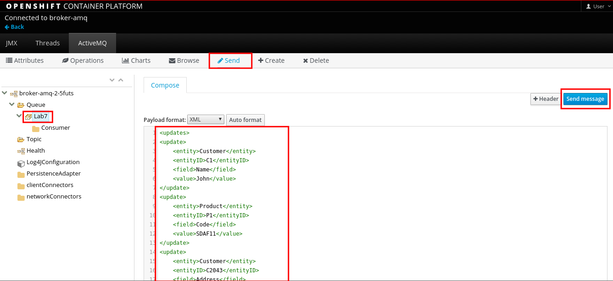

1. Click on the **<-Back** link.

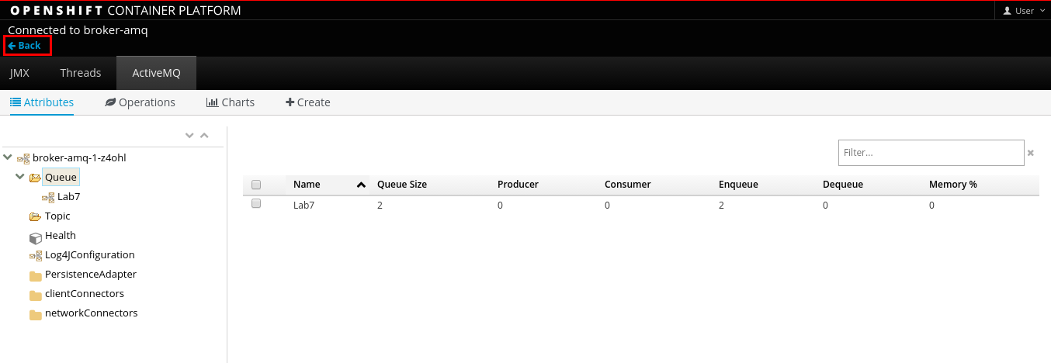

1. Back in **Openshift Console**, click on **Applications -> Pods.**
2. Click on the **lab7-xxxxx** pod (the one that doesn’t say “build” or “deploy”).

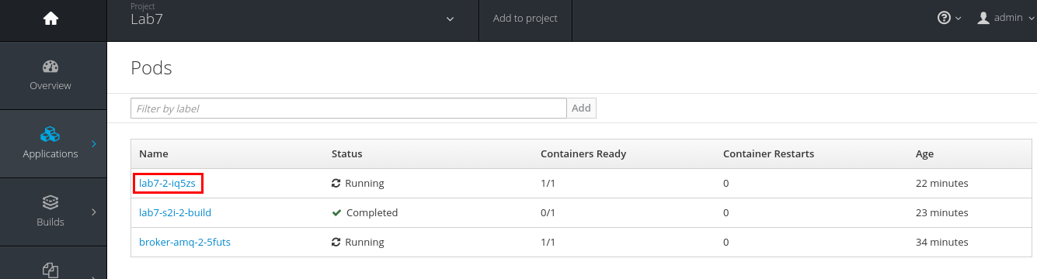

1. Click on the **Logs** tab.
2. Click on the **Follow** link.

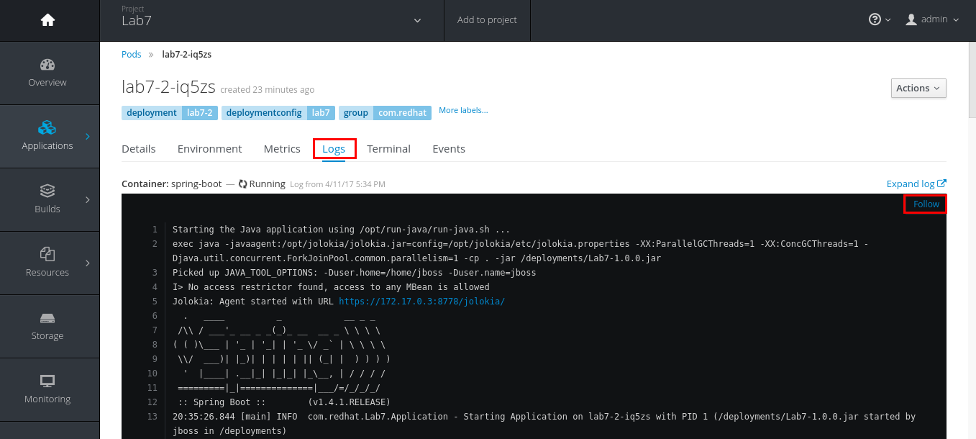

1. There should be a log message for each element of the XML message.



# Lab 8 - Debugging

|  |  |
| --- | --- |
| RH_Icon_Compass_Shiny.png | In this lab you will learn how to use the debugger feature to go through the route execution step by step, understanding which path the message is taking. |

## Part A - Local Debugging

1. Select **File -> Import -> General -> Existing Projects into Workspace**.
2. Browse to **FuseWorkshop/support/Lab8/Lab8.zip.**
3. Double-click on **camel-context.xml** under **Camel Contexts.**
4. Hover the mouse over the **Log** component.
5. Click on the red ball to add a breakpoint.

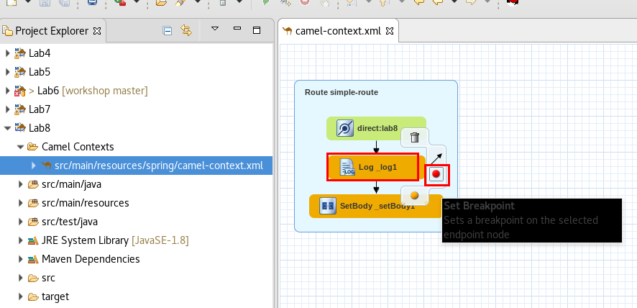

1. Right-click on the **camel-context.xml** file, **Debug As -> Local Camel Context (without tests)**.
2. Open the **Web Service Tester** view (**Windows -> Show View -> Other**)
3. Enter <http://localhost:8080/lab8>
4. Select **POST**.
5. Expand **Request Headers** and add **Content-type=application/text**
6. Enter any text in the **Request Body**.
7. Click on the **Invoke** icon.

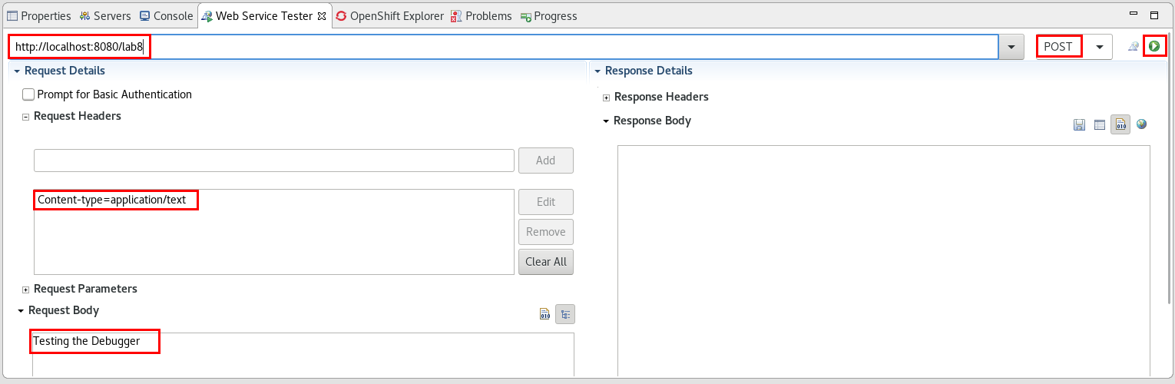

1. The Debug perspective will show up.
2. Click on the variables tab, and scroll to find the Message element.
3. Expand the **Message** element, and click on **MessageBody**.

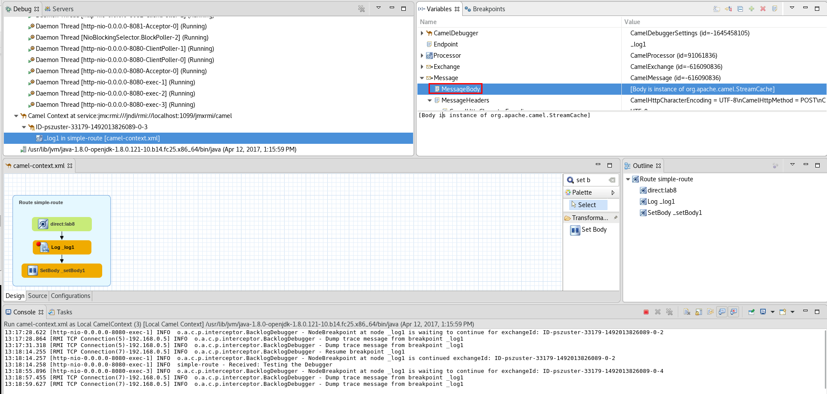

1. Click on the **step-over** button.



1. Step over the route and inspect the exchange values.
2. Click on the **Resume** button.



1. Click on the **Fuse Integration** perspective button.
2. Check the response in the **WebServices Tester**.
3. Stop the debugger (in the **Console** view).
4. Close the camel-context.xml file.

## Part B - Server Debugging

1. Go to the **OpenShift Explorer** view.
2. Right-click on the **admin** connection and select  **New -> Project.**
3. Enter the following values:
   1. **Project Name:** lab8
   2. **Display Name:** Lab8
   3. **Description:** Lab8 - Debugging
4. Click **Finish.**

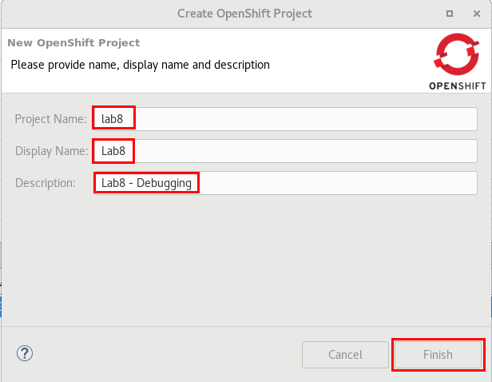

1. Go to the **Project Explorer** view.
2. Right-Click on the **Lab8** project and select **Run As -> Run Configurations.**
3. Select **Maven Build -> DeployLab8.**
4. Click on the **JRE** tab.
5. Change -**Dkubernetes.master**  to match your instance #.
6. Click **Apply**.
7. Click **Run**.
8. Once the deployment is finished, go to the **OpenShift Explorer**  view.
9. Expand **Lab8 -> lab8** **-> lab8-xxxx** ,right-click on the Pod and select **Show in -> Web Console.**
10. Click on the **Open Java Console** link.

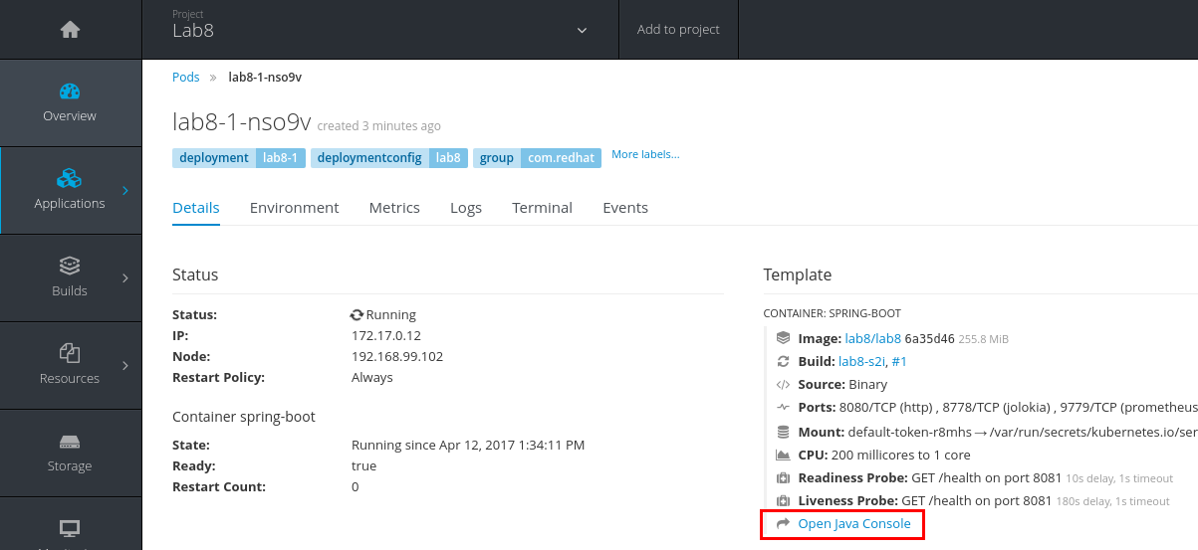

1. Click on the **“simple-route”** camel route.

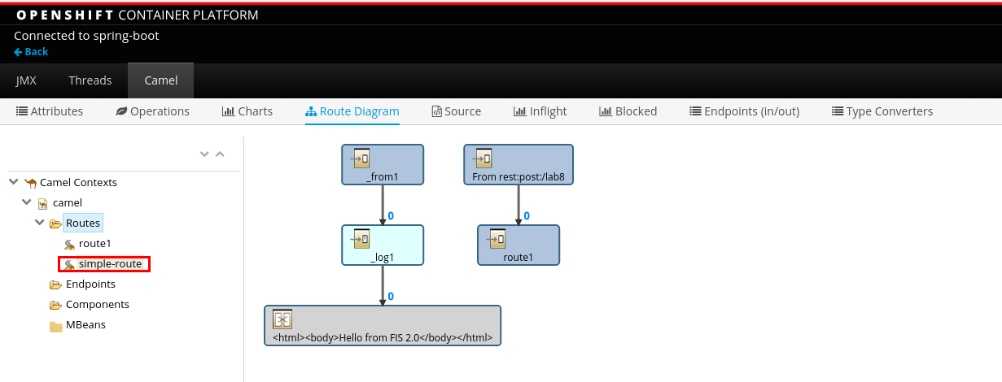

1. Click on **Debug.**
2. Click on the **Start debugging** button.

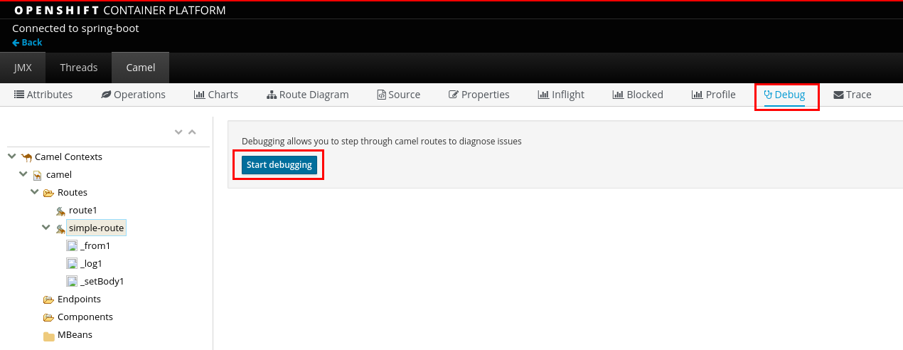

1. Double-click on the **Log** component of the route to set a breakpoint.

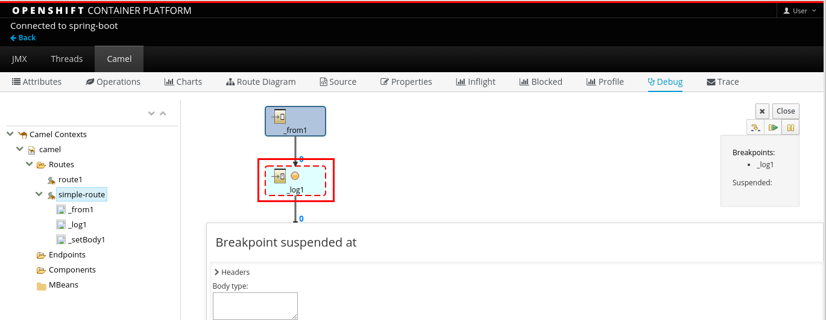

1. Back to JBDS, go to the **Web Service Tester.**
2. Enter the following:
   1. **URL**: [http://lab8-lab8.apps.fis[your](about:blank) instance #].rhcol.com[/lab8](http://lab8-lab8.apps.192.168.99.102.nip.io/lab8)
   2. **Request Headers:** Content-type=application/text
   3. **Request Body:** any text
   4. **Method**:POST
3. Click on the **Invoke** icon.

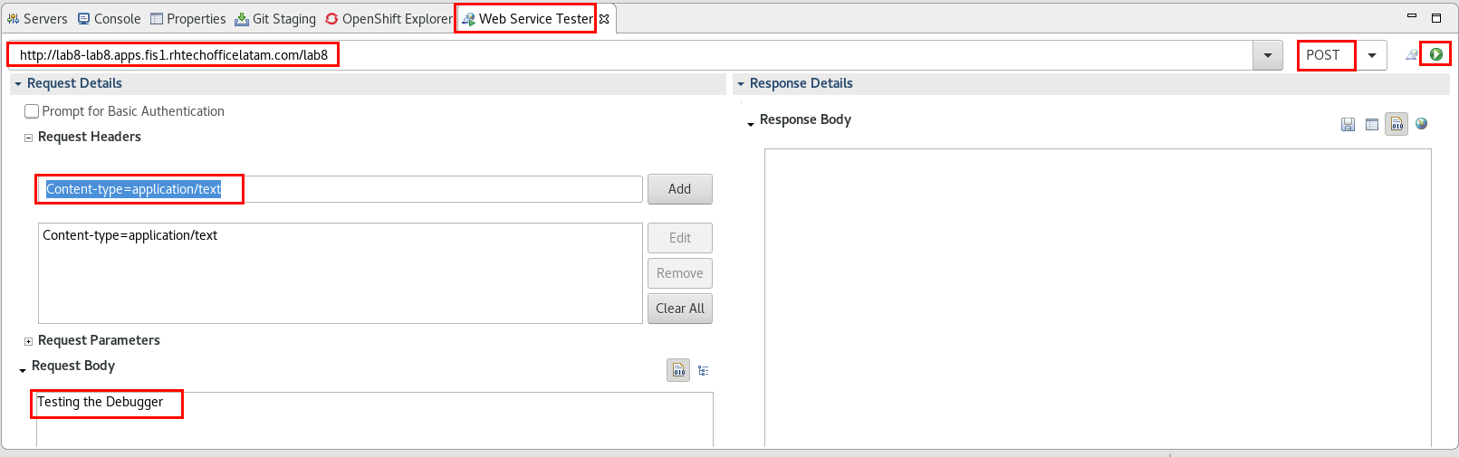

1. Go back to the web browser.

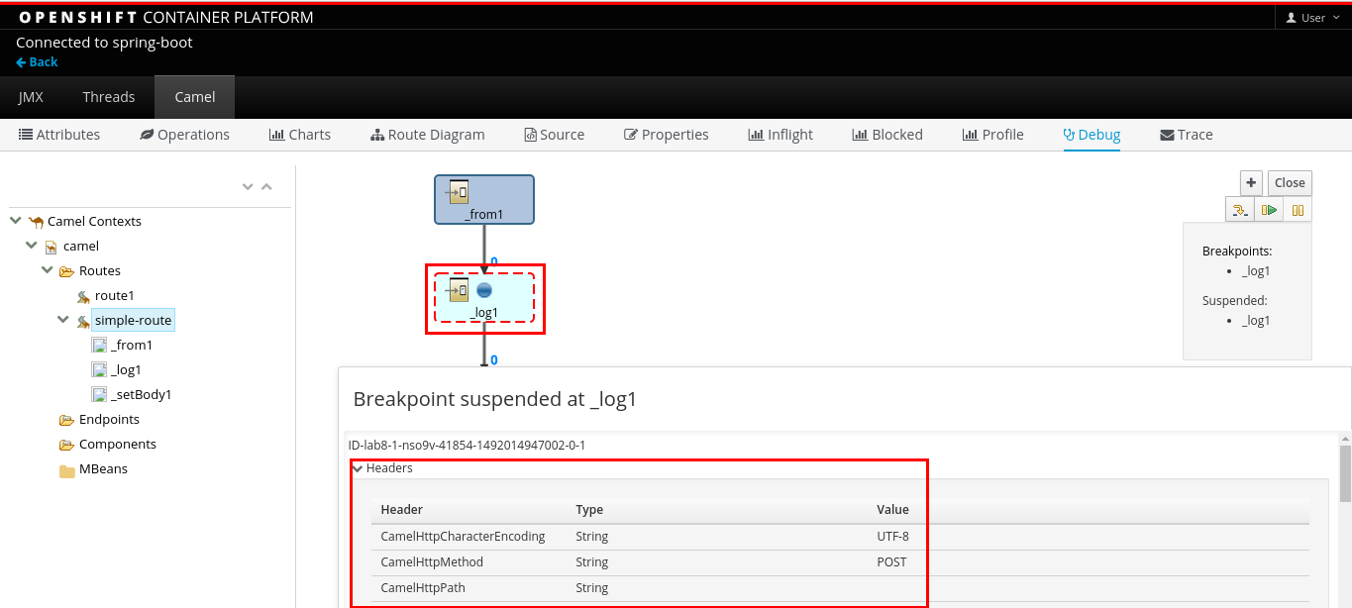

1. Expand the Headers section and review the message content.
2. Click on the **Step into** button.



1. Click on the **Resume** button to let the route continue.



1. Click on the **Close** button to stop the debugger.

# 

# Lab 9 - Circuit Breaker

|  |  |
| --- | --- |
| RH_Icon_Compass_Shiny.png | In this lab you will explore the use of a “Circuit Breaker” in JBoss Fuse, using the Netflix Hystrix EIP, a latency and fault tolerance library designed to isolate points of access to remote systems, services and 3rd party libraries, stop cascading failure and enable resilience in complex distributed systems where failure is inevitable. |

1. Select **File -> Import -> General -> Existing Projects into Workspace**
2. Browse to **FuseWorkshop/support/Lab9** and select **Lab9.zip**
3. Double-click on the **camel-context.xml** file.
4. Click on the **Source** tab.

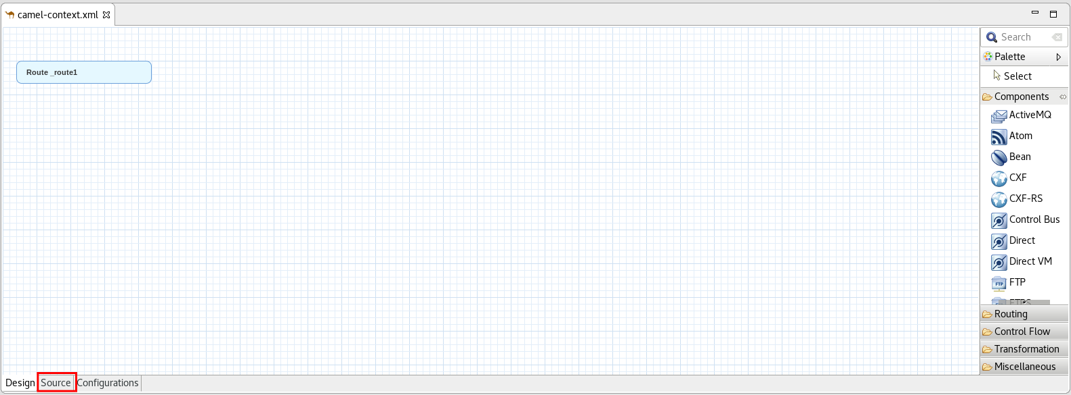

1. Copy and paste the following XML lines before **<camelContext>**.

|  |
| --- |
| <bean  class="org.springframework.boot.context.embedded.ServletRegistrationBean" id="hystrixServletReg">  <property name="name" value="HystrixServlet"/>  <property name="loadOnStartup" value="1"/>  <property name="servlet" >  <bean class="org.apache.camel.component.hystrix.metrics.servlet.HystrixEventStreamServlet" id="hystrixServlet"/>  </property>  <property name="urlMappings" value="/hystrix.stream"/>  </bean> |

1. Copy and paste the following XML lines inside **<camelContext>**

|  |
| --- |
| <restConfiguration component="servlet"/>  <rest path="/">  <get outType="java.lang.String" produces="application/json" uri="/orders/{orderid}">  <to uri="direct:orders"/>  </get>  </rest> |

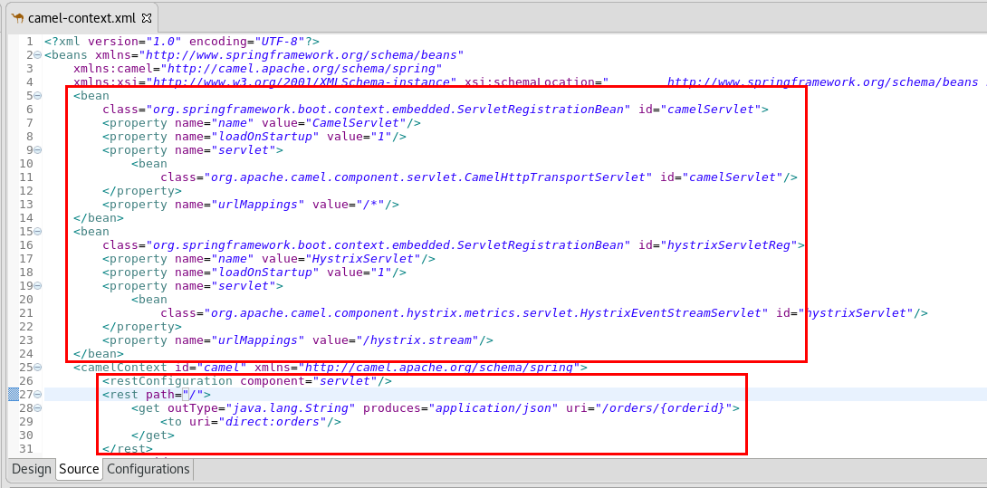

1. Click on the **Design** tab.
2. Drag a **Route** component from the **Routing** palette and drop it into the canvas.
3. Drag a **Direct** component from the **Components** palette and drop it into the **Route**.
   1. **Advanced -> Path:** orders

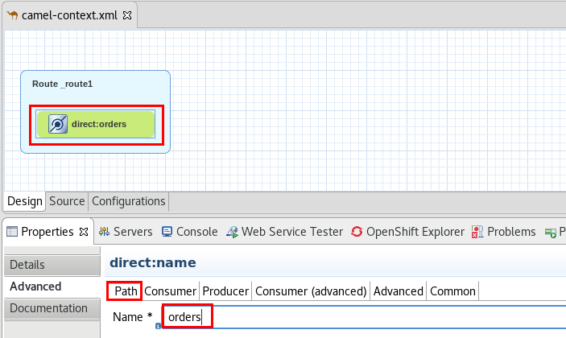

1. Drag a **Hystrix** component from the **Routing** palette and drop it onto the **direct** component.
2. Drag a **OnFallback** component from the **Control Flow** palette and drop it inside the **Hystrix** component.

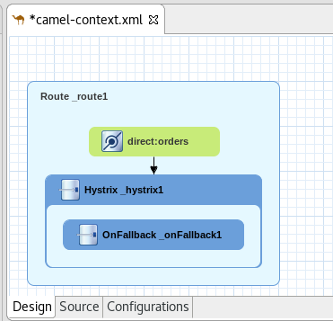

1. Drag a **SetHeader** component from the **Transformation** palette and drop it onto the **Hystrix** component.
2. Click on the **Properties** tab.
   1. **Language:**  simple
   2. **Expression:** orderid=${header.orderid}
   3. **Header Name:** CamelHttpQuery

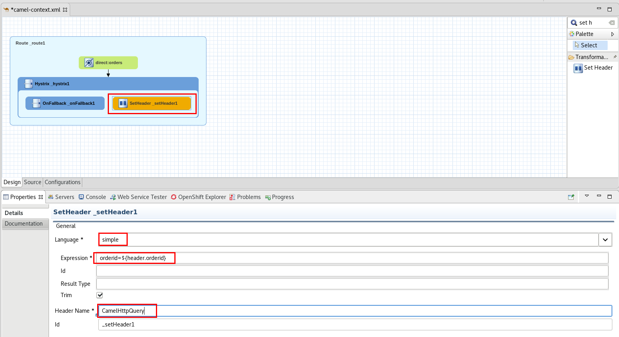

1. Drag a **Netty4HTTP** component from the **Components** palette and drop it onto the **SetHeader** component.
   1. **Advanced->Path->Host:** fis2td-ws.ws.svc.cluster.local
   2. **Advanced->Path->Protocol:** http
   3. **Advanced->Path->Port:** 8080
   4. **Advanced->Common->BridgeEndpoint:** true

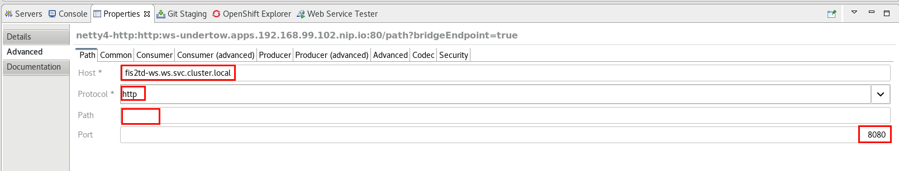

1. Drag a **SetBody** component from the **Transformation** palette and drop it onto the **OnFallback** component.
   1. **Language**: constant
   2. **Expression:** FALLBACK

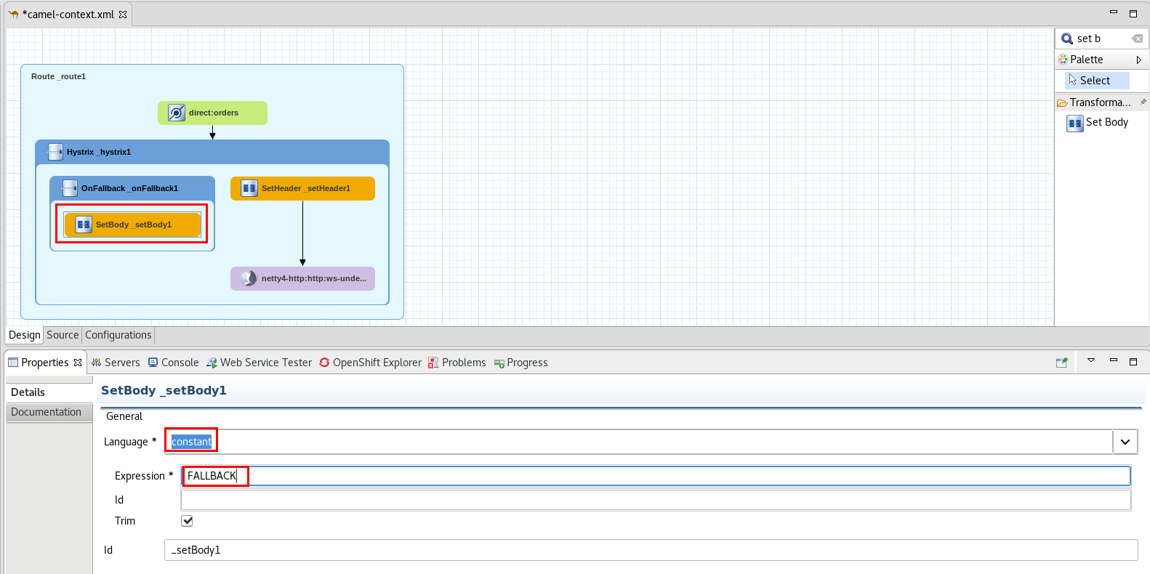

1. Link the **Netty4HTTP** component with the **OnFallback** component.

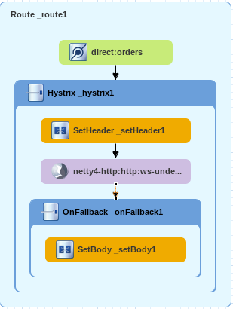

1. Save the file (Ctrl+S).
2. Go to the **OpenShift Explorer** view.
3. Right-Click on the **admin** connection and select  **New -> Project**.
   1. **Project Name**: lab9
   2. **Display Name:** Lab9
   3. **Description:** Lab9 - Circuit Breaker

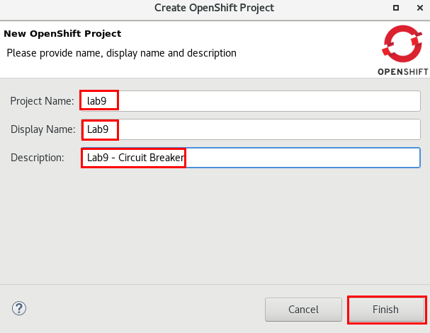

1. Go to the **Project Explorer** view.
2. Right-click on the **Lab9** project and select **Run As -> Run configurations**.
3. Click on the **Maven Builds -> DeployLab9** configuration.
4. Click on the **JRE** tab.
5. Change **-Dkubernetes.master** to match your instance #.
6. Click **Apply.**
7. Click **Run**.
8. When the deploy completes, go to the **OpenShift Explorer** view.
9. Expand **Lab9->lab9**.
10. Right-click on the lab9-xxxx pod and select **Show In -> Web Console**.

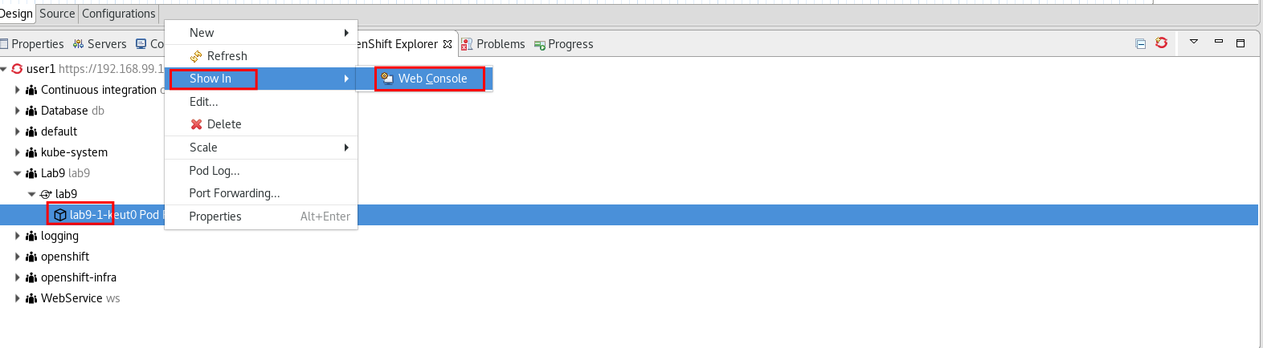

1. Open a new web browser tab and go to [http://lab9-lab9.apps.fis[your instance #].rhcol.com/orders/123](about:blank)
2. It should return a valid json object.
3. Open another web browser tab and go to [http://hystrix-dashboard.fis[your](about:blank) instance #].rhcol.com/hystrix
4. Enter the following values:
   1. **URL:** [http://lab9-lab9.apps.fis[your instance #].rhcol.com](http://lab9-lab9.apps.192.168.99.102.nip.io/orders/123)[/hystrix.stream](http://lab9-lab9.apps.192.168.99.102.nip.io/hystrix.stream)
   2. **Title:** Lab9
5. Click on the **Monitor Stream** button.

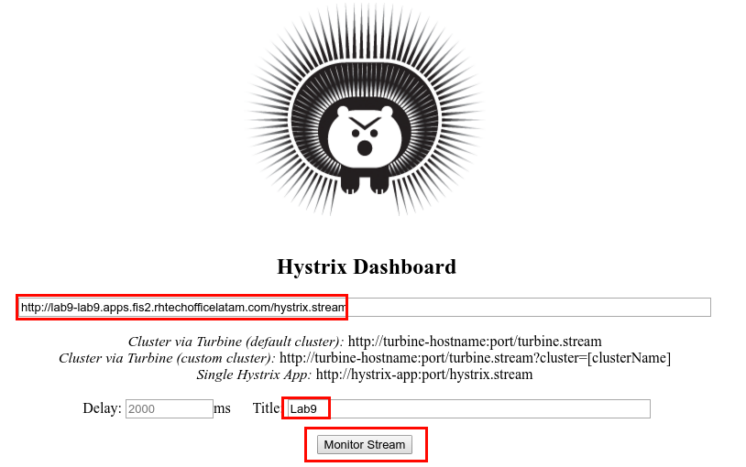

1. Go back to the previous web browser tab ([http://lab9-lab9.apps.fis[your instance #].rhcol.com/orders/123](about:blank)) and refresh it a couple of times.
2. Return to the Hystrix Dashboard’s tab, it should have a **closed circuit** and look like this:

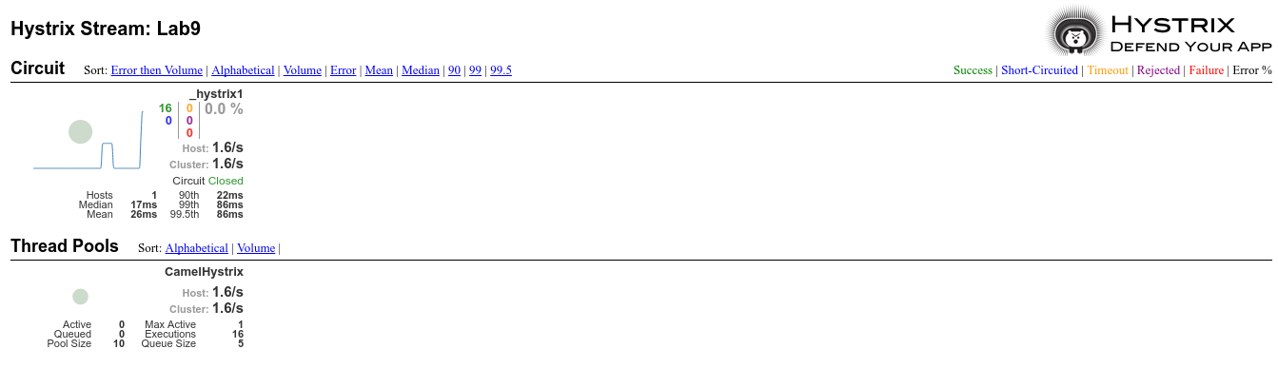

1. Go back to JBDS.
2. Go to the **OpenShift Explorer** view.
3. Expand **Webservice -> fis2td-ws** .
4. Right-Click on the **fis2td-ws** pod and select **Scale -> Down**.
5. Accept the warning.
6. Go back to the web browser and go to [http://lab9-lab9.fis[your instance #].rhcol.com/orders/123](about:blank)
7. Refresh 20 times.
8. Go back to the web browser tab with Hystrix Dashboard.
9. Circuit should be opened.

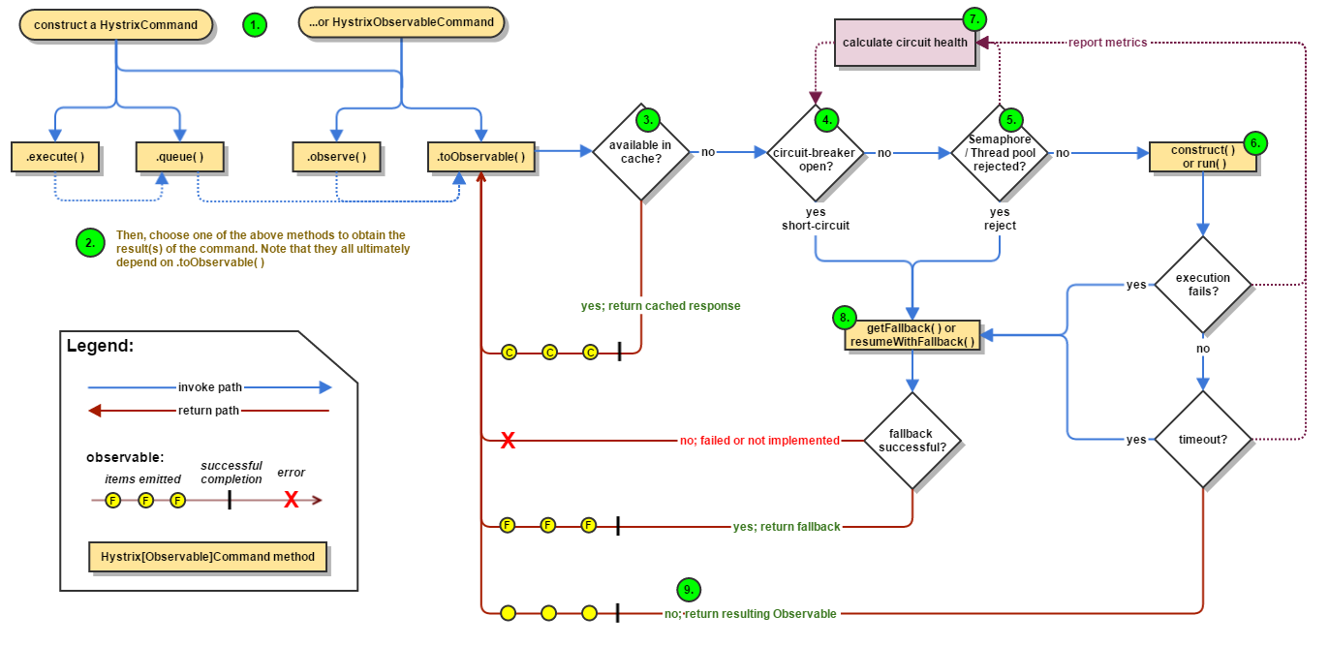

# 

# 

# Lab 10 - Security

|  |  |
| --- | --- |
| RH_Icon_Compass_Shiny.png | In these labs you will learn how to secure the inflight messages by encrypting the payload, securing the transport and enforcing authentication. |

## 10a - Payload Level Security

1. Open JBDS.
2. Click on **File -> Import -> General -> Existing Projects into Workspace**.
3. Browse to **FuseWorkshop/support/Lab10a.zip**.
4. Double-click on the **camel-context.xml** file.
5. Click on the **Source** tab.
6. Copy and Paste the following XML elements beforethe **<camelContext>** element

|  |
| --- |
| <crypt:keystore id="keyStore" location="classpath:keys/keystore.jceks" password="secret" type="JCEKS"/>  <crypt:secretKey alias="shared" id="secretKey" keystore-ref="keyStore" password="secret"/> |

1. Copy and Paste the following XML elements inside the **<camelContext>** element.

|  |
| --- |
| <restConfigPayloaduration component="servlet"/>  <rest path="/lab10">  <get outType="java.lang.String" produces="application/json" uri="/{text}">  <to uri="direct:encrypt"/>  </get>  </rest> |

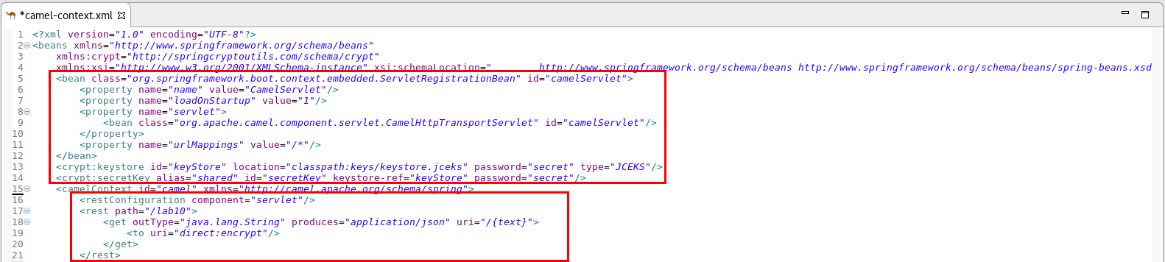

|  |  |
| --- | --- |
| general_info_polished.png | *The KeyStore bean defines the location and characteristics of the key store, while the secretKey bean defines the reference id and characteristics of the key used to encrypt the message payload.* |

1. Click on the **Configurations** tab.
2. Click on the **Add** button.
3. Select **Data Format**.

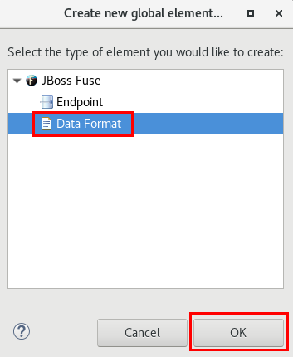

1. Select **crypto** and enter “encrypt” as the **ID**.

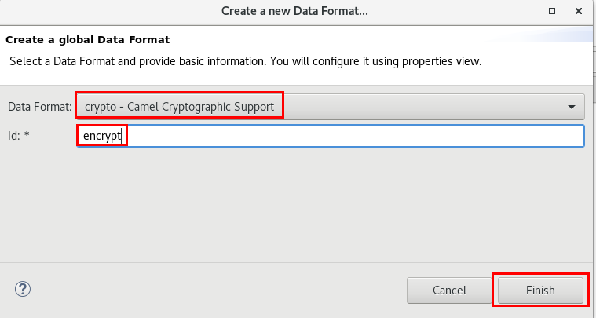

1. Enter the following values:
   1. **Algorithm:** DES
   2. **Key Ref:** secretKey
   3. **Mac Algorithm:** HmacSHA1

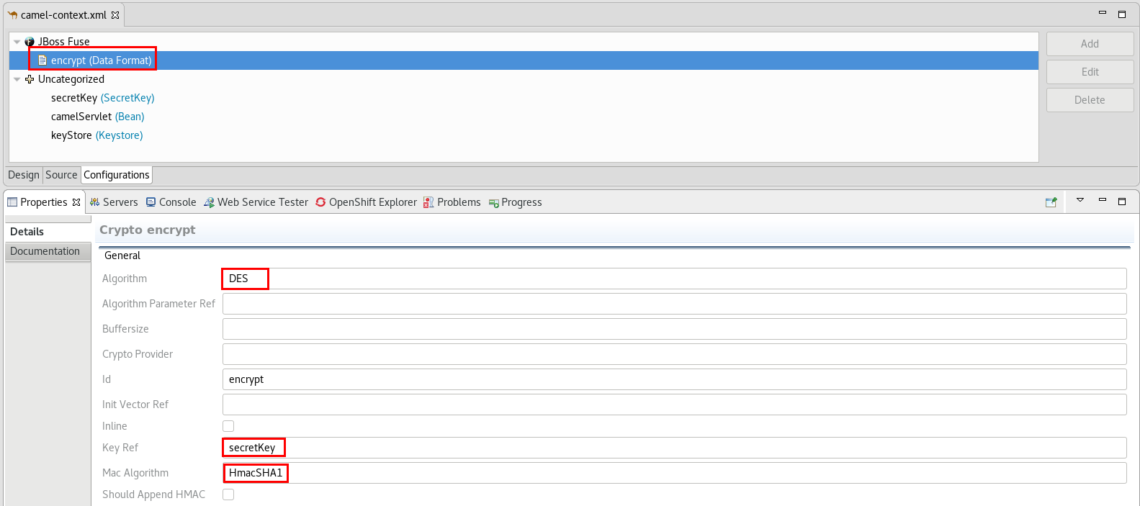

1. Click on the **Design** tab.
2. Drag a **Route** component from the **Route** palette and drop it into the canvas.
3. Drag an **Direct** component from the **Components** palette and drop it into the route.
   1. Edit its properties:
      1. **Advanced -> Path:** encrypt

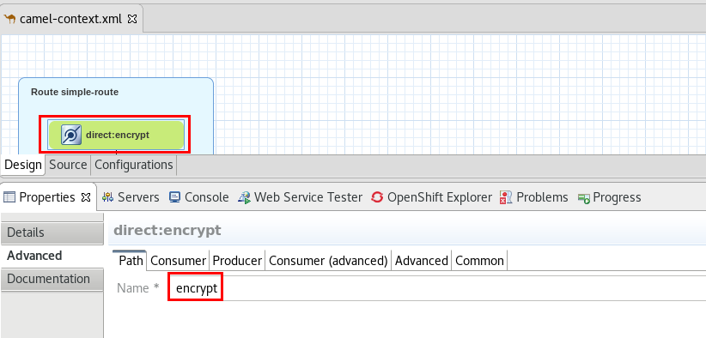

1. Drag a **SetBody** component from the **Transformation** palette and drop it onto the **Direct** component.
   1. **Language:** header
   2. **Expression:** text

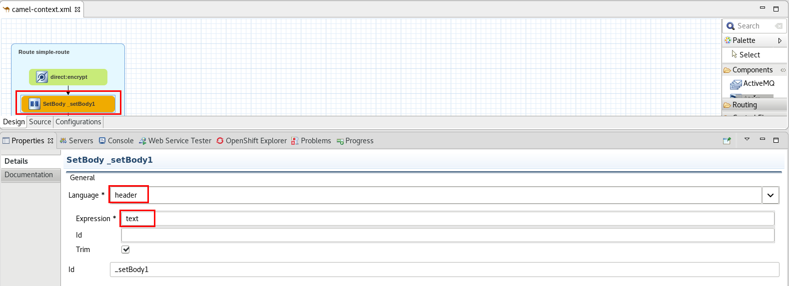

1. Drag a **Marshal** component from the Transformation palette and drop it onto the amq component.
   1. **Ref**: encrypt

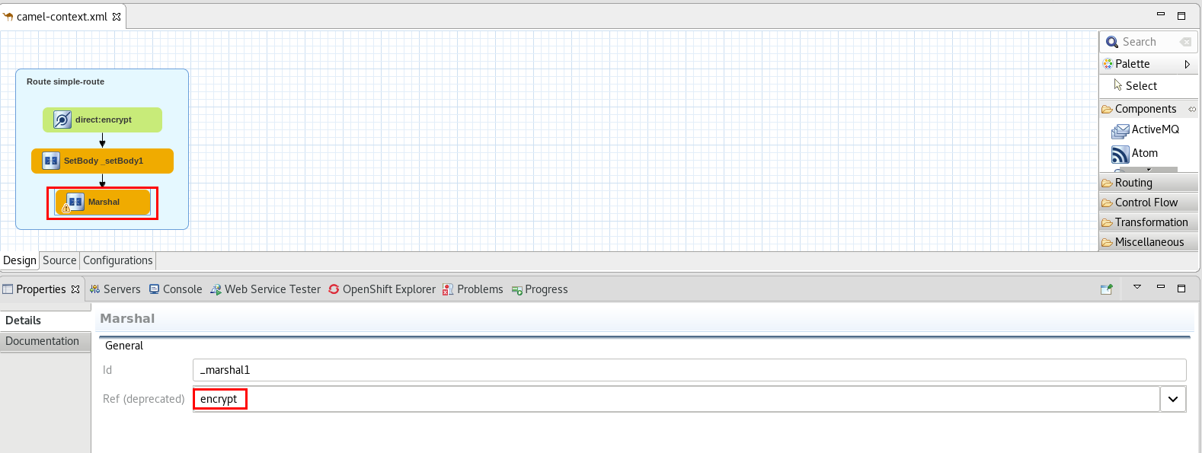

1. Save the file (Ctrl+S).
2. Right-click on the **camel-context.xml** file, **“Run As” -> “Local Camel Context (without tests)”**
3. Go to the **Web Service Tester** view
4. Enter URL: [http://localhost:8080/lab10/test123](http://localhost:8080/lab10/text123)
5. Select **GET** as HTTP Method
6. Click on the **Invoke** icon.

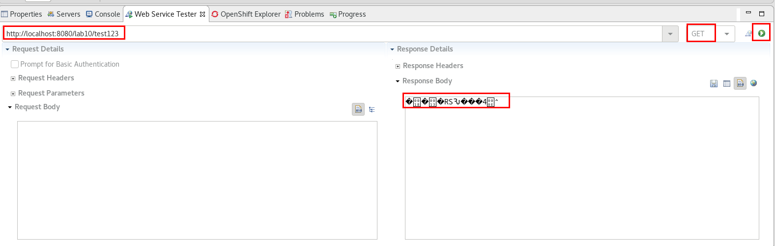

1. You should receive the encrypted text as a result.
2. Stop the Camel route (**console** view).



## 10b - Transport Level Security

1. Click on **File -> Import -> General -> Existing Projects into Workspace**.
2. Browse to **FuseWorkshop/support/Lab10b** and select **Lab10b.zip**.
3. Double-click on **camel-context**.**xml**.
4. Take a look at the defined simple route.
5. Double-click on **application.properties** under **src/main/resources.**
6. Enter the following properties:
   1. **server.port**=8443
   2. **server.ssl.key-store**=classpath:keys/serviceKeystore.jks
   3. **server.ssl.key-store-password**=sspass
   4. **server.ssl.key-password**=skpass
7. Save and close the file (Ctrl+S).

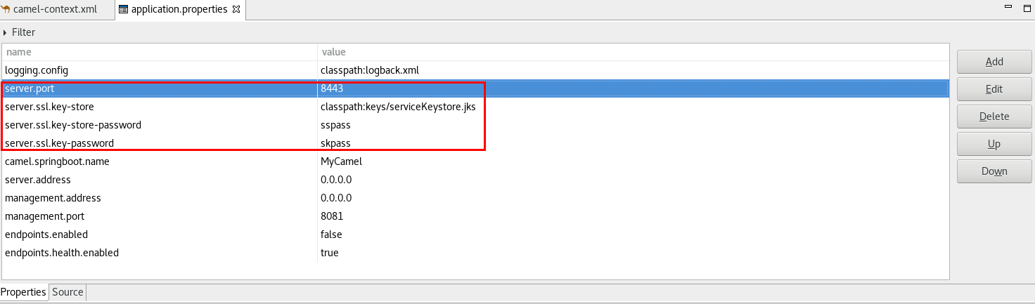

1. Right-click on the **camel-context.xml** file, **“Run As” -> “Local Camel Context (without tests)”**.
2. Open a web browser and go to <https://localhost:8443/lab10/test123>
3. Add the security exception for the untrusted SSL Certificate.
4. You should receive a successful response.
5. Stop the Camel route (**console** view).



## 10c - Authentication

1. Click on **File -> Import -> General -> Existing Projects into Workspace**.
2. Browse to **FuseWorkshop/support** and select **Lab10c.zip.**
3. Double-click **camel-context.xml** file.
4. Take a look at the defined simple route.
5. Double-click on the **application.properties** file under **src/main/resources** folder.
6. Add the following property:
   1. **security.user.password**=password

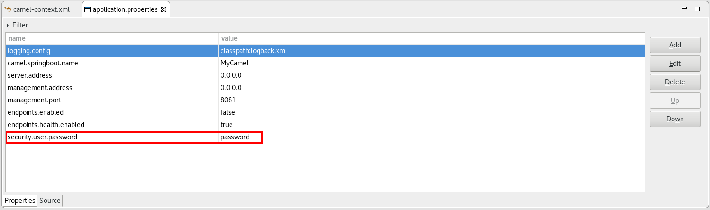

1. Right-Click on the **camel-context.xml** file and **Run As -> Local Camel Context (without tests)**.
2. Open a web browser and go to <http://localhost:8080/camel/lab10/test123>.
3. Login with
   1. **User:** user
   2. **Password:** password

# 

# 

# Lab 11 - Continuous Integration / Continuous Delivery

|  |  |
| --- | --- |
| RH_Icon_Compass_Shiny.png | In these labs you will use CI/CD to build and deploy a Fuse project.  Continuous Integration (CI) is a development practice that requires developers to integrate code into a shared repository several times a day. Each check-in is then verified by an automated build, allowing teams to detect problems early. By integrating regularly, you can detect errors quickly, and locate them more easily.  Continuous delivery (CD) is a software engineering approach in which teams produce software in short cycles, ensuring that the software can be reliably released at any time.It aims at building, testing, and releasing software faster and more frequently. The approach helps reduce the cost, time, and risk of delivering changes by allowing for more incremental updates to applications in production. A straightforward and repeatable deployment process is important for continuous delivery. |

1. In JBDS, click **File -> Import -> Git -> Projects from Git.**
2. Select **Clone URI** and click **Next**.
3. Enter
   1. **URI:**[http://gogs.fis[your instance #].rhcol.com/user1/lab11.git](http://gogs.apps.192.168.99.102.nip.io/user1/lab11.git)
   2. **User:** user1
   3. **Password:** user1

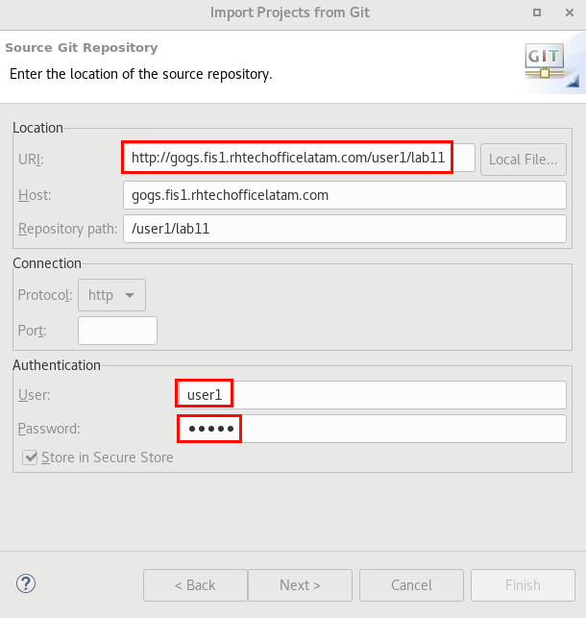

1. Click **Next.**
2. Click **Next.**
3. Click **Next.**
4. Verify that **Lab11** is in the list of projects to be imported.

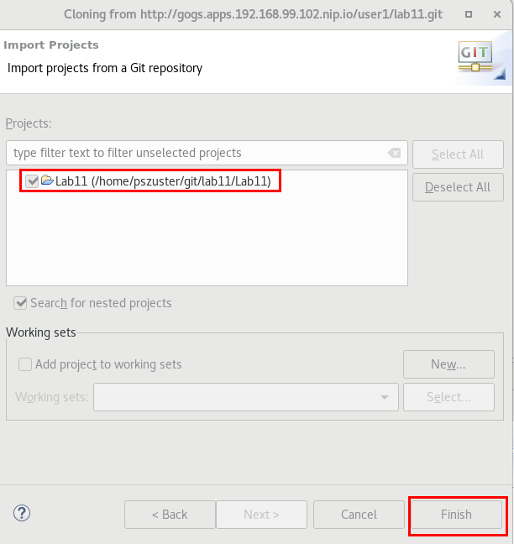

1. Take a look at the Lab11 project (**camel-context.xml**, **application.properties**).
2. It contains a simple REST route which returns a message with the received query parameter.
3. Go to the **OpenShift Explorer** view.
4. Right-click on the **admin** connection and select **New -> Project.**
5. Enter the following values:
   1. **Project Name:** lab11
   2. **Display Name:** Lab11
   3. **Description:** Lab11 - CICD
6. Click **Finish.**

**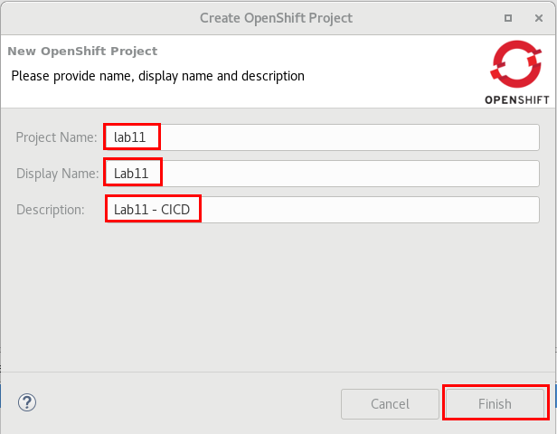**

1. Right-click on **Lab11** and select **New -> Application**.
2. Click on the **Browse** button next to **Eclipse Project** and select **Lab11**.
3. Click on the **Custom Template** tab.
4. Click on the **Browse File System** button.
5. Select **FuseWorkshop/support/Lab11/lab11\_template.json**.

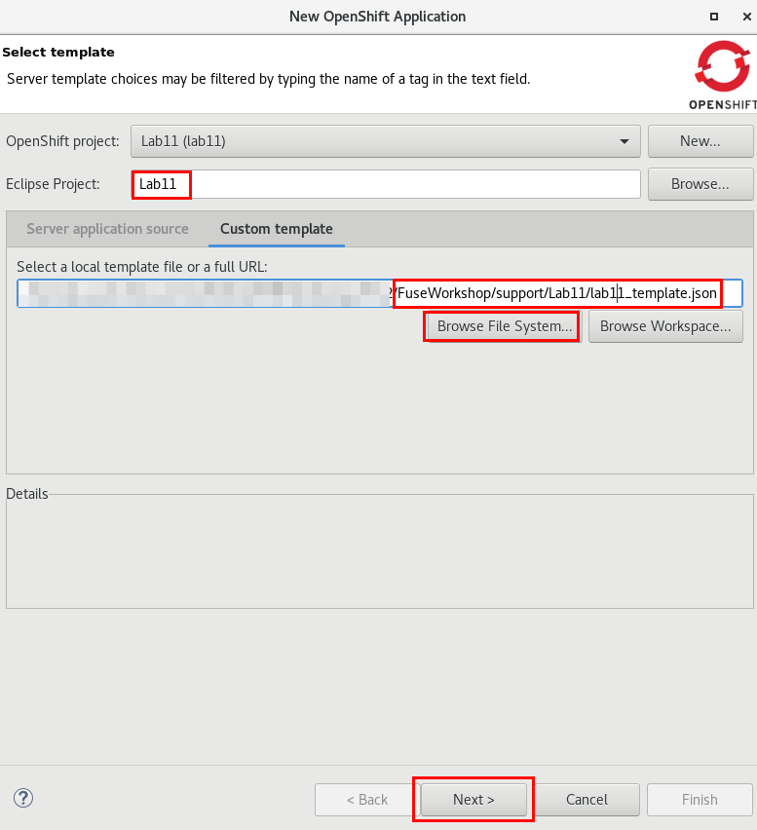

1. Click **Next**.
2. Enter **GIT\_CONTEXT\_DIR:** Lab11.

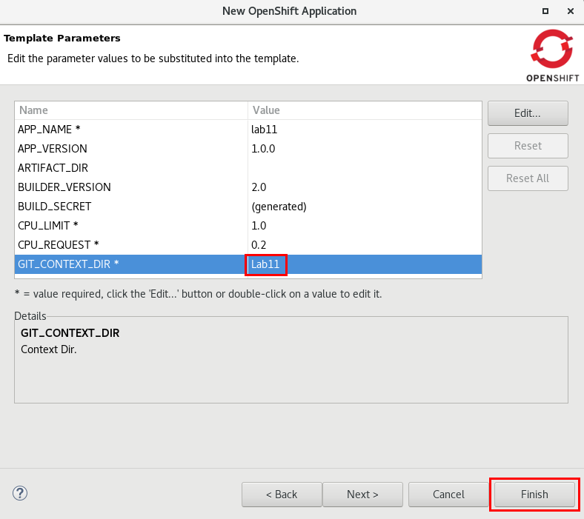

1. Click **Finish**.
2. Click **Ok.**
3. After the build & deployment is finished, open a web browser and go to [http://lab11-lab11.apps.fis[your instance #].rhcol.com/lab11/123](about:blank).
4. Go back to JBDS.
5. Right-Click on the **Lab11** project and select  **New -> Resource.**
6. Click on the **Browse File System** button and select **FuseWorkshop/support/Lab11/development-pipeline.json**.
7. Click **OK**.
8. Right-Click on the **Lab11** project and select **Show In -> Web Console**.
9. Click on **Builds -> Pipelines**.
10. Click on the **lab11-development-pipeline** link.

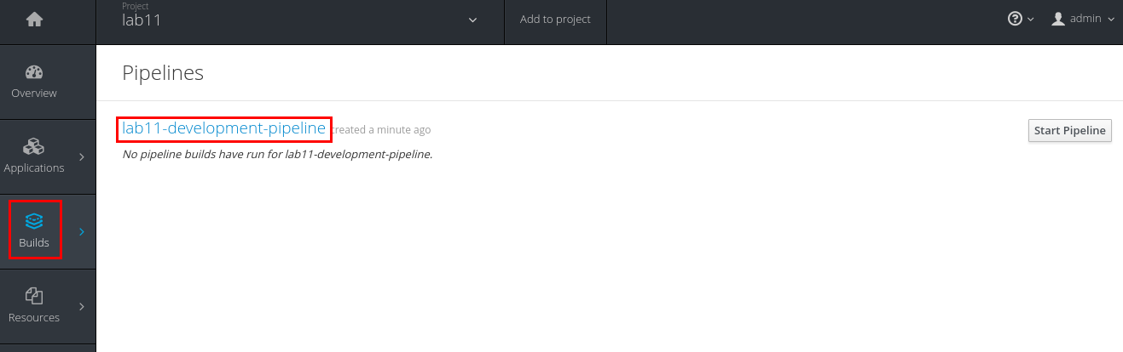

1. Click on the **Configuration** tab.
2. Click on the **Copy to Clipboard** icon next to **GitHub Webhook URL**.

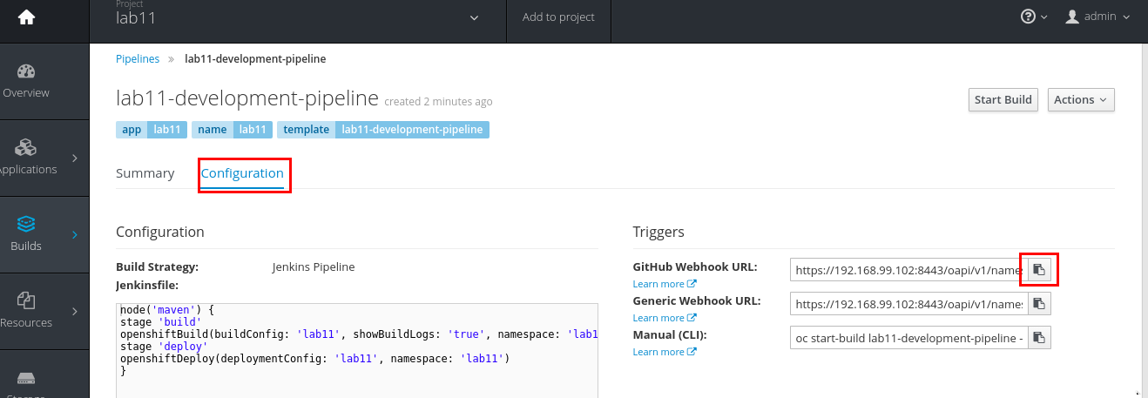

1. Open a new web browser tab and go to [http://gogs.fis2.rhcol.com/user1/lab11](http://gogs.fis2.rhtechofficelatam.com/user1/lab11)
2. Login as **user1**/**user1**.
3. Click on the **Settings** button.

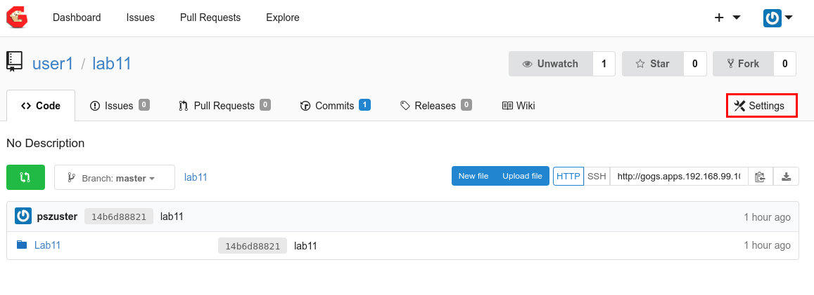

1. Click on the **Webhooks** link.
2. Click on the **Add Webhook** button and select **Gogs**.

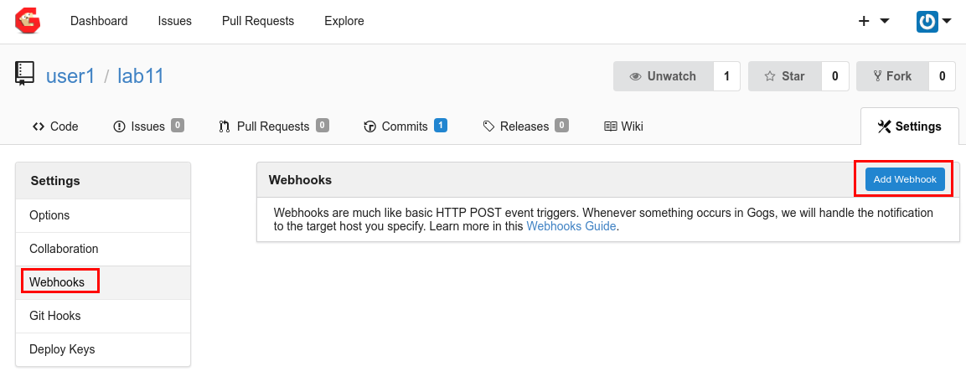

1. Paste the GitHub Webhook URL in the **Payload** field.
2. Click on the **Add Webhook** button.

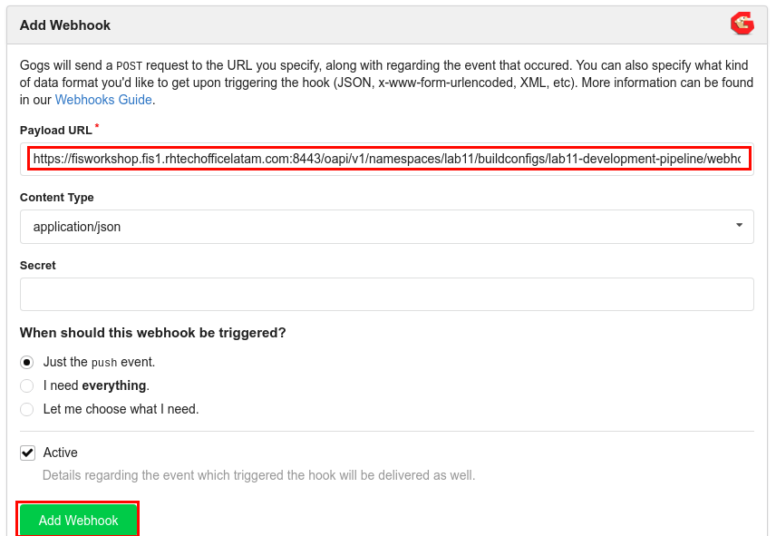

1. Go back to JBDS.
2. Go to the **Project Explorer** view and expand **Lab11**.
3. Double-click on the **camel-context.xml** file.
4. Click on the **SetBody** component.
5. Click on the **Properties** tab.
6. Change the **Expression** to: You sent this text: "${header.text}" - Lab11.

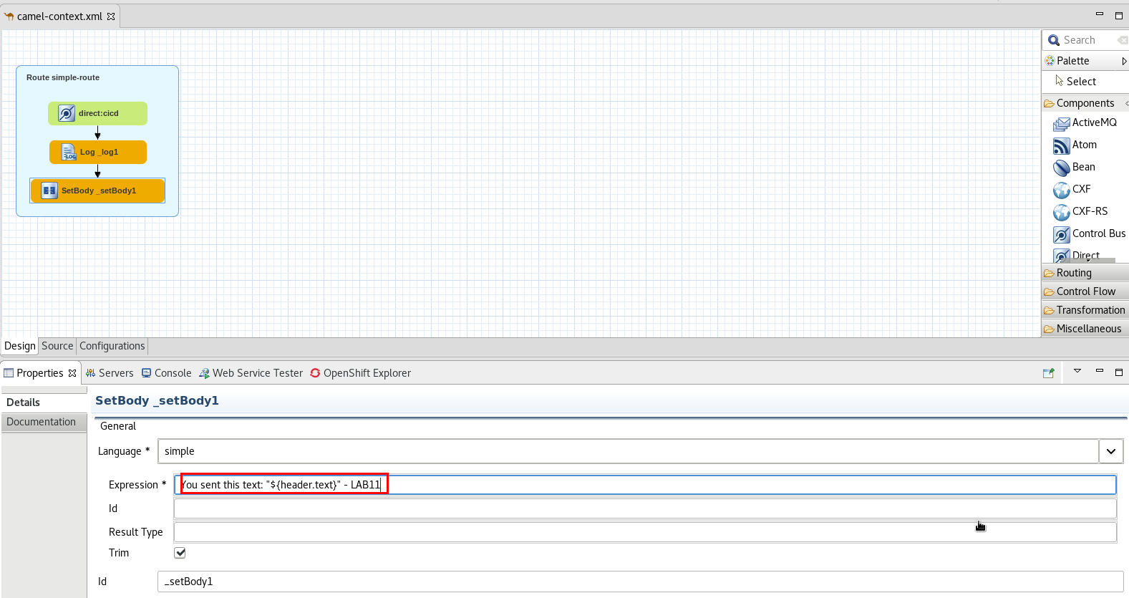

1. Save the file (Ctrl+S).
2. Go to the **Project Explorer** view.
3. Right-click on the **Lab11** project and select **Team -> Commit.**
4. Select the **unstaged changes,** right-click and select **Add to index**.

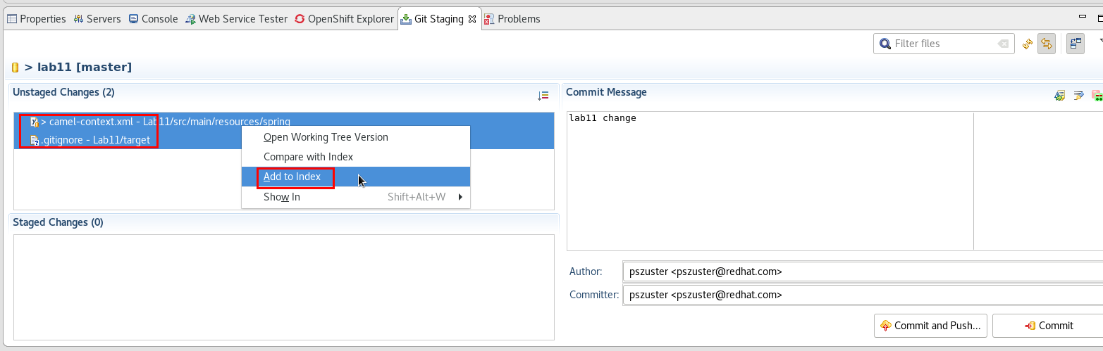

1. Enter some commit message and click **Commit and Push**.

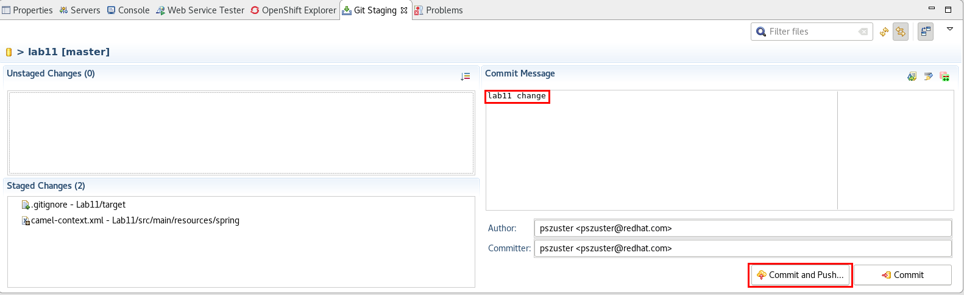

1. Click **OK**.
2. Go to the **OpenShift Explorer** view.
3. Right-click on the **Lab11** project and select **Show In -> Web Console**.
4. Select **Builds -> Pipelines**.
5. The created development-pipeline should be executing the stages of the defined pipeline.

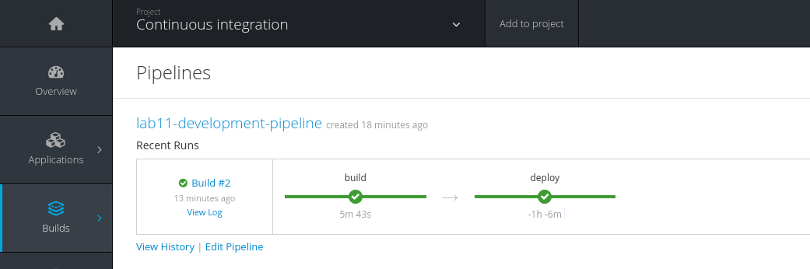

1. Once it finishes, you can access [http://lab11-lab11.apps.fis[your](about:blank) instance #].rhcol.com/[lab11/123](http://lab11-lab11.apps.192.168.99.102.nip.io/lab11/123) and validate the changed version is working.

# 

# Lab 12 - Testing

|  |  |
| --- | --- |
| RH_Icon_Compass_Shiny.png | In these labs you will configure a testing pipeline for a Fuse project. |

1. In JBDS, click **File -> Import -> Git -> Projects from Git.**
2. Select **Clone URI** and click **Next**.
3. Enter
   1. **URI:**[http://gogs.fis[your](about:blank) instance #].rhcol.com/user1/lab12[.git](http://gogs.apps.192.168.99.102.nip.io/user1/lab12.git)
   2. **User:** user1
   3. **Password:** user1

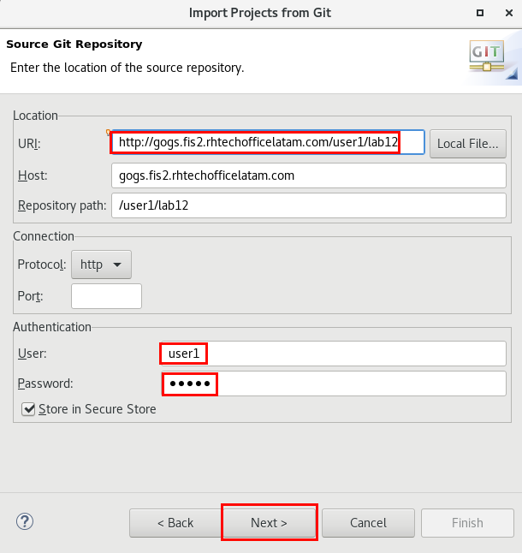

1. Click **Next.**
2. Click **Next.**
3. Click **Next.**
4. Verify that **Lab12** is in the list of projects to be imported.

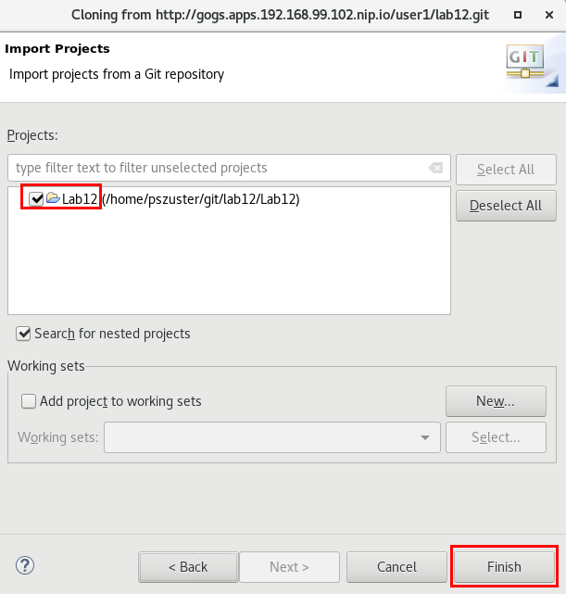

1. Take a look at the Lab12 project (**camel-context.xml**, **application.properties**).
2. It contains a simple REST route which returns a hardcoded message.
3. Right-Click on the **com.redhat.Lab12** packageunder **src/test/java/** and select **New -> Camel Test Case**.

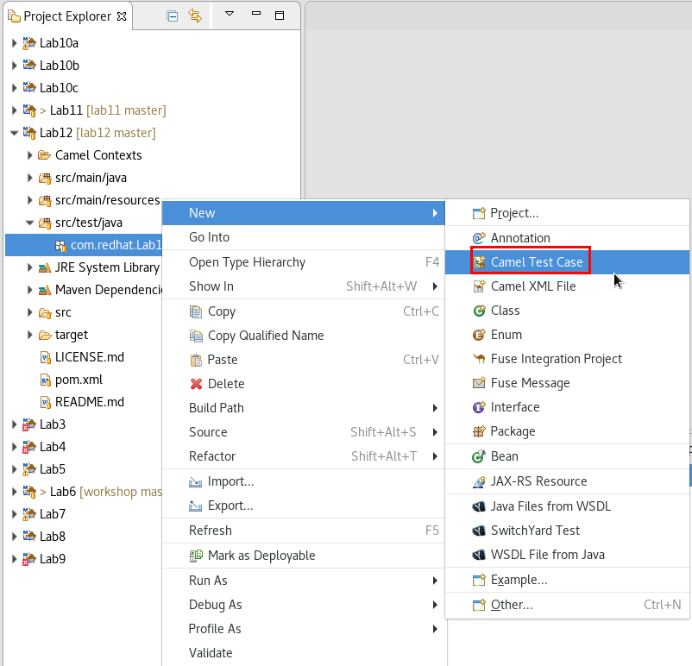

1. Click on the **Browse** button to search for the **Camel XML file under test**.
2. Select **camel-context.xml**.
3. Click **Finish**.

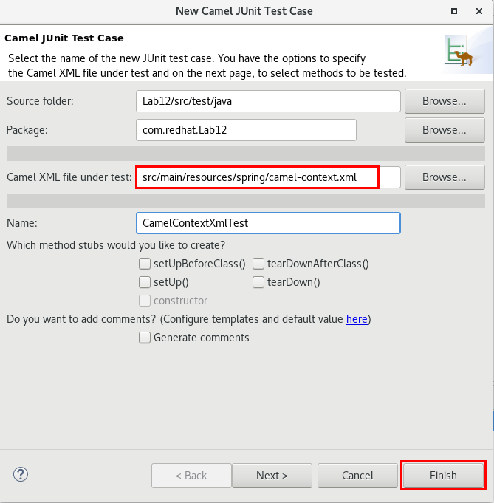

1. The java class file with the pre-built test cases will be opened.
2. Look for the **testCamelRoute** method.
3. Replace its contents with the following lines of code:

|  |
| --- |
| String resp = (String) inputEndpoint.requestBody("");  assertStringContains(resp, "Hi thereNOT"); |

1. It should look like this:

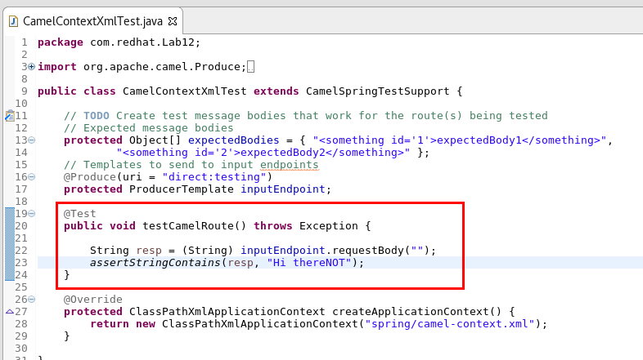

1. Save the file (Ctrl+S).
2. Right-click on **CamelContextXmlTest.java** under **src/test/java/com.redhat.Lab12** and select **Team -> Add to Index**.
3. Right-Click on the **Lab12** project and select **Team -> Commit**.
4. Enter some text in the **Commit Message** field and click on the **Commit and Push** button.

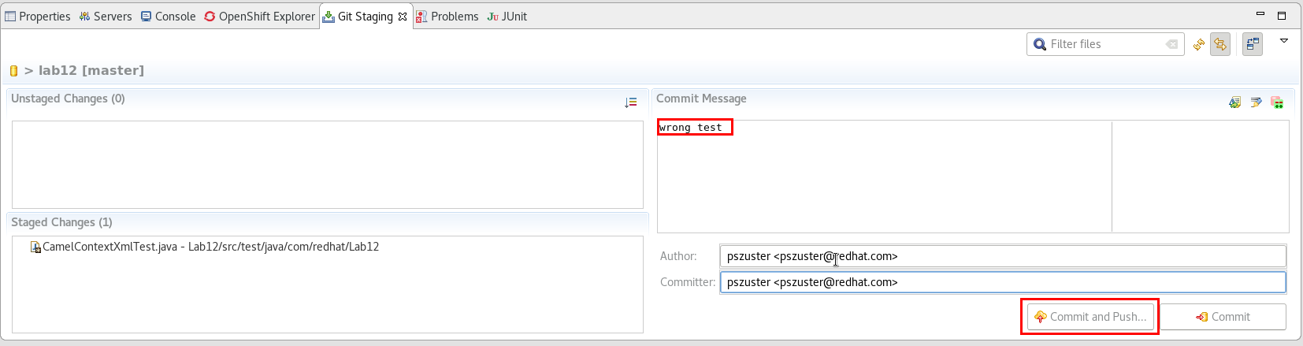

1. Click **Ok**.
2. Go to the **OpenShift Explorer** view.
3. Right-click on the **admin** connection and select **New -> Project.**
4. Enter the following values:
   1. **Project Name:** lab12
   2. **Display Name:** Lab12
   3. **Description:** Lab12 - Testing
5. Click **Finish.**

**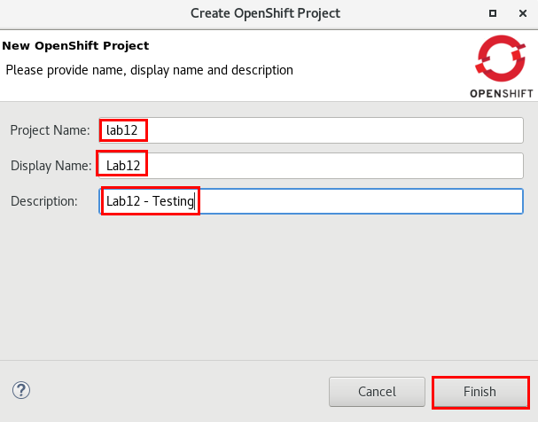**

1. Right-Click on the **Lab12** project and select **New -> Application**.
2. Click on the **Browse** button next to **Eclipse Project** and select **Lab12**.
3. Click on the **Custom Template** tab.
4. Click on the **Browse File System** button and select **FuseWorkshop/support/Lab12/lab12\_template.json**
5. Click **Next**.
6. Set **GIT\_CONTEXT\_DIR** to **Lab12.**
7. Click **Finish**.

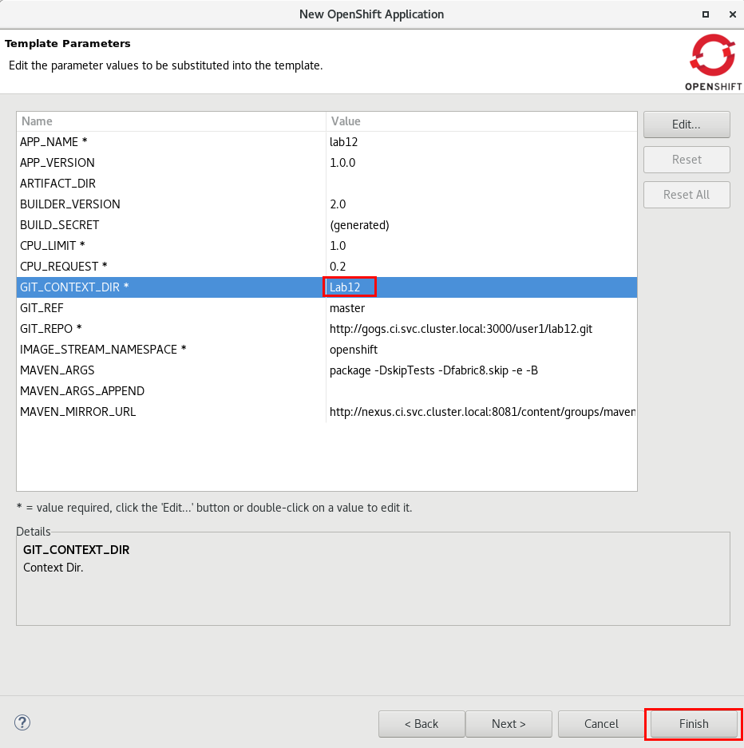

1. Click **OK**.
2. The created application contains a Build Config, Deployment config, service and route, but it won’t start any build/deployment (this is intended).
3. Right-click on the **Lab12** project and select **New -> Resource.**
4. Click on the **Browse File System** button and select **FuseWorkshop/support/Lab12/testing-pipeline.json.**
5. Click **OK**.
6. This will create a jenkins pipeline and therefore create a jenkins master pod configured to run it.
7. Right-Click **Lab12** and select **Show In -> Web Console.**
8. Select **Builds -> Pipelines**.
9. Click on **lab12-testing-pipeline**.

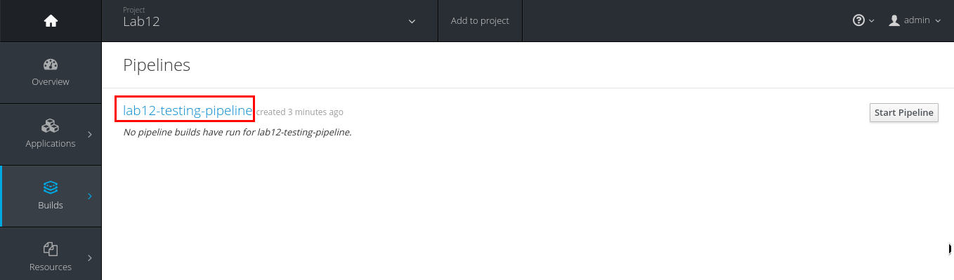

1. Click on the **Configuration** tab.

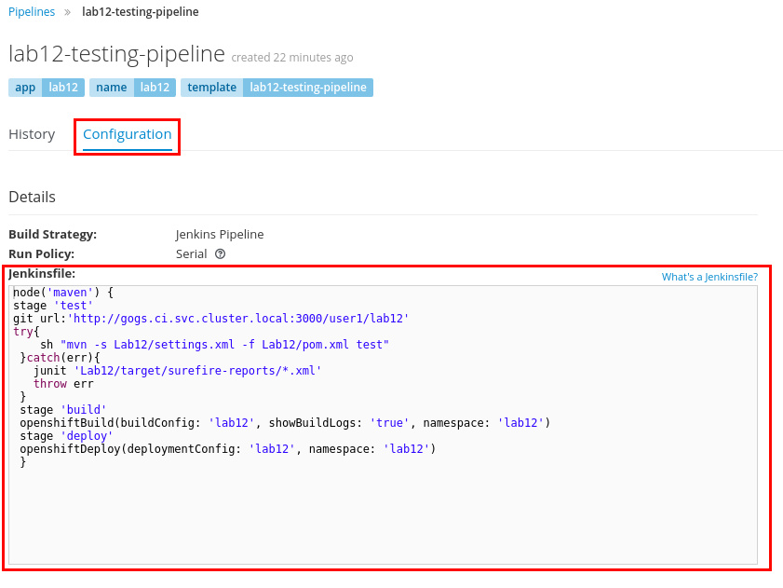

1. Take a look at the pipeline steps:

|  |
| --- |
| 1. Test stage:    1. Grab the code from Gogs.    2. Perform a maven test.    3. In case of error, save junit test results. 2. Build Stage:    1. Start an Openshift build of lab12. 3. Deploy Stage:    1. Start an Openshift deployment of lab12. |

1. Go back to the pipelines list and click on the **Start Pipeline** button.

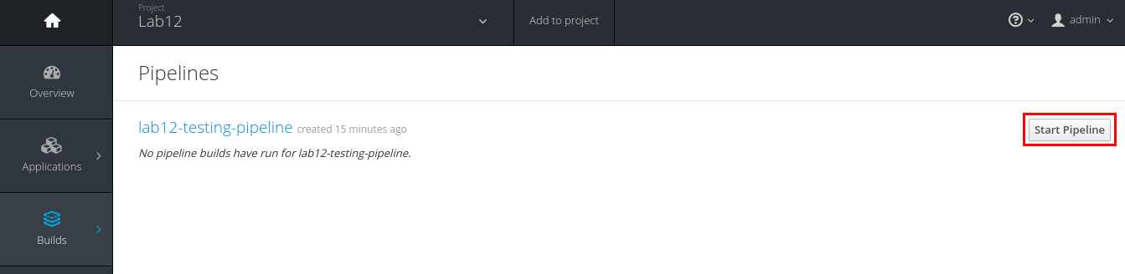

1. Click on the **View Log** link under the new **Build.**

**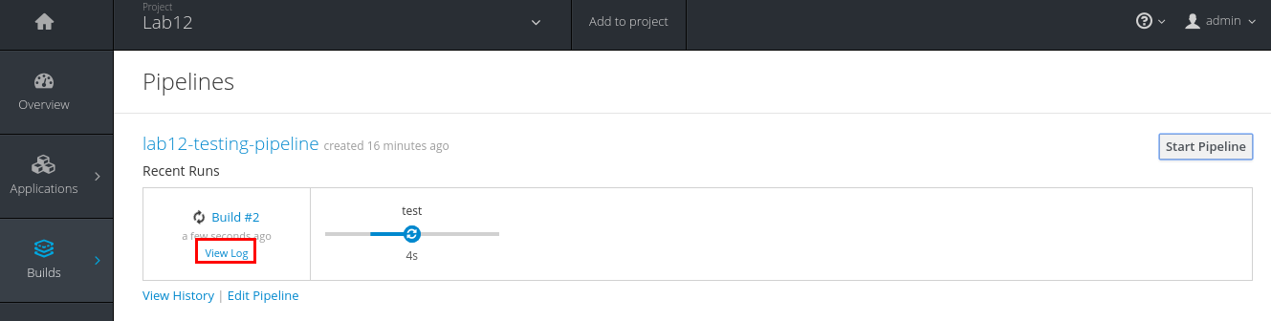**

1. Click on the **Login with Openshift** button.
2. Login as admin/admin.
3. Click on the **Allow selected Permissions** button.
4. Click on the **Open Blue Ocean** button to see the new jenkins UI.

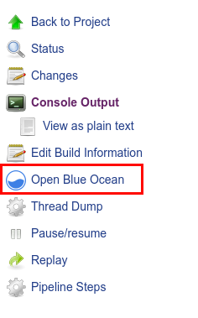

1. After ~2min the pipeline should fail, because of the failed test.
2. Click on the **Tests** tab.

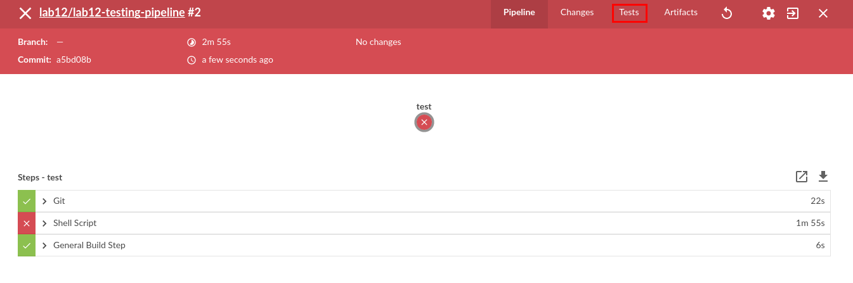

1. Expand the existing failure to display the failed test.

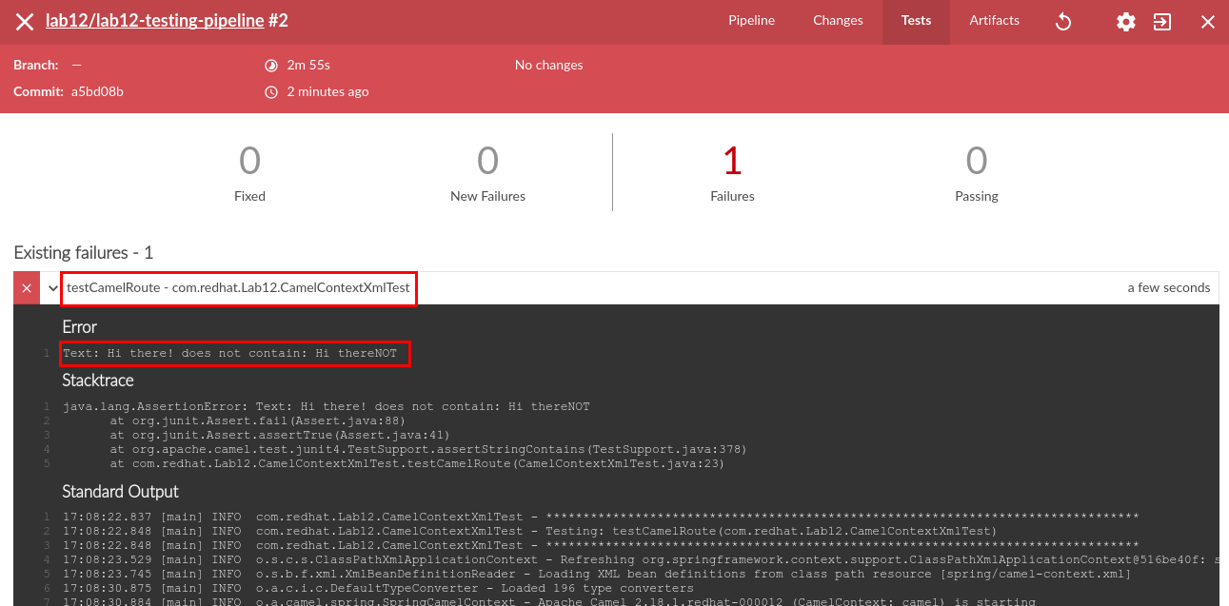

1. Close the web browser tab.
2. Now go back to JBDS to fix the test case.
3. Double-click on the **CamelContextXmlTest.java** file under **src/test/java**.
4. Change the assertion to the correct expected text:

|  |
| --- |
| assertStringContains(resp, "Hi there"); |

1. The fixed test case should look like this:

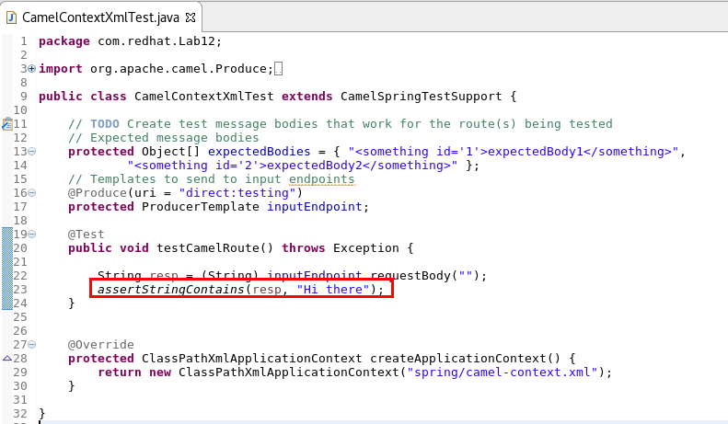

1. Right-Click on the **CamelContextXmlTest.java** file and select **Team -> Add to Index.**
2. Right-Click on the **CamelContextXmlTest.java** file and select **Team -> Commit**.
3. Enter “correct test” as the **Commit Message**.
4. Click on the **Commit and Push** button.

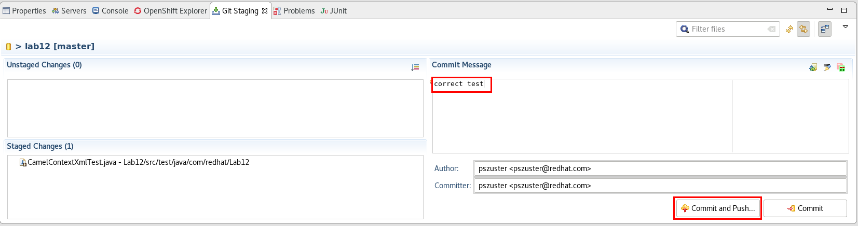

1. Click **OK**.
2. Go back to the web browser, to the **Lab12** project.
3. Click on **Builds -> Pipelines**.
4. Click on the **Start Pipeline** button.
5. Click on the **View Log** link under the new **Build**.
6. Click on the **Open Blue Ocean** button.
7. After ~2min the test should pass with no errors, and the pipeline should start a build (~5min) and deployment (~1min) of a container to Openshift.

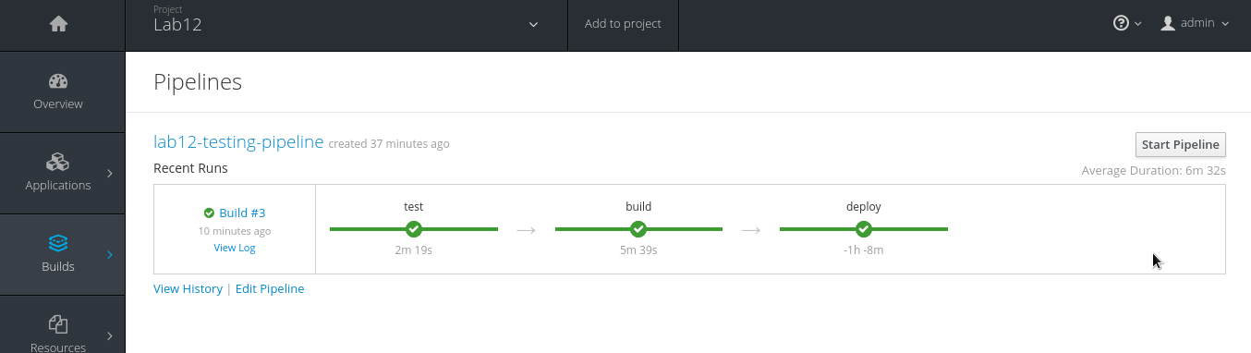

## 

# Lab 13 - Scalability

## Part A - High Availability

|  |  |
| --- | --- |
| RH_Icon_Compass_Shiny.png | In this lab you will test Openshift HA capabilities for Fuse. |

1. Go to the **OpenShift Explorer** view.
2. Right-click on the **admin** connection and select **New -> Project**.
3. Enter the following values:
   1. **Project Name:** lab13
   2. **Display Name:** Lab13
   3. **Description:** Lab13 - High Availability
4. Click **Finish**.

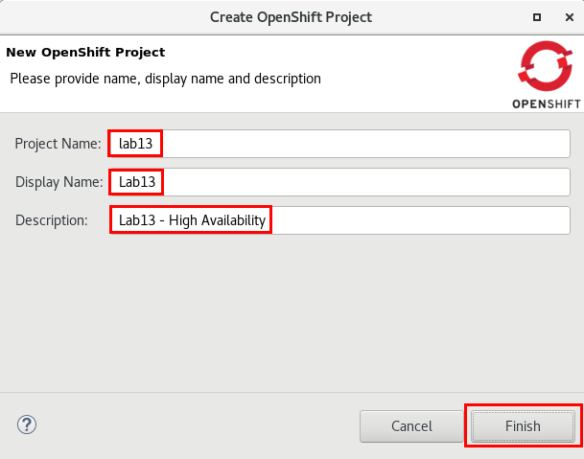

1. Go to the **Project Explorer**.
2. Click on the menu **File->Import..**
3. Select **General-**> “**Existing Project into Workspace**” and click Next.
4. Click on “**Select** **archive file**” and browse to **~/FuseWorkshop/support/Lab13/Lab13.zip**
5. Click **Finish.**
6. Expand **src -> main -> fabric8** folders (below **Maven Dependencies)**.
7. Double-click on **deployment.yml**.

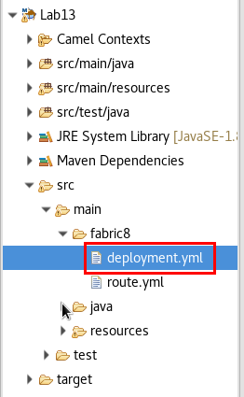

1. Change the number of replicas from 1 to **2**.
2. Save the file (Ctrl+S).

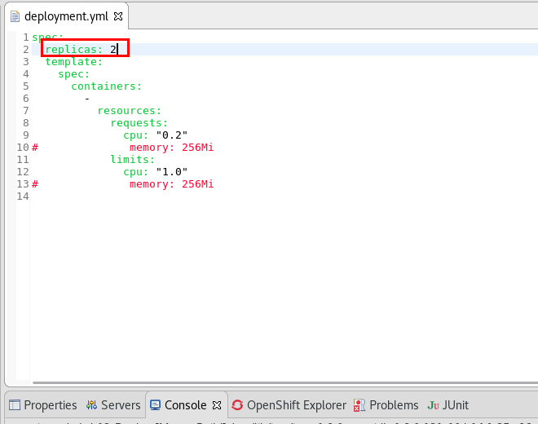

1. Right-Click on the **Lab13** project and select **Run As -> Run Configurations..**
2. Select  **Maven Build -> Lab13-Deploy**.
3. Click on the **JRE** tab.
4. Correct **-Dkubernetes.master** to match your instance #.
5. Click **Apply.**
6. Click on the **Run** button.
7. Open a web browser and go to [https://fisworkshop.fis[your instance #].rhcol.com:8443/console/project/lab13/overview](about:blank)
8. After ~2min the deployment should have finished, resulting in 2 copies of the container running:

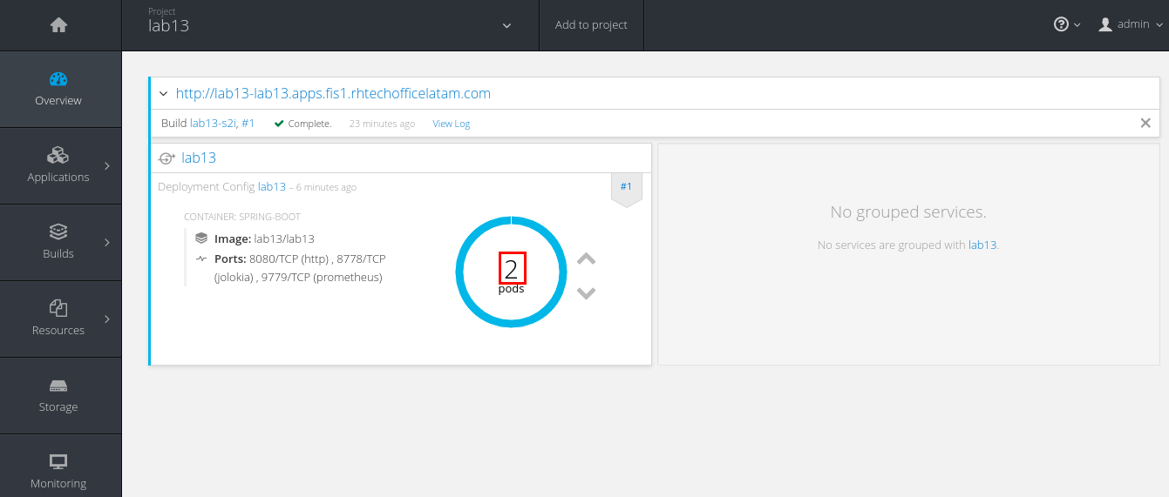

1. Click on the **2** inside the blue circle.
2. Click on any of the two running pods.

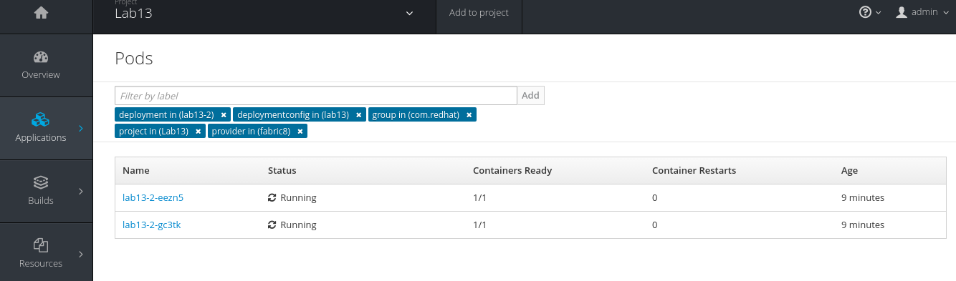

1. Click on the **Actions** button and select **Delete.**

**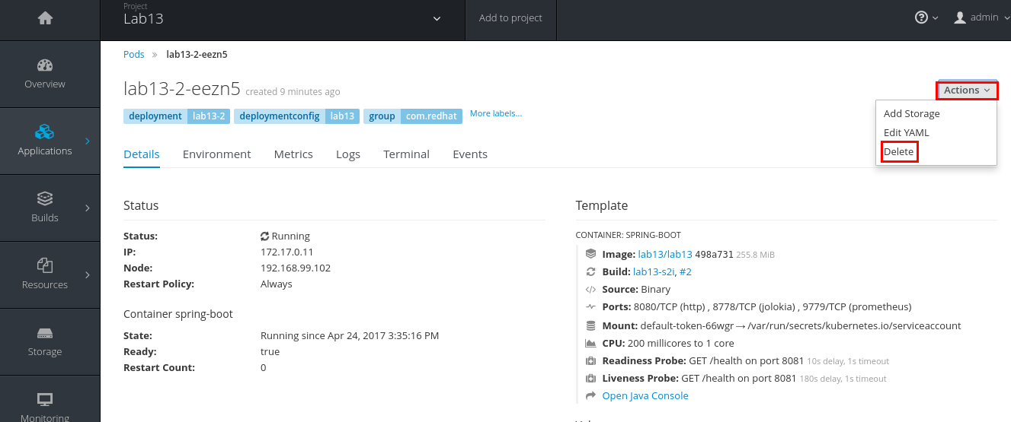**

1. Click on the **delete** button to confirm.

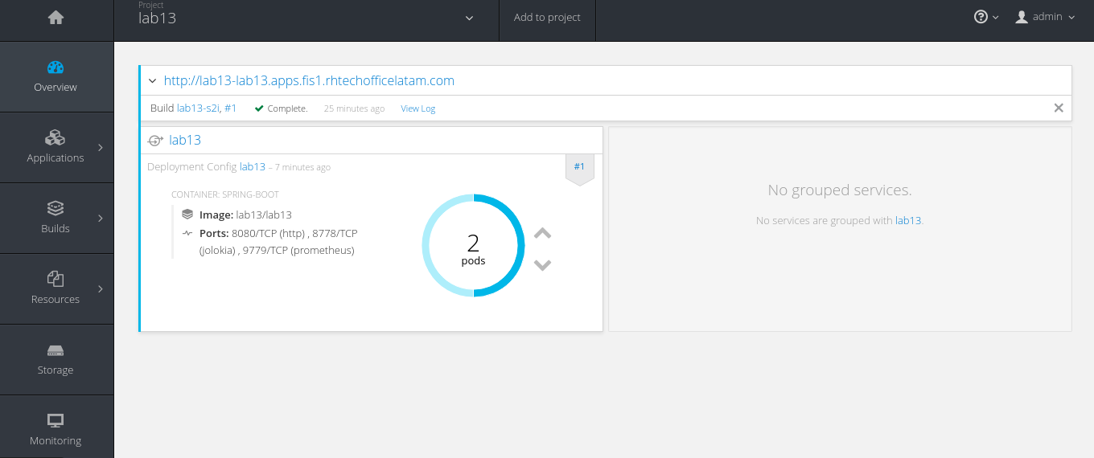

1. OpenShift will detect there is one pod less than the minimum defined (two) and will create a new copy of the pod.

## Part B - Load Balancing

|  |  |
| --- | --- |
| RH_Icon_Compass_Shiny.png | In this lab you will test the load balancing feature of OpenShift for Fuse. |

1. Go back to JBDS.
2. Go to the **Web Service Tester** view
3. Enter the following url: [http://lab13-lab13.apps.fis[your instance #].rhcol.com/lab13/pablo](about:blank)
4. Select **GET** as the HTTP method.
5. Click on the **invoke** icon.

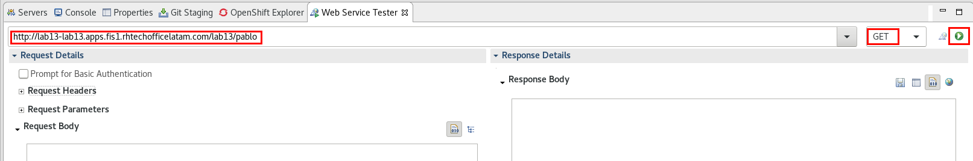

1. Click on the **invoke** icon several times.
2. You should receive responses from both active containers.

## Part C - Manual Scaling

|  |  |
| --- | --- |
| RH_Icon_Compass_Shiny.png | In this lab you will test manual scaling in Openshift for Fuse. |

1. Open a web browser and go to [https://fisworkshop.fis[your instance #].rhcol.com:8443/console/project/lab13/overview](about:blank)
2. In the overview tab, click on the **scale up** icon.

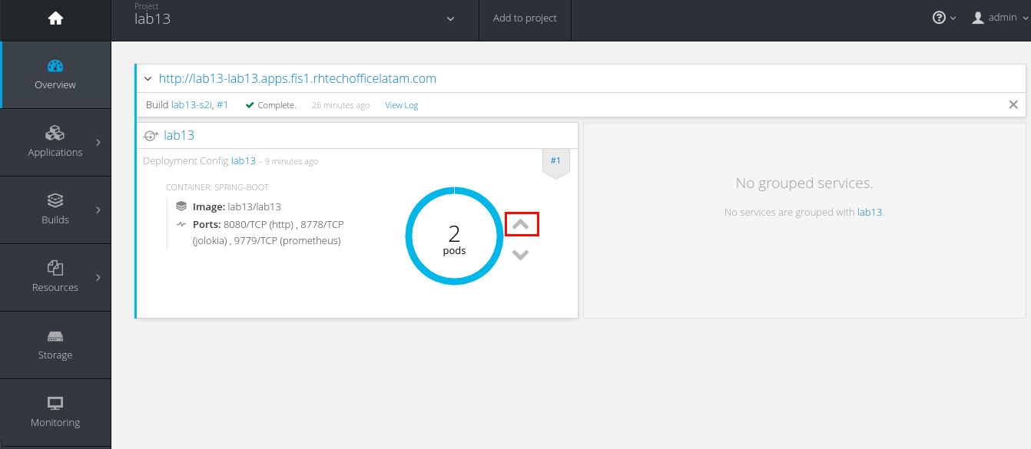

1. OpenShift will create a third copy of the lab13 pod and start it.
2. Go back to JBDS.
3. Go to the **Web Service Tester** view
4. Enter the following url: [http://lab13-lab13.apps.fis[your instance #].rhcol.com/lab13/pablo](about:blank)
5. Select **GET** as the HTTP method.
6. Click on the **invoke** icon.

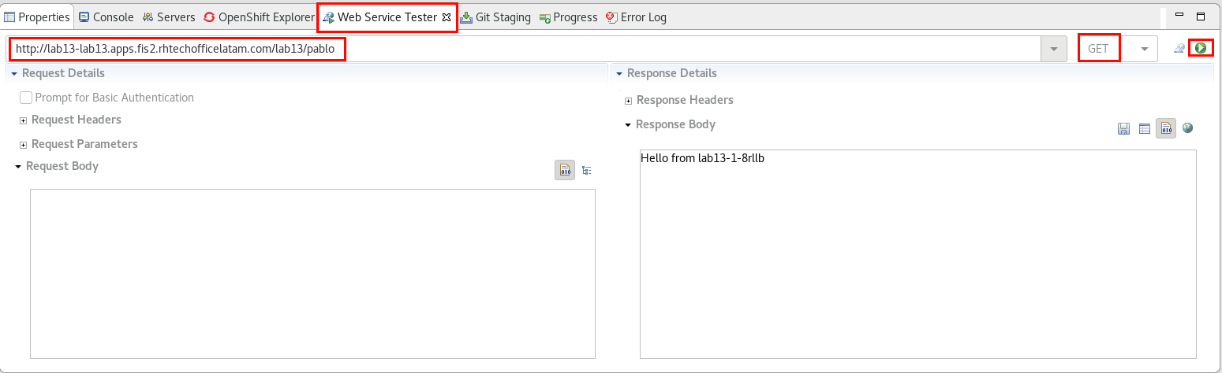

1. Click on the **invoke** icon several times.
2. You should receive responses from the three active containers.

# 

# Appendix

## Components reference

## 

|  |  |
| --- | --- |
| **ActiveMQ** | The ActiveMQ component allows messages to be sent to a [JMS](http://java.sun.com/products/jms/) Queue or Topic; or messages to be consumed from a JMS Queue or Topic using [Apache ActiveMQ](http://activemq.apache.org/). |
| **Choice** | Routes messages based on a series of predicates |
| **CXF** | The cxf: component provides integration with [Apache CXF](http://incubator.apache.org/cxf/) for connecting to JAX-WS services hosted in CXF. |
| **Enrich** | The Enrich pattern uses a producer to pull data from an endpoint outside of the route and uses it to enrich the message the route is processing. An AggregationStrategy is used to determine how the data is combined. |
| **File** | The File component provides access to file systems, allowing files to be processed by any other Apache |
| **FTP** | This component provides access to remote file systems over the FTP and SFTP protocols. |
| **Jetty** | The jetty component provides HTTP-based [endpoints](http://camel.apache.org/endpoint.html) for consuming and producing HTTP requests. That is, the Jetty component behaves as a simple Web server. Jetty can also be used as a http client which mean you can also use it with Camel as a producer. |
| **JDBC** | The JDBC component enables you to access databases through JDBC, where SQL queries (SELECT) and operations (INSERT, UPDATE, and so on) are sent in the message body. This component uses the standard JDBC API, unlike the [SQL Component](https://access.redhat.com/documentation/en-US/Red_Hat_JBoss_Fuse/6.2/html/Apache_Camel_Component_Reference/IDU-SQLComponent.html) component, which uses spring-jdbc. |
| **Log** | The log: component logs message exchanges to the underlying logging mechanism. |
| **Marshal** | The Marshal pattern uses Apache Camel's pluggable data format mechanism to convert messages into a format appropriate for transmission by one of the Apache Camel components. |
| **SetBody** | Sets the contents of the message body |
| **SetHeader** | The Set Header pattern sets the contents of a message header using an expression. |
| **SetProperty** | Converts the message data received from the wire into a format that Apache Camel processors can consume |
| **Split** | The Split pattern breaks a message into a number of smaller messages based on an expression. When used in routes whose exchange pattern is in-out, the Split pattern can either return a copy of the original message or use an aggregation strategy to recombine the responses into a reply. |
| **Transform** | The Transform pattern transforms the body of the message using an expression. |
| **Unmarshal** | Converts the message data received from the wire into a format that Apache Camel processors can consume |
| **When** | Routes messages based on a series of predicates |